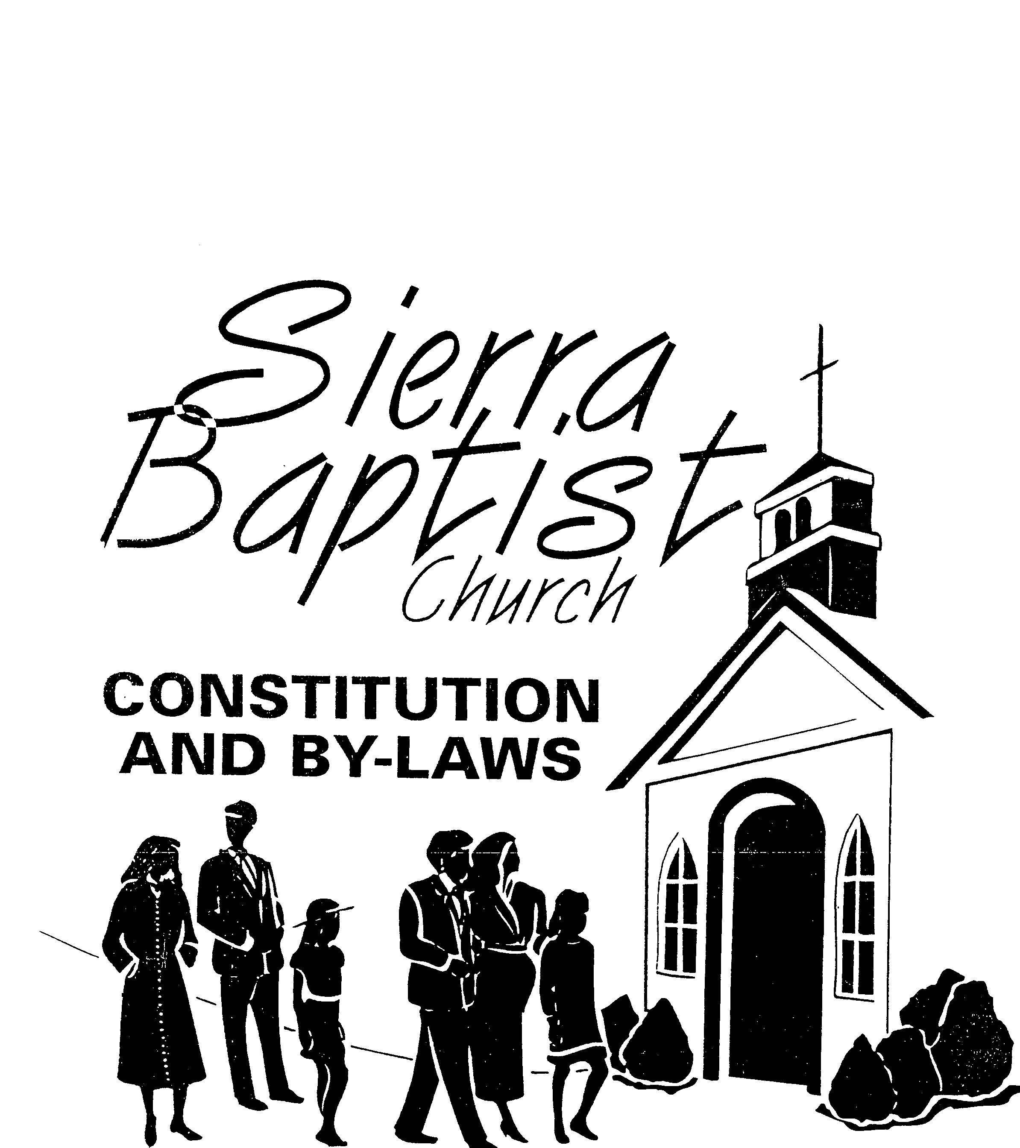
TABLE OF CONTENTS
CONSTITUTION 1
Article I. NAME, SEAL AND DURATION 1
Article II. STATEMENT OF FAITH 1
Article III. ORDINANCES 1
Baptism and The Lord’s Supper: 1
A. Baptism 1
B. The Lord’s Supper 1
Article IV. PURPUSE AND VISION STATEMENT 1
A. Purpose 1
B. Vision 1
Article V. COVENANT AND DOCTRINE 2
A. Government 2
B. Doctrine 2
Article VI. CHURCH COVENANT (Altered 06/18/2006) 2
BY-LAWS 3
Article I. MEMBERSHIP 3
A. Reception of Members Shall Be By 3
B. Termination of Membership Shall Be By 3
C. Duties of Members 4
Article II. CHURCH OFFICERS & STAFF, QUALIFICATIONS & CONDITIONS 4
A. Church Officers and Staff 4
1. Pastor 4
2. Church Staff 5

CONSTITUTION

NAME, SEAL AND DURATION
This congregation in accordance with its’ charter, shall be known as SIERRA BAPTIST CHURCH, Oakdale, California, and shall exist for the maximum period allowed by the laws of this state unless sooner lawfully dissolved. It shall have a corporate seal of a circular design on which shall be engraved the words “Sierra Baptist Church of Oakdale, Cali9fornia 95361, Incorporated August 5, 1992, with the word “Seal” in the center.
“SIERRA BAPTIST CHURCH OF OAKDALE”, is a non-profit organization, and shall not permit the use of its facilities for the financial gain of itself or any member or non-member.

STATEMENT OF FAITH
We believe that the Holy bible is the inspired Word of God and is the basis for any Statement of Faith. The church subscribes to the doctrinal statement of the Southern Baptist Faith and Message as adopted by the Southern Baptist Convention. We band ourselves together as a body of born again, baptized believers in Jesus Christ personally committed to sharing the good news of salvation to lost mankind.

ORDINANCES

Baptism and The Lord’s Supper:
- Baptism: Baptism by immersion is an act of obedience symbolizing the believer’s faith in the Lord Jesus Christ. Being a church ordinance, it is a prerequisite to the privileges of church membership and The Lord’s Supper.
- The Lord’s Supper: The Lord’s Supper is a symbolic act of obedience whereby members of a church of like faith and order, partaking of the bread and fruit of the vine, memorialize the death of the Redeemer and anticipate His second coming. Members will exclude or include himself/herself after self-examination under the direction of the Holy Spirit.

PURPUSE AND VISION STATEMENT
- Purpose: Sierra Baptist Church of Oakdale is a family oriented church with a focus on teaching Bible truths and living according to the Word of God so that others in the community might see God’s love and saving grace within us for His Glory.
- Vision: At Sierra Baptist Church of Oakdale, we desire to be a place where you:
  - Always feel at home and accepted;
  - Find exciting answers to life’s tough questions from God’s Word;
  - Are encouraged to develop your God-given personal skills and spiritual gifts to serve Christ in a powerful way;
  - Meet God personally and experience the awesomeness of His presence;
  - Become an active part of an ongoing effort to meet the needs of society;
  - Feel needed, loved, and appreciated as you fulfill your place of service in God’s ministry;
  - Grow toward spiritual maturity by being fed by the Pastor and other assined church teachers and/or leader;
  - Have a place to worship.

COVENANT AND DOCTRINE
- Government: The government of this church is vested in the body of believers who compose the control of no other ecclesiastical body but it recognizes and sustains the obligation, counsel and cooperation, which are common among Southern Baptist churches and is practical, this church will cooperate with and support the Central Valley Southern Association and the Southern Baptist General Convention of California of California affiliates and the Southern Baptist Convention.
- Doctrine: This church receives the scriptures as authority in matters of faith and practice. Xxx of Christian truth as contained therein is in essential accord with the belief of other Baptist.

CHURCH COVENANT (Altered 06/18/2006)
Having been led by the Spirit of God to receive Jesus Christ as Savior and Lord by faith, and having publicly confessed him by baptism in the name of God the Father, Son, and Holy Spirit, we freely and joyfully enter into covenant with one another as one body in Christ.
We pledge, therefore, by the aid of God's Spirit: to live together in Christian love, to work for the advancement of God's kingdom through this church in knowledge, holiness, and mutual care, to support its ministry by a faithful stewardship of money, time, and talents, and to sustain its worship, ordinances, doctrines, and disciplines.
We also pledge to maintain family and private worship, to rear our children in the nurture and teachings of the Lord, to seek the salvation of all members of our own families and of our acquaintances, and to strive for maturity in ourselves and our fellow Christians.
We further pledge to follow Christian principles of morality in our daily living, to be ethical in our dealings and faithful in our commitments, to promote the unity of fellowship by proper attitudes and godly speech, and to be zealous in our efforts to advance the kingdom of God and the Gospel witness here and throughout the world.

BY-LAWS

MEMBERSHIP
This is a sovereign and democratic Sierra Baptist Church under the leadership of Jesus Christ. The membership retains unto itself the right of exclusive self-government in all phases of the spiritual and temporal life of this Church. The membership reserves the exclusive right to determine who shall be members of this Church and conditions of membership.
Reception of Members Shall Be By:
Profession of faith in Jesus Christ and baptism as authorized by this church.
Promise and transfer of a letter from another Baptist church or a church of like faith and order. Candidates for church membership who come from churches other than churches of like faith and order will be received into this church by baptism.
Statement of former membership in a Baptist church or a church of like faith and order may be accepted when a church letter cannot be obtained because of loss of records or similar unavoidable circumstances.
Termination of Membership Shall Be By:
Letter being sent to another church of like faith and order.
Certificate of Christian Standing being sent to a church not of like faith and order.
Erasure – in the event a person’s name has been placed on the church roll by mistake, or by their request.
Exclusion – after the church has counseled and exhausted the scriptural methods of restoration, in the case of a person who holds membership in the church who had departed from the faith, is living in open immorality contrary to the covenant of the church; or who is guilty of sowing discord among the membership; OR WHO IS UNSUPPORTIVE OF THE PASTOR AND/OR LEADERSHIP COUNSEL DEACON BOARD; and for such reasons as the church shall demm worthy of exclusion.
Exclusion and the procedures for same shall be instituted in the following manner:
The member will be asked to meet with the Pastor / Leadership Council / Deacon Board. The Pastor / Leadership Council / Deacon Board will counsel the member toward resolving any / all problem issues: The member will be asked to accept the counsel of The Pastor / Leadership Council / Deacon Board.
If the member refuses to meet with The Pastor / Leadership Council / Deacon Board, and / or of the member meets with The Pastor / Leadership Council / Deacon Board and refuses council, the member’s name will be brought before the Church by the Pastor / Leadership Council / Deacon Board with the recommendation by a two-third (2/3) vote, the member will be classified as Excluded.
The Act of Exclusion is defined as follows:
The member will be sent a letter informing them that due to their decision of not being present for a discussion of problems with The Pastor / Leadership Counsel / Deacon Board, or for their decision to not follow the advice or counsel of The Pastor / Leadership Counsel / Deacon Board, their name is excluded from the active church membership and they will be unable to vote or hold church leadership positions.
The member may be reactivated from inactive status following a six month period in which said member is supportive of church ministries, agrees to strive to support the work of The Pastor / Leadership Counsel / Deacon Board, exhibits love for the Church Family, and strives to follow the Church Covenant.
If a member declines to reactivate from inactive exclusion the member will be sent a letter, encouraging them in love to seek out a Church of like faith in order to enable them to grow and serve our Lord. The letter will further state to the member wording to this effect:
Since you have declined and have not disclosed a desire to reactivate your membership, you have left us with no choice except to take your name from our membership roll. We pray that God will bless your efforts in finding a place of Christian worship and growth
When a member has not been in attendance for a six month period, unless ill or unable to attend, as is determined by The Pastor / Leadership Council / Deacon Board; has not been supportive of the church ministries either financially and/or vocally, the said member will be sent a letter stating their membership is being moved to inactive. At that time, voting rights of said member and the privilege to hold any and/or all church offices(s) will be suspended.
Death.
Duties of Members:
It shall be the duty of each member of Sierra Baptist Church of Oakdale, California to:
Keep the covenant obligations set forth in the Constitution and By-Laws and assist fellow members in keeping theirs;
To render due honor and esteem for the Pastor, to pray for him fervently and daily;
To manifest a proper attitude toward the entire work of the church and;
To serve in proportion to his/her ability.

CHURCH OFFICERS & STAFF, QUALIFICATIONS & CONDITIONS
Church Officers and Staff
Pastor
Shall be duly licensed and ordained by a church of like faith and order as a minister of the Gospel;
Shall be in agreement with Southern Baptist ministry;
Shall be called for an indefinite period unless otherwise agreed upon at the time of the call and shall be paid such salary as may be fixed by the church in its annual budget;
Responsible for leading the church in functioning as a New Testament Church;
Will lead, with the support and input from the Leadership Council / Deacon Board, the congregation, the organizations and the church staff in performing their tasks;
A major concern of the Pastor is to perform Pastoral responsibilities;
Will be the leader of worship, proclamation, education and Pastoral ministry;
Shall be chosen and called by the church whenever a vacancy occurs;
His election shall take place at a meeting called for that purpose, of which at least one weeks notice to the membership shall be given.
Church Staff
This church shall employ such staff members, as the church shall need. A job description shall be written when the need for staff is determined.

