Pick up location and artist’s traffic flow at St. David’s GT Hospital
on Sept. 15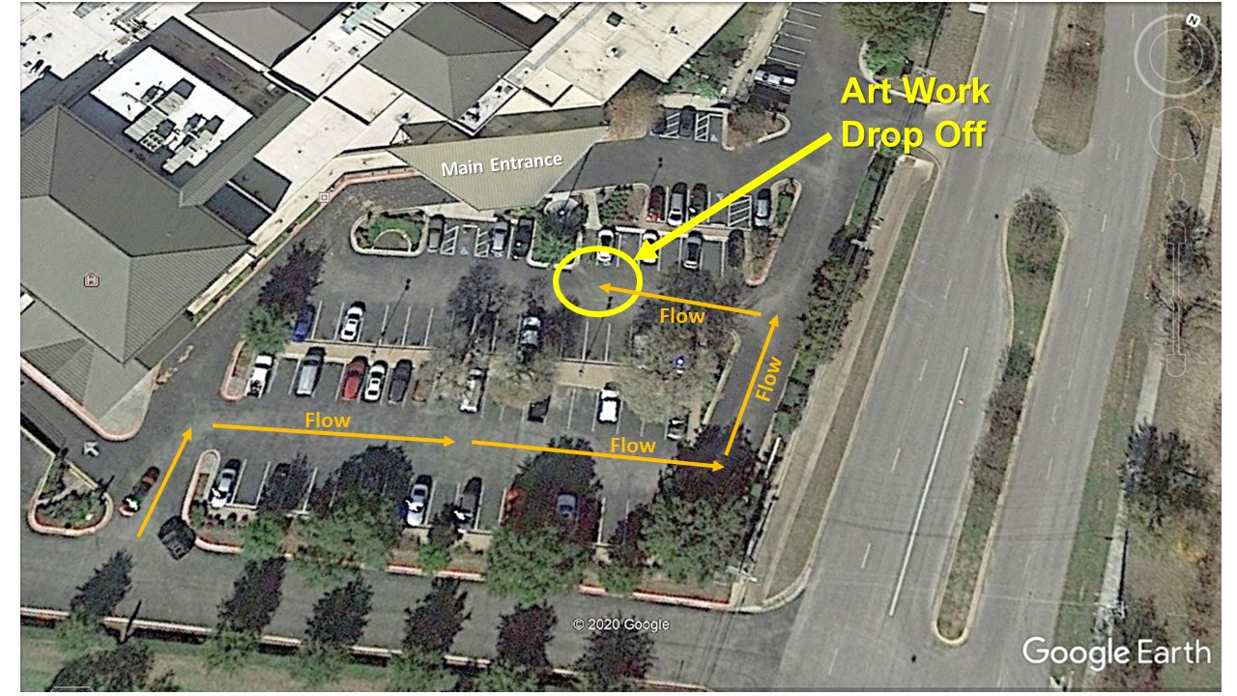
Artwork
Pick up

Note: This pick up location is not in the covered lane closest to the Main Entrance doors. We will start taking down the art at 12:00
It will be available as soon as we can walk them out of the building.
We anticipate releasing it before 12:45.

