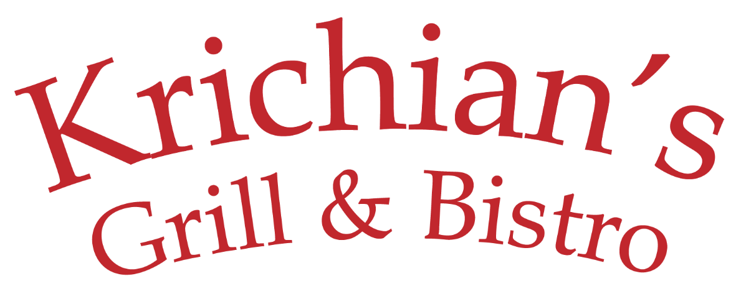

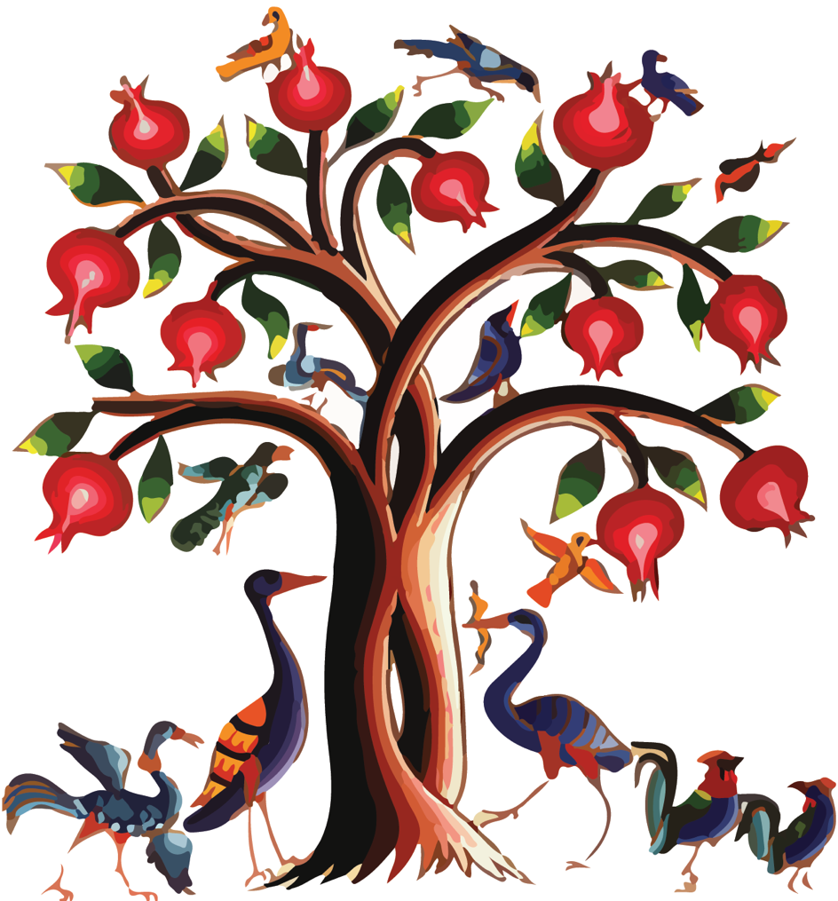

COLD APPETIZERS
Hummus Chickpea dip with tahini, lemon juice & garlic $6
Bistro Hummus Garnished with sautéed diced basturma or beef shawerma $9
Baba Ghanoush Broiled eggplant blended with tahini, garlic and lemon juice $7
Muhammara Hot red pepper, bread crumbs, walnuts, pomegranate molasses, olive oil and spices $8
Basturma Aged beef, coated with a mixture of fenugreek, garlic and spices $10
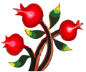
Chi Kofte (kibbeh nayeh) beef with bulgur garnished with parsley, onion & olive oil $12
Labneh Yogurt dip blended with garlic and walnuts $7
Yalanji (6 pcs) Stuffed grape leaves with rice, onion, olive oil, lemon juice and spices $7
Mezze Sampler Hummus , Baba Ghanoush, Labneh , Muhammara $10

HOT APPETIZERS
Falafel Crushed Garbanzo, fava beans, exotic natural spices and deep fried in pure vegetable oil (4 pcs) $7
Monte Crispy beef wontons served with garlic yogurt $10
Sujuk Armenian sausage prepared with ground beef, sautéed with fresh tomato, garlic, herbs and spices $10
Kibbeh Beef, cracked wheat, and spices shaped and fried (4 pcs) $7

Cheese Turnovers Blend of white cheese folded in homemade dough & fried in pure vegetable oil (5 pcs) $7
Arayis Toasted pita filled with seasoned ground beef $8
Liver Grilled lamb liver served over onion piaz $10
Fried Halloumi Grilled Greek Halloumi cheese $10

SALADS
Tabbouleh Chopped parsley, scallions, diced tomatoes, lemon juice, olive oil, cracked wheat and spices $8
Armenian Shepherd Salad Diced tomato, cucumber, onions, parsley and special dressing $8
Fattoush Salad Lettuce, tomato, cucumber, peppers, mint, onion, parsley, pita chips with sumac dressing $8
Greek Salad Tomato, cucumber, onion, parsley and topped with olives, feta cheese and special dressing $10
Bulgur Salad Cracked wheat in tomatoes sauce, garnished with scallion & parsley served over endive $8
Mixed Green Salad Baby greens served with balsamic vinaigrette, cranberries, and nuts $8
Avocado Salad Chopped cilantro, scallions, tomatoes, garlic, lemon juice and olive oil $10
Arugala Salad Sliced red onion, lemon juice and olive oil $8

SOUP
Yogurt Kibbeh $10  Beef, cracked wheat and spices shaped and served in  homemade yogurt soup | Soup of the Day $5 | Manti Soup $10  Tender beef dumplings in  chicken broth topped with homemade yogurt

DINNERENTREES
All entrees are char-broiled to perfection and
served with rice or lentil pilaf, vegetables and yogurt sauce

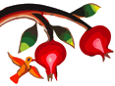
Filet Shish Kebab Filet Mignon, marinated and grilled $19
Luleh Kebab Ground lamb and beef mixed with parsley, onion and spices $15
Shrimp Kebab Jumbo shrimp, seasoned and grilled $19
Chicken Kebab Breast of chicken, marinated and grilled $15
Kebab Combo I One skewer each of luleh and chicken $15
Kebab Combo II One skewer each of filet mignon and shrimp $19
Kebab Combo III One skewer each of filet mignon, luleh and chicken $20
Rack of Lamb Marinated and grilled $20
Lamb & Beef Shawerma (Gyro) Marinated and broiled ground lamb and beef $15
Chicken Shawerma (Gyro) Marinated and broiled $15
Chicken Chops Marinated and grilled chicken thighs $14
Grilled Salmon Fillet Char-broiled served over sautéed spinach and topped with caramelized leeks $20
Samak El Hara Baked Tilapia filet in tahini sauce blended with garlic, cilantro, onion and nuts $20
Grilled Whole Fish in Season Served with lemon-garlic and tahini sauce $ Market Price

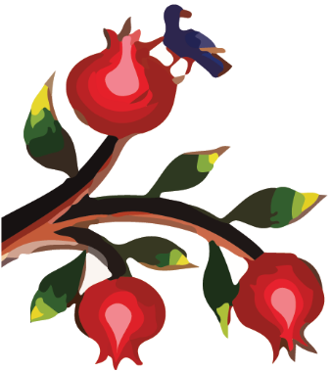
CHILDREN’S MENU
Chicken Tenders with French Fries $10
Chicken Kebab with Rice Pilaf $10
Luleh Kebab with Rice Pilaf $10

DESSERT
Please ask server for availability
Baklava Layers of crispy filo dough filled with ground walnut drizzled with syrup $5
Kadaif with Nuts Shredded filo dough filled with nuts & topped with light syrup $5
Hallawa bil Jebneh Middle eastern cheesecake with ice cream $7
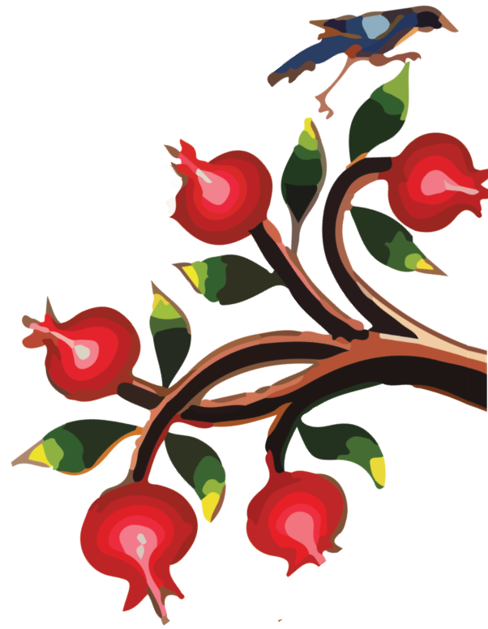Shahbyette Layered filo dough filled with cream and drizzled with syrup $3
Ashtah Vanilla ice cream topped with pistachio, rose jam and drizzled with syrup $5
Ice Cream Vanilla or Plain $4

BEVERAGES
Soda $2 Coffee $2
Snapple $3 Armenian Coffee $2.50
Pellegrino small $2 large $4 Tea Regular, Herbal or Armenian $2.50
Juice cranberry – orange – apple $3 Tan yogurt drink $3

