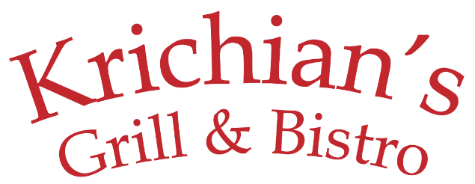
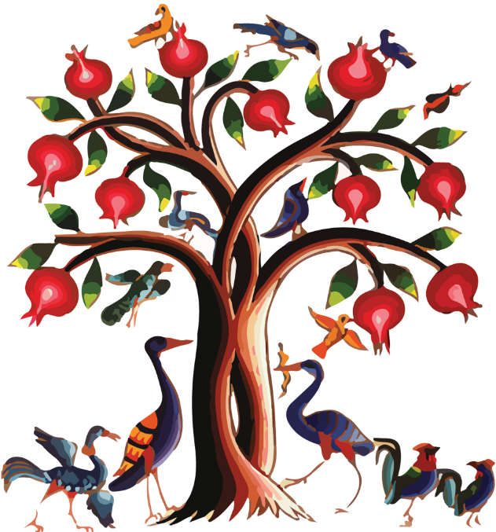
It All Started When…
Lunch Menu

Tel: (973) 569-1033
krichianfood@gmail.com
Fax: (973) 569-1034
www.krichianfood.com
399 Crooks Ave
Paterson, NJ 07503

Friends and family knew, anytime they visited Anahid and Aram, they would eat well! They would be treated to delicious Armenian and Middle Eastern food that was beyond anything that they could prepare at home themselves.
First came the mezze platters with boreg and dolma... then the beautifully decorated spreads alongside warm fresh pita… then the mouth-watering kebabs, perfectly grilled to be juicy and tender… then all the handmade pastries you can imagine. Combined with plenty of drinks, good music and fun friends… every meal felt like a true dinner party.
Word got around that Anahid and Aram were excellent chefs and they began being asked to sell their home-made delicacies. Soon a specialty catering business was born and a short time later they opened Krichian Foods, a little luncheonette that specialized in catering. Over the years, the business continued to grow in popularity and it was clear a new and larger space was needed.
After years of hard work, Anahid and Aram’s dream of a full restaurant became reality. In 2010 Krichian’s Grill & Bistro celebrated a grand opening.
Thank you for coming and continuing the tradition of enjoying Anahid and Aram’s recipes and hospitality. Enjoy.
Բարի եկաք
Paree Yegak
Welcome

Krichian's Grill & Bistro
lovingly prepares
authentic, hand-made,
Armenian and Middle Eastern food
using only the highest quality ingredients.

2021

SALAD
Armenian Shepherd Salad $8
Greek Salad $9
Tabbouleh Salad $8
Fattoush Salad $8
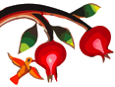
Add skewer of grilled chicken $6

SANDWICH
on pita with lettuce, tomato, onion & pickle
Falafel with Tahini Sauce $5
Chicken Shawerma (Gyro) $7
Beef Shawerma (Gyro) $7
Chicken Kebab $7
Luleh Kebab $7
Filet Beef Shish Kebab $9
Hummus $4

PANINI
on lavash bread
Chicken Cheese Panini $9
Grilled chicken & white cheese, with lettuce
tomato & garlic sauce
Vegetarian Panini $9
Grilled vegetables, cheese, tomato & pickle
Basturma Panini $10
Armenian pastrami, cheese, tomato & pickle
Soujouk Panini $10
Armenian sausage, cheese, tomato & pickle
Mesakhan Panini $9
Grilled chicken, sauteed onion, with
sumack & tahini sauce
LUNCH PLATTERS
choice of rice, french fries or lentil pilaf and served with salad, hummus & pita
$11

Filet Beef Shish Kebab
Filet mignon, marinated & grilled
Luleh Kebab
Ground lamb & beef
Chicken Kebab
Marinated & grilled
Beef Shawerma (Gyro)
Chicken Shawerma (Gyro)
Chicken Chops
Marinated & grilled chicken thighs (2)

VEGETARIAN
no dairy or animal fat
Falafel Combo $8
Three falafels over salad, hummus & pita
Super Falafel Combo $10
Three falafels over salad, hummus, cracked wheat salad, baba ghanoush, stuffed grape leaves & pita
Mujadara $8
Lentil & cracked wheat, served with
tossed salad, hummus & pita
Eggplant with Mujadara $10
Lentil & cracked wheat, served with
tossed salad, hummus & pita
Okra with Mujadara $10
Lentil & cracked wheat, served with
tossed salad, hummus & pita

Soup
Soup of the Day $5
Manti Soup $10
SIDES
Small Large
Hummus $3.50 $6
Baba Ghanoush $3.50 $7
Labneh $3.50 $7
Muhammara $4 $8
French Fries $4
Cheese Turnovers (5 pcs) $6
Kibbeh (4 pcs) $7
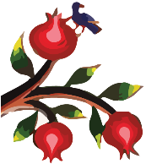
Spinach Pie (4 pcs) $5
Grape Leaves (6 pcs) $7

DESSERT
Baklava (4 pcs) $5
Kadaif $5
Hallawa bil Jebneh $5
Ice Cream, Pistachio & Rose Jam $5

BEVERAGE
Bottled Water $2
Pellegrino $2
Tan $3
Soda $2
Snapple $3
Juice $3
Coffee or Tea American $2
Armenian Coffee $2.50
Armenian Tea $2.50
Fresh Mint Tea $2.50

