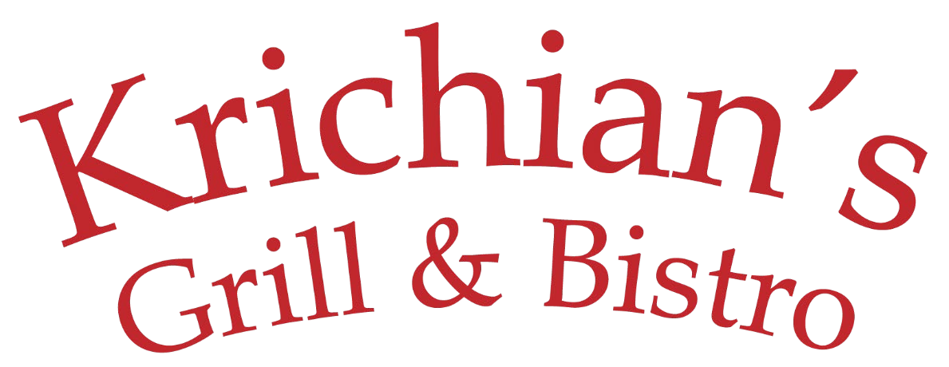

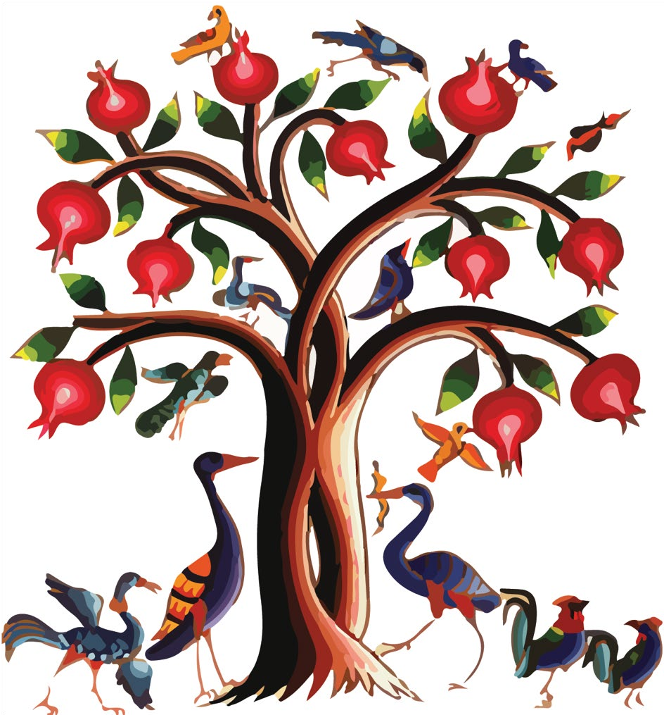

COLD APPETIZERS

Hummus Chickpea dip with tahini, lemon juice & garlic $8
Bistro Hummus Garnished with sautéed diced basturma or beef shawerma $10
Baba Ghanoush Broiled eggplant blended with tahini, garlic and lemon juice $8
Muhammara Hot red pepper, bread crumbs, walnuts, pomegranate molasses, olive oil and spices $10
Basturma Aged beef, coated with a mixture of fenugreek, garlic and spices $12

Chi Kofte (kibbeh nayeh) beef with bulgur garnished with parsley, onion & olive oil $16
Labneh Yogurt dip blended with garlic and walnuts $8
Yalanji (6 pcs) Stuffed grape leaves with rice, onion, olive oil, lemon juice and spices $9
Mezze Sampler Hummus , Baba Ghanoush, Labneh , Muhammara $12

HOT APPETIZERS
Falafel Crushed Garbanzo, fava beans, exotic natural spices and deep fried in pure vegetable oil (4 pcs) $8
Monte Crispy beef wontons served with garlic yogurt $11
Sujuk Armenian sausage prepared with ground beef, sautéed with fresh tomato, garlic, herbs and spices $12
Kibbeh Beef, cracked wheat, and spices shaped and fried (4 pcs) $9
Grilled Kibbeh Saj Beef, cracked wheat, and spices shaped and grilled (4 pcs) $12
Cheese Turnovers Blend of white cheese folded in homemade dough & fried in pure vegetable oil (5 pcs) $9
Arayis Toasted pita filled with seasoned ground beef $10
Liver Grilled lamb liver served over onion piaz $12
Fried Halloumi Grilled Greek Halloumi cheese $12

SALADS
Tabbouleh Chopped parsley, scallions, diced tomatoes, lemon juice, olive oil, cracked wheat and spices $14
Armenian Shepherd Salad Diced tomato, cucumber, onions, parsley and special dressing $13
Fattoush Salad Lettuce, tomato, cucumber, peppers, mint, onion, parsley, pita chips with sumac dressing $13
Greek Salad Tomato, cucumber, onion, parsley and topped with olives, feta cheese and special dressing $13
Bulgur Salad Cracked wheat in tomatoes sauce, garnished with scallion & parsley served over endive $10
Mixed Green Salad Baby greens served with balsamic vinaigrette, cranberries, and nuts $12
Avocado Salad Chopped cilantro, scallions, tomatoes, garlic, lemon juice and olive oil $12
Anise Apple Salad Cilantro, sliced almond garlic and olive oil $13

Yogurt Kibbeh $12
Beef, cracked wheat and spices shaped and served in homemade yogurt soup

SOUP
Manti Soup $12
Soup of the Day $6 chicken broth topped with Tender beef dumplings in
homemade yogurt

DINNERENTREES
All entrees are char-broiled to perfection and

served with choice of rice, lentil pilaf, or french fries and vegetables


Filet Shish Kebab Filet Mignon, marinated and grilled $26
Luleh Kebab Ground lamb and beef mixed with parsley, onion and spices $19
Shrimp Kebab Jumbo shrimp, seasoned and grilled $22
Chicken Kebab Breast of chicken, marinated and grilled $19
Kebab Combo I One skewer each of luleh and chicken $19
Kebab Combo II One skewer each of filet mignon and shrimp $24
Kebab Combo III One skewer each of filet mignon, luleh and chicken $25
Rack of Lamb Marinated and grilled $28
Lamb & Beef Shawerma (Gyro) Marinated and broiled ground lamb and beef $19
Chicken Shawerma (Gyro) Marinated and broiled $19
Chicken Chops Marinated and grilled chicken thighs $17
Grilled Salmon Fillet Char-broiled served over sautéed spinach and topped with caramelized leeks $26
Samak El Hara Baked Tilapia filet in tahini sauce blended with garlic, cilantro, onion and nuts $26
Grilled bronzini Served with lemon-garlic and tahini sauce $ 26

CHILDREN’S MENU
Chicken Tenders with French Fries $14
Chicken Kebab with Rice Pilaf $14
Luleh Kebab with Rice Pilaf $14

DESSERT
Please ask server for availability
Baklava Layers of crispy filo dough filled with ground walnut drizzled with syrup $5
Kadaif with Nuts Shredded filo dough filled with nuts & topped with light syrup $6
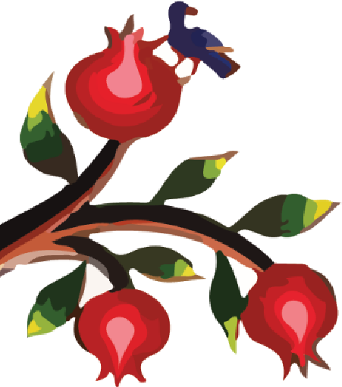
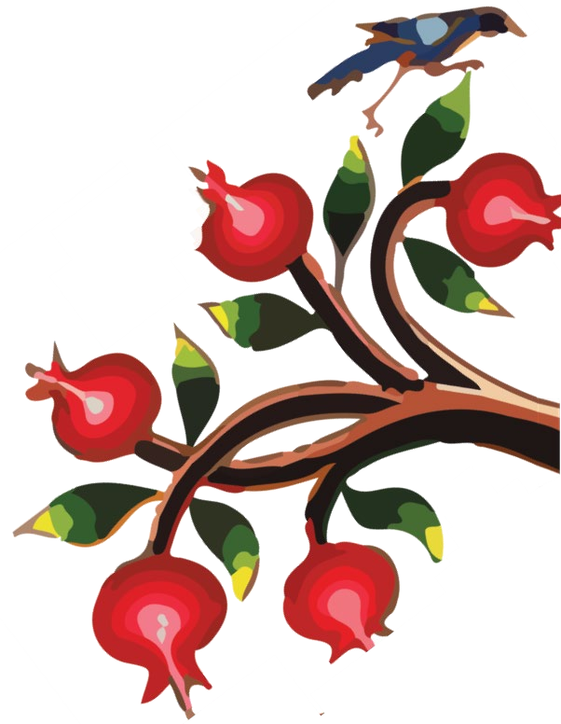
Hallawa bil Jebneh Middle eastern cheesecake with ice cream $7

Shahbyette Layered filo dough filled with cream and drizzled with syrup $3
Ashtah Vanilla ice cream topped with pistachio, rose jam and drizzled with syrup $5 Ice Cream Vanilla or Plain $4

BEVERAGES
Soda $3 | Coffee $3
Snapple $4 | Armenian Coffee $3
Pellegrino small $4 large $6 | Tea Regular, Herbal or Armenian $3
Juice cranberry – orange – apple $3 | Tan yogurt drink $4

