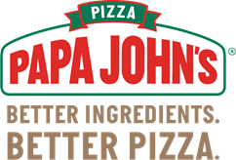

Buy a Papa John’s Coupon Card and support

Puckett’s Mill Elementary School!

**ONLY $10 each** and pays for itself in one use!

Buy as many as you want!

Card good for Online Ordering and includes $10 off, 4-buy one get one free, and 4-30% off coupons!

**Total of 9 coupons that can only be used once and good till end of 2023**

Return bottom order form with payment and card(s) will be sent home with your student.

Cash or Check made payable to PMES PTA

Student Name:__________________________Teacher:_____________

Parent Name:___________________________________ Qty:________

Parent Email:___________________________________________

PTA Use: ______Cash _______Check _______Qty _______Initials ________Date