STANLEY TAP AND DIE ORDER

All,
CORRECTED TABLE
After months of delays, I finally have final cost pricing for virtually all Stanley bench plane taps and dies. In my defense, I would like to say the logistics of finding a supplier with the best pricing, ensuring all the parts had the correct specifications, learning about the differences in carbon hex dies vs. high speed steel dies, starter taps vs. bottoming taps, consolidating orders from as many people as possible to get bulk discounts and spread out the machine setup costs, then putting it all together was far more than I ever expected.

I specified all bottoming taps as they will be used to correct existing blind holes. I also elected to specify all High-Speed Steel (HSS) dies vs. lower cost carbon hex dies. While a carbon hex die will work to “clean-up” existing threads, it cannot be used to cut threads on new material. If you wanted to produce a new threaded rod for the tote or knob, the carbon hex die would strip out. Additionally, the carbon hex die will have a limited life if you are having to straighten existing threads vs. just removing stubborn debris. In the end, I feel the value of the high-speed steel dies is worth the added cost.

You will have to pay for shipping, but it should be $7.75 or less USPS flat rate padded envelope which I will add to your order and let you know the total. I am asking for payment at time order via Paypal (aPlaneLife@comcast.net) , Venmo (@aPlaneLife) or you can mail a check.

International shipping will obviously be more, and I suggest you check to ensure you want to order. International may also face import fees. I am willing to ship international.

Here are the prices I have managed to obtain. The cost will be at or below these prices. Given enough volume, we may get additional discounts on pieces. I will pass along any savings.

PART # | PART | DESCRIPTION | Price | QTY
1 | LEVER CAP | 9/32"-24  American Unified Form  BOTTOM TAP | $41.00
1 | LEVER CAP | 9/32"-24 American Unified  HSS 1" OD R A DIE | $60.00
3 | DEPTH ADJ NUT | 9/32"-24  LEFT-HAND  American Unified  BOTTOM TAP | $41.00
3 | DEPTH ADJ NUT | 9/32"-24  LEFT-HAND  HSS 1" OD R A DIE  American Unified | $61.00
4, 6 & 7 | TOTE/KNOB/FROG | #12-20 BOTTOM TAP | $28.20
4, 6 & 7 | TOTE/KNOB/FROG | #12-20  HSS 1" OD R A DIE | $55.20
5 | FROG ADJ SCREW | 1/4"-24  H3 BOTTOM TAP | $25.00
8 | FROG ADJ PLATE SCREW | 7/32"-24  HSS WHITWORTH BOTTOM TAP | $50.00

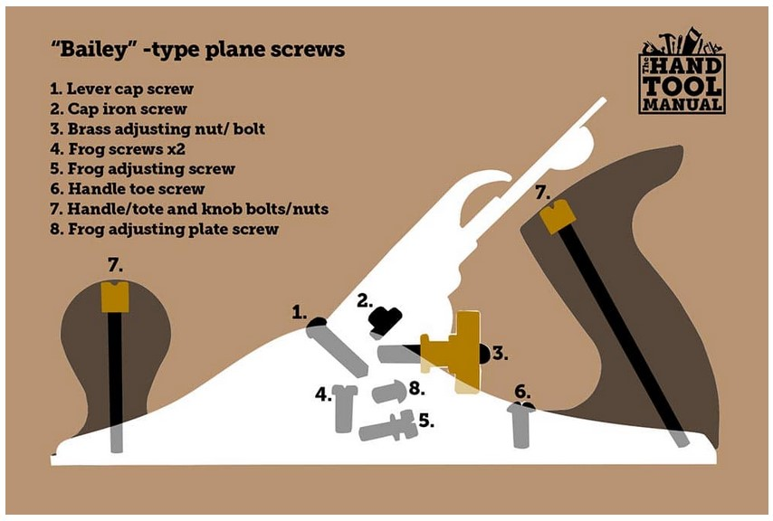

I recommend a 3-screw adjustable die stock (handle). These are adjustable high-speed steel dies, meaning you can micro adjust the actual cutting diameter as needed for your part when using a compatible adjustable die stock.

https://www.mcmaster.com/25565A21/

1” HSS Round Adjustable dies require a compatible wrench handle.

An adjustable tap handle will work for the knob, tote, depth adjusting stud, lever cap screw, and frog attachment screws.

https://www.mcmaster.com/25605A75/

The frog adjusting screw requires an extension to clear the plane bed.

https://www.mcmaster.com/2760A15/

Let me know what you want to purchase by putting the quantity in the table and sending it to me.

The order will take 3-6 weeks as many of the components are custom machining. I will order extras to hit minimums and you will see these extras listed for sale on my web site at retail prices.

If you have any questions, feel free to contact me via email, FB message or call 914-886-8834.

