Head south on 74 out of Peachtree City toward GA-85, turn right on GA-85
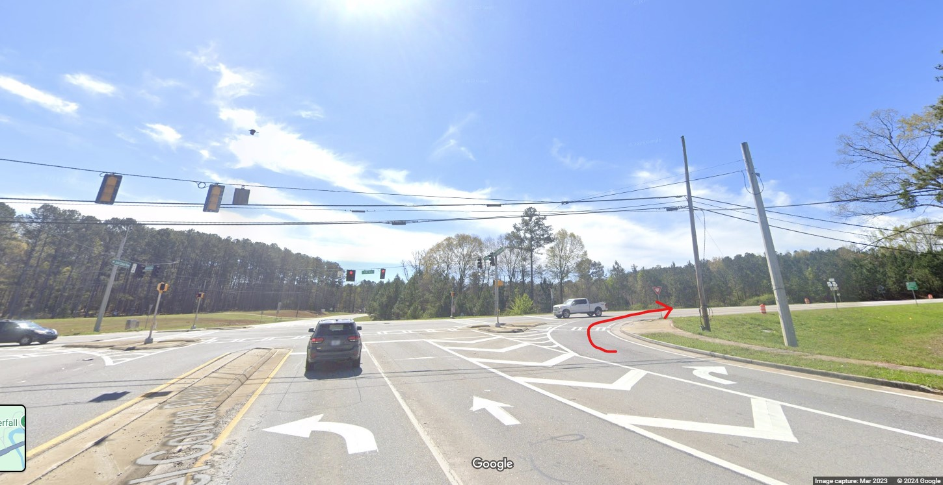
Head south on GA-85 to Woodbury Rd / GA74 (in this picture it says Main Street) and is after Ingles, turn left on Woodbury Rd / GA-74
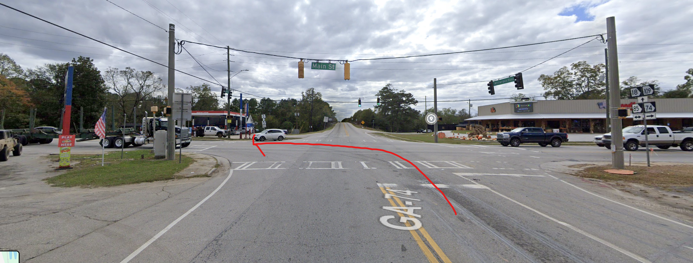

Head down Woodbury Rd. Lawrence Rd, turn Right on Lawrence and immediately turn right on Thundering Springs Rd. (note the Gerald Lawhorn Scouting Base Sign)
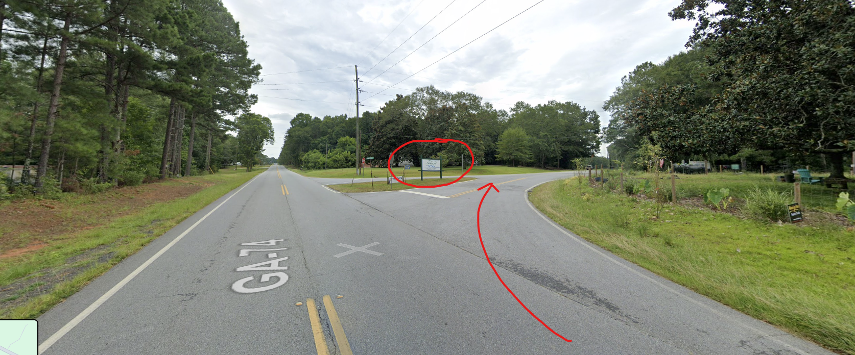
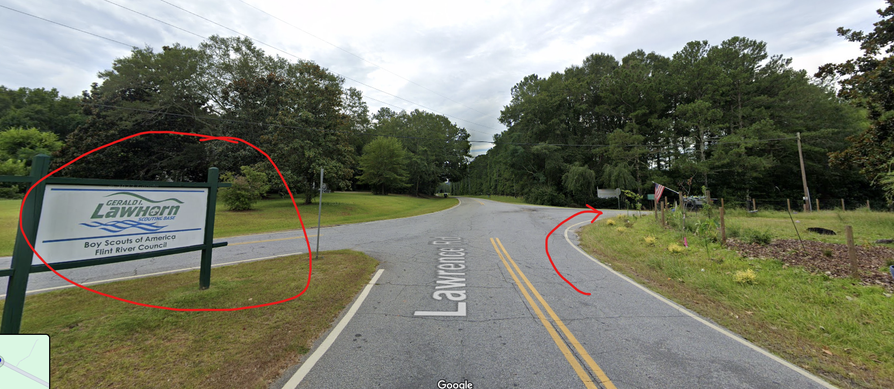

When you get to the lake please stay straight
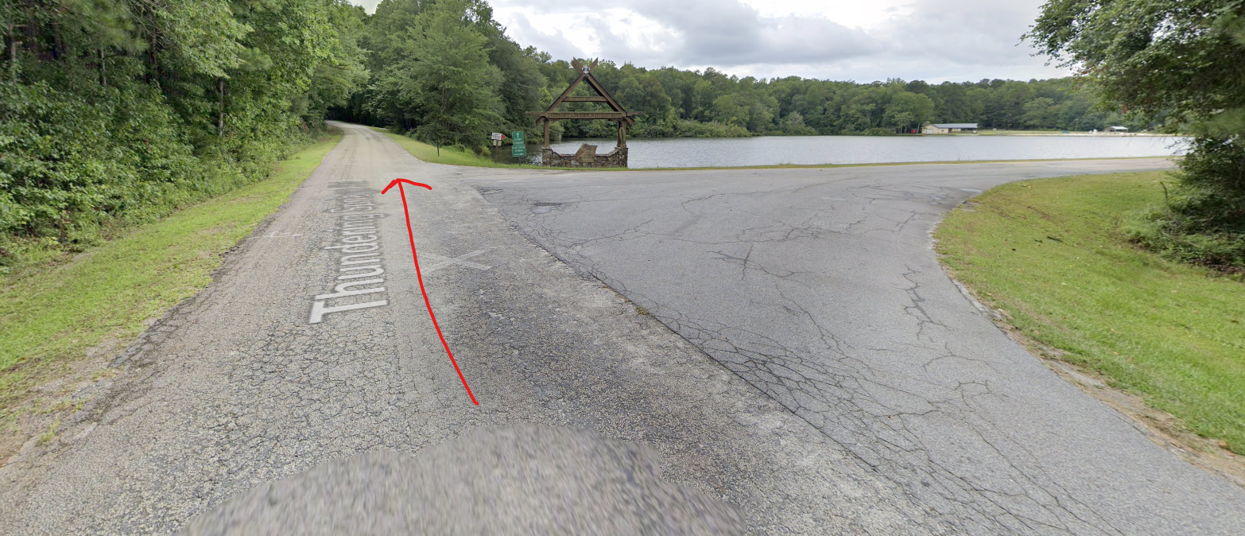
This is the main entrance and the gate will be open when you arrive, you will turn right into the camground:
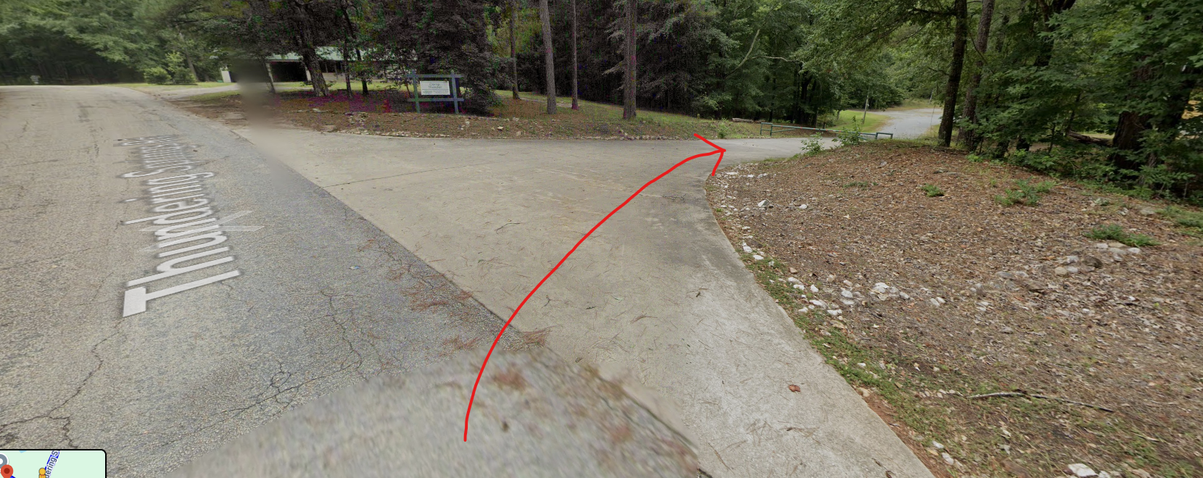

Once you make the above right you will come to a parking lot. This is where we need to park for our stay. I have circled the right turn on this map and the parking lot. Welcome to camp! If you make it to the Howard Lodge you have gone too far.
