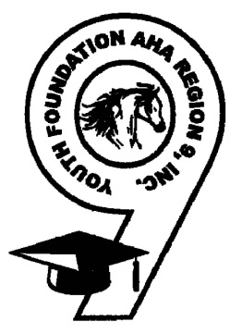
2018 Region 9 Championship Show

Box Seating Order Form

Benefiting Youth Foundation Region 9 AHA, Inc.

We are pleased to announce that the proceeds of the Box Seating Donor Program of the 2018 AHA Region 9 Championship Show in Fort Worth will benefit the Youth Foundation Region 9 Scholarship Program. You can join in this endeavor. Your support through the purchase of Box Seating at the Region 9 Championship Show will enable the Youth of Region 9 to continue their education after High School through our needs-based program.

About The Youth Foundation Region 9 AHA, Inc.
The Youth Foundation was established in 1989 with the goal of creating scholarships for youth throughout Region 9 and is currently a 501c(3) tax-exempt organization. The impact of our program has helped students live out their dream by becoming Lawyers, Veterinarians, Doctors and Accountants just to name a few. Each semester we help an average of 18 to 19 students continue their education at approximately 13 universities across the United States. Thank you for your support and we look forward to seeing you at the Region 9 Championship Show.

For more information about Youth Foundation Region 9,
please visit our website at http://www.youthfoundationregion9.org

BOX SEAT TICKETS

For 4 days and 4 evenings
Quantity Early Bird Pricing After May 7, 2018
Box seats for 6 $150 $250

Box seats for 8 $200 $300

Box seats for 12 $300 $400

DONOR INFORMATION

Name of Contributor

Address/City/State/Zip

Telephone Email

PLEASE MAKE CHECKS PAYABLE TO: Youth Foundation Region 9 AHA Inc.

Please mail this form and payment by May 7, 2018 to:
Region 9 AHA c/o Cynthia Savage
PO Box 911
Belton, TX 76513
34

