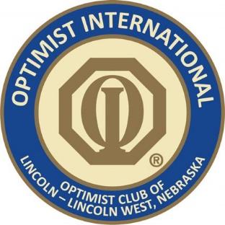

LINCOLN WEST OPTIMIST CLUB
PO Box 231 Malcolm, NE 68402 www.lincolnwestoptimists.com l.w.o.club@gmail.com
LWOC Foundation 501(c)(3) 23-7069388

Dear Sponsor,

Please allow me to introduce myself—my name is Angie Birkett, and I am the Chair of the Lincoln West Optimist Club (LWOC) Fundraising Committee.

The Lincoln West Optimist Club is a non-profit youth service organization dedicated to supporting and enriching the lives of young people in our community. Each year, thousands of local youth - Boy Scouts, Girl Scouts, and other groups - make use of our facilities at Branched Oak Lake. Our five-acre site includes a large open lodge, a deck overlooking the lake, campgrounds, a campfire amphitheater, sand volleyball, horseshoe pits, a professional frisbee golf course, hiking trails, a new playground, and access to fishing and water activities.

Beyond our facilities, LWOC is known for our hands-on youth programming, including:
- Homer’s Heroes, a summer baseball program for special needs youth
- Friendship Home Holiday Party, supporting children and families affected by domestic violence
- Big Brothers/Big Sisters Events, including movie outings for foster families at Marcus Grand Theater
We also proudly support academic achievement by sponsoring students for Essay and Oratorical competitions and provide scholarships to local area youth. In addition, LWOC was instrumental in the development of the Optimist Sports Complex Baseball Fields, which continue to serve countless children and families in the community.
We are thrilled to announce our Second Annual Poker Run Fundraiser will take place on Saturday, September 27, 2025. This exciting event will cover approximately 200 miles and raise critical funds to support our youth programs.
We are currently seeking raffle and silent auction donations, as well as monetary contributions to help us reach our fundraising goals. Financial donations will go toward purchasing raffle items, event supplies, and supporting ongoing LWOC youth initiatives throughout the year.
On behalf of the entire LWOC team, I want to thank you for your time, your generosity, and your continued support of our mission. We would be honored to have you as a sponsor for this year’s event.
To learn more about our organization, please visit our website or follow us on Facebook.
Thank you again for your consideration and participation.
Angie Birkett
Chair LWOC Fundraising Committee 402-335-0305
abirkettmk@yahoo.com

