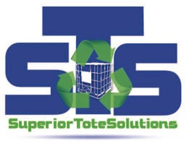
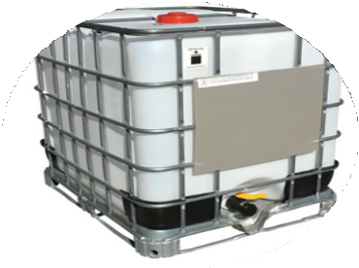
AG SPEC IBC'S IN STOCK!

CALL NOW
765-536-8088 x2
INDUSTRIAL PACKAGING NEEDS

NEW 275-Gallon RECON 275-Gallon DEF
Oil
AG Chem
Return Program Incentives

Pick-Up & Delivery Available

CONTACT US
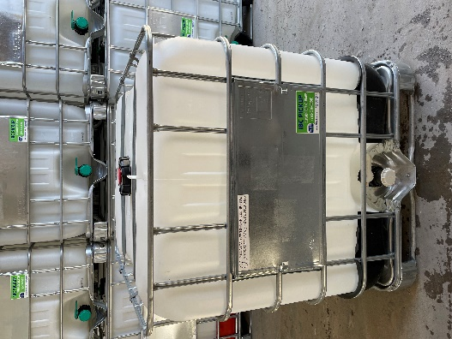
(765) 536-8088 x2
kelly@stsindiana.com www.stsindiana.com
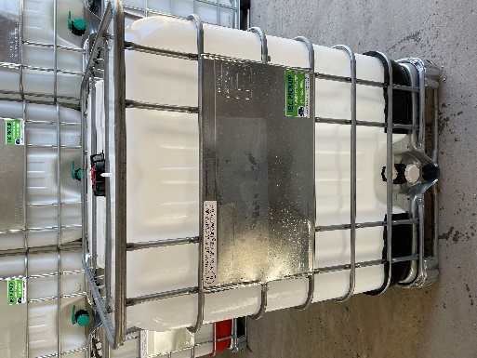
401 N. Main St. Summitville, IN 46070
We can service your facility with both 275 and 330 gallon units!

