

Permanent Makeup Nano Brows
Before/After Care
Failure to Follow After-Care Instructions May Result in Infections, Pigment Loss, or Discoloration
At First Sign of Infection Contact your Physician Immediately!
Pre-Care
- Avoid drinking coffee or any caffeinated beverages prior to your appointment.
- Avoid drinking alcohol 24 hours before the procedure.
- Avoid tanning or sunbathing three days before your appointment.
- No aspirin, fish oil, vitamin E, and other blood thinners including pain killers for at least 24 hours before the procedure.
- Avoid using Retin-A/Retinoids/Retinols, Filler and Botox for two weeks prior.
- No working out after on the day of procedure.
- No Chemical peels or harsh exfoliating treatments for at least one week prior.

After-Care
Day of the treatment: Gently blot the area with clean tissue to absorb excess lymph fluid, if any. Do this every 10/15 minutes for the next few hours until oozing has stopped. Removing this fluid prevents hardening of the lymph.
A few hours after the procedure wash eyebrows with water and mild, fragrance free antibacterial soap (Cetaphil, Neutrogena, Dial.) Get a good lather in your finger tips and do circular motions from one end of the eyebrow to the other, rinse with luke-warm water and then pat dry with a paper towel. Apply a rice- grain amount of Aquaphor with a cotton swab and spread it across the treated area. Wipe off excess with the dry end. Repeat this all before bed and then starting the next day morning and night x 5-7 days. Eyebrows will appear very dark until the healing process is complete and takes up to three weeks to completely oxidize into their softened color.

Limit your showers to under 10 minutes so that you do not create a lot of steam in the first week. Keep your face/procedure area out of the water, while you wash your body, then, at the end of the shower wash your hair. Your face should only be getting wet at the very last end of the shower. Avoid excessive rinsing and hot water on the treated area.

Things to Remember :
- Expect slight swelling, thickness and/or redness for 1-2 days following the procedure. Brows will appear darker for the first few days.
- Use fresh pillow cases. Avoid sleeping on your face for the first 10 days.
- Let any scabbing or dry skin naturally exfoliate away. DO NOT rub, pick, or scratch the treated area to avoid scarring and pigment loss.
- Avoid hot, sweaty exercise and long hot showers for 7 days.
- Avoid direct sun exposure or tanning for 4 weeks after the procedure. Wear a hat or sunglasses if you need to when outdoors.
- No facials, botox, chemical treatments, or microdermabrasion for 4 weeks following procedure.
- Avoid sunscreen on the area until healed.
- Avoid any water submerging (swimming, lakes, hot tubs) for first week.
- Avoid touching the area of tattoo unless necessary and always make sure hands are clean.
- After brows are healed, continue to avoid scrubbing and exfoliating the area.
- Avoid any products that contain Retin-A or Glycolic Acids around eyebrow area.
- You may fill in any voids with an eyebrow pencil or brow powder until touchup after the first week if cuts are completely closed.
- As swelling dissipates, unevenness usually disappears. If some remains we will make adjustments during the touchup appointment.
- As the procedure area heals, the color will lighten up and sometimes seem to disappear in some places. This can all be addressed during the touchup appointment, which is why the touch up is necessary. Complete healing takes about 4 weeks before any adjustments can be made.
- Future touchups will depend on your skin, medications, sun exposure, and products used. Color will soften 30-40% when healed.

Powder/Ombre/Combo Brows:
Day 1-2: Color will be darker and bolder in width (keep moist with Aquaphor)
Day 3: Exfoliation will begin causing the excess pigment surrounding the eyebrow procedure to flake away and eyebrows will appear narrower
Day 4: Eyebrow may itch, this is the normal healing process-don not pick the area!
Day 5: Pigment will peel off and the eyebrows will appear softer
Day 6-14: Color enhances to final results.
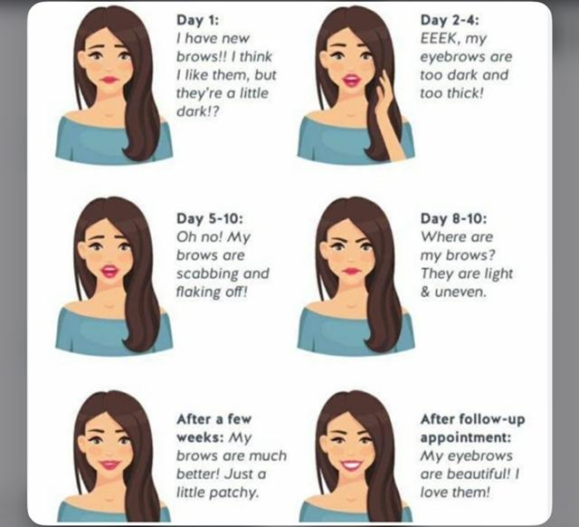

Contacts of Emergency
Kissed with Ink, LLC
(770) 895-2002
1810 Cumming Highway (inside Sola Suites)
Suite 113
Canton, GA 30115

Cherokee County Environmental Health
(770) 479-0444
1130 Bluffs Parkway
Canton, GA 30114

