

Permanent Makeup Lip Blushing
Before/After Care
Failure to Follow After-Care Instructions May Result in Infections, Pigment Loss, or Discoloration
At First Sign of Infection Contact your Physician Immediately!
Pre-Care
30 Days Prior:
- Avoid botox and fillers around the lip area
- Avoid Glycolic acid, chemical peels, and laser treatments on the face
- Avoid Retinols and anti-aging creams ex: Retin
14 Days Prior:
- Avoid all facials, bleaching treatments, or waxing around lip area
- Avoid extensive sun exposure and sunburn on the face
7 Days Prior:
- Avoid Motrin, Advil, Ibuprofen, Naproxen (Tylenol/Acetaminophen is ok to consume)
- Avoid fish oils, DHA supplements, cayenne supplements, turmeric, vitamin E, niacin, or anything that cause blood thinning
- If you have been prone to any type of cold sores or fever blisters this procedure may trigger one to pop up and it is recommended to reach out to your physician about obtaining a prescription of Acyclovir or another antiviral in order to lessen the chances of an outbreak.

1-3 Days Prior:
- Avoid alcohol
- Avoid caffeine or tea (1/2 cup is ok, drink decaffeinated) or excessive amounts of caffeine
- Gently exfoliate your lips 2 days prior to your procedure, 2x a day (you can use sugar and coconut oil mixture for a natural exfoliate)
- Hydrate! Hydrate! Hydrate! Drink Plenty of Water!

After-Care
Day of the treatment: Gently blot the area with clean tissue to absorb excess lymph fluid, if any. Do this every 10/15 minutes for the next few hours until oozing has stopped. Removing this fluid prevents hardening of the lymph.
Expect moderate swelling, usually 1-2 days following procedure. Applying ice for the first 2 hours is the most important part and please continue throughout the day. Keep moist with Aquaphor for the next 5-7 days, then switch to Chapstick or lipstick with a SPF of 15 or greater as the sun tends to fade lip color quickly.
Note: after the procedure, the lips may appear to have too much color. You may add makeup to soften the color. After 3-4 days, the color will become lighter as the epidermis sloughs off; it will appear that you lost all color. However, when your lips have healed completely, the dermal layer will gradually become darker. Two or three applications may be required to achieve the desired results. It is not uncommon to lose up to 70% of the color on the first application.

Things to Remember :
- Avoid touching lips with fingers
- Use gentle dental care during the healing process
- Cut your food up nice and small and drink out of a straw if possible to avoid cracking!
- Do not rub, pick, or peel your lip skin
- Use medication if necessary for cold sores
- To avoid infection, do not kiss until scabs have completely come off
- No conventional lipstick can be worn during the healing process or any petroleum products
- Try to sleep on your back as much as possible
- Smoking/ Vaping is highly discouraged as it can prolong the healing process
- Avoid direct sun exposure. Once healed, use a chapstick with SPF to help prevent loss of color
- The color of the lips you leave the appointment with is not your final color and you should expect them to soften up about 40-50%
- Perfection/touch up appointment should take place between 6-8 weeks after initial appointment
Just relax and be Patient. It’s a Process!
Day 1-2: Swelling, tender, color bold and thicker. ICE ICE BABY!
Day 3-4: Less swelling, might be reddish or tender still. Exfoliation/Peeling begins causing very chapped lips. Keep them coated with Aquaphor. Watch the temperature of your food and cut it up small. Use a straw when possible.
Day 5-6: They will be almost finished with the chapped stage. A soft rich color begins to appear.
Day 7-14: Ghosting phase. Color disappears and they may look a little frosty as a whitish, lighter, haze appears.
Day 15+: Color slowly and gradually develops from within each day until final 6 weeks.
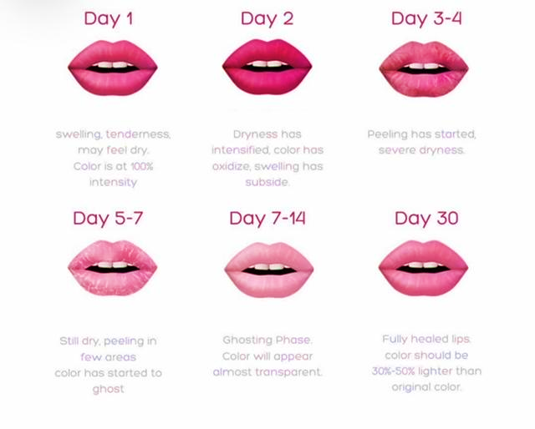

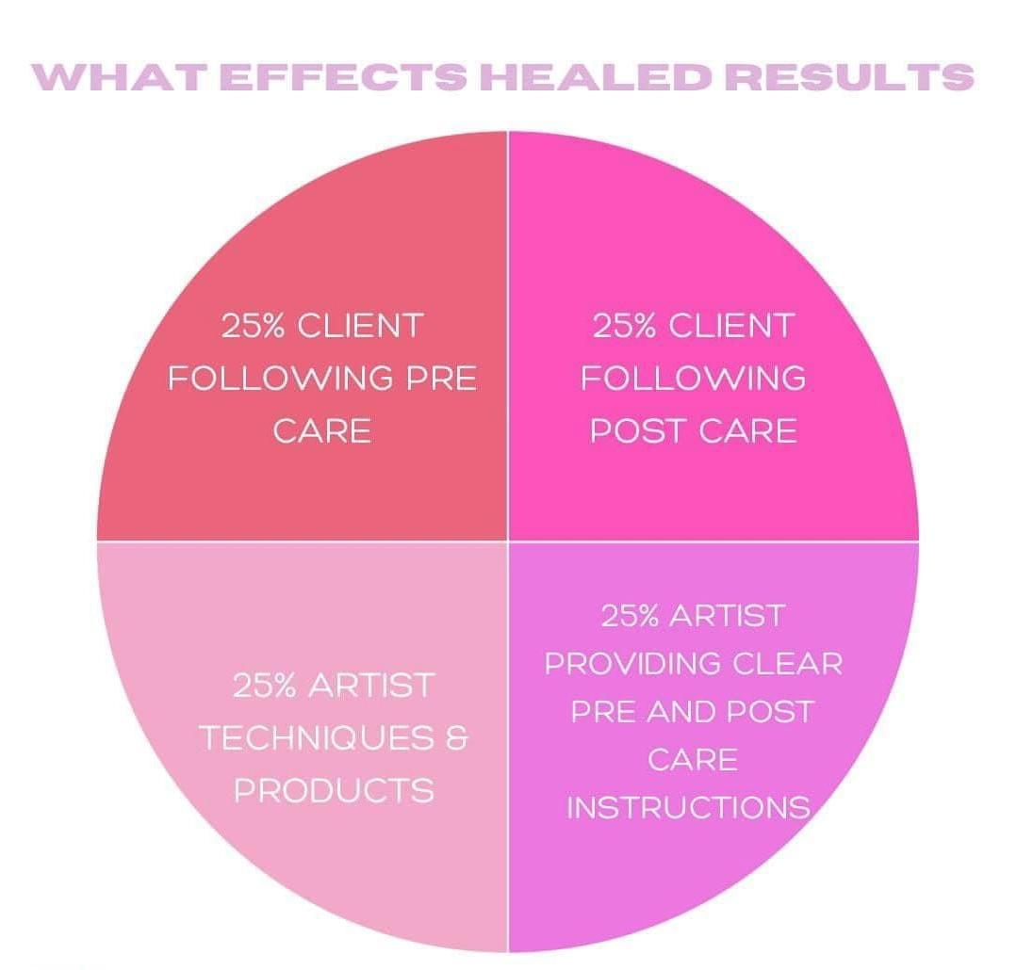
Contacts of Emergency
Kissed with Ink, LLC
(770) 895-2002
1810 Cumming Highway (inside Sola Suites)
Suite 113
Canton, GA 30115

Cherokee County Environmental Health
(770) 479-0444
1130 Bluffs Parkway
Canton, GA 30114

