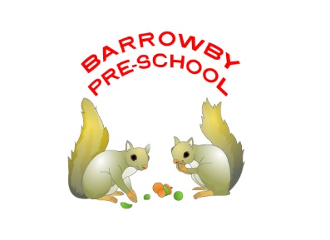

**Healthy Lunch Box Policy**

Barrowby Preschool aims to adhere to the national guidance on healthy eating. As stated below our suggestions for a healthy lunchbox are guidelines not rules. At preschool we will continue to teach and discuss aspects of a healthy lifestyle, of which healthy eating is only one. We hope you feel able to support our efforts to help our children to make healthy choices.

**Food and drink in packed lunches.**

The preschool will provide appropriate dining arrangements and adequate time for children to eat a packed lunch and ensure that fresh drinking water is readily available at all times. As fridge space is not available in preschool, you are advised to send packed lunches in insulated bags with freezer blocks, where possible, especially during Summer. A good substitute for a freezer block is a frozen drink which will defrost during the morning. The preschool will encourage parents to consider the guidelines for a healthy packed lunch listed below. Please ensure that boxes, bottles etc are all labelled with your childs name. All uneaten food and waste will be kept in the lunchbox and returned home with the child so that parents are able to monitor their child’s food consumption.

**The following are intended as guidelines, not rules**. However, we feel as a preschool that consideration of these guidelines will support the whole of the preschool community in developing healthy eating habits.

Packed lunches should include:

At least one portion of **fruit** and one portion of **vegetables** each day e.g. carrot sticks, cucumber, small apple or orange, banana, dried fruit, mini tomatoes, mango cubes. Please ensure grapes etc are sliced length ways to prevent choking.

Meat, fish, or vegetarian source of **non-dairy protein** e.g. chicken, turkey, ham, beef, pork, tuna, lentils, kidney beans, chickpeas, falafel, soya, tofu.

A **starchy food** e.g. bread, pasta, rice, crackers, rice cakes, oat cakes, pitta bread, tortilla wraps.

**Dairy food** e.g. milk, cheese, eggs, yoghurt, fromage frais.

A **drink** of either water, fruit juice, milk, yoghurt drink, smoothie. (No fizzy drinks or glass bottles please.)

Please do not include sweets and chocolate bars in a lunchbox. We do not expect sweets to be eaten in preschool except on special occasions. (The amount of sweets would then be limited.)

Please do not include crisps in a lunchbox every day. Good alternatives are savoury crackers or breadsticks, cereal bars. (Remember to avoid nuts as we are a nut free preschool school.)

We would hope that cake would be limited. Perhaps consider healthy recipes such as fruit cake and carrot cake.

High fat meat products such as sausage rolls, individual pies, corned meat and sausages should only be included occasionally.

**Children will be encouraged to eat their savoury food first.**

Children should not swap food. Parents expect their child to eat the lunch that they have provided.

Encourage children to regard foods very high in sugar or fat as treats and not staple foods for a lunchbox. The preschool will, from time to time, send lunchbox ideas home.

**Special diets and allergies**. Be aware of food allergies, often nuts, but not exclusively. Barrowby preschool is a nut-free preschool. Preschool recognises that some children may require special diets that do not allow for the guidelines to be adhered to exactly. Parents will provide the appropriate diet for that child, another reason why children should not swap food items.

**Storage of Packed Lunches**

The preschool will provide storage area / facilities for packed lunch bags, in the most convenient and appropriate place possible. However the preschool cannot provide cooled storage areas and therefore cannot take legal responsibility for foods prepared at home and then brought into preschool.

This policy has been adopted by Barrowby Preschool

Signed on behalf of the setting by:

*………………………………………………………* Chairperson

............……………………………………………… Manager

Date: Review Date: