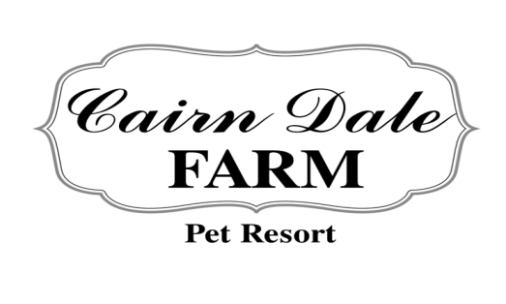
2610 RINIEL RD, LENNON, MI 48449
www.CAIRNDALEFARM.COM
(810) 621-3414

Dear Loyal Customers,
As you may have noticed there have been many changes to Cairn Dale Farm this year. First and foremost, we have lost our beloved leader, Marie. Marie started Cairn Dale Farm in 1961 with a love for animals and believing in serving both pets and their pet parents. Marie took a dream and transformed into the amazing business we have now. Upon her getting ill she and her husband Jeff, entrusted the continuation of the business to me, their niece.
Cairn Dale Farm will continue to operate under the same core values as before, however you will see some changes in order to best serve you and your pets. There will be positive changes in protocol, procedures, staffing, and building renovations.
I look forward to meeting you and your pet. Please say hello on your next visit!
As of January 1st, 2019 our prices and multi-pet discounts will be as follows:
1 Dog: $25 per night
2 Dogs in the same run: 20% off total boarding cost= $40 per night
3 Dogs must be quoted on an individual basis
1 dog and 1 cat: 10% off total boarding cost= $36 per night
2 cats in the same condo: 20% off total boarding cost=$24 per night
Dog baths will be prices based on size and coat type
All current reservations and those made before December 30th, 2018 at 5:00PM, must put down a 25% non-refundable, non-transferable deposit in order to lock in the 2018 price.
As of January 1st, 2019 the following new policies will go into effect:
- Clients who reserve a space for their pet and choose to pick up early will be charged for the entire reservation
- Cancellation and change policy- Failure to give a 3 day notice of change or cancellation will result in a charge of the full amount of the reservation
I am excited to carry on my Aunt Marie’s legacy! We thank you for your continued loyalty and look forward to serving your family.
Sincerely,

Kristen Swanson-Hampton
Director/Partner, Cairn Dale Farm

