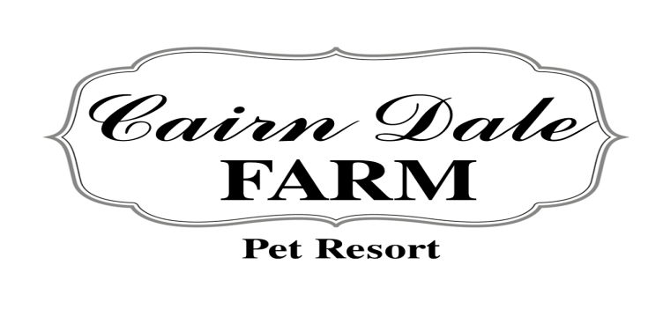
Drop off: _______________ AM/PM
Pick up: ________________ AM/PM

6210 Riniel Rd. Lennon, MI
Phone: 810-621-3414

Welcome to Cairn Dale Farm Pet Resort; we are so excited to have your pet stay with us!
Here at our pet resort we strive to make sure your pet is happy and healthy. Our kennel is climate controlled with heating and air conditioning, as well as we use fans to circulate the air. Most of the time soft music will be playing in the background to comfort and soothe the pets. All dogs will be provided bedding. All pets are fed in the morning; a second feeding can be requested between 3:00-5:00PM. Cats are free fed unless otherwise specified. For our dogs we serve Purina Dog Chow and our cats are served Purina Cat Chow. However you are more than welcome to bring blankets, toys, and their food from home if you wish. Clean water will always be readily available in their suite. If your pet is on medication that is not a problem. We will dispense it as prescribed by your veterinarian; if we have a question we will personally contact them. We require all pets to be up to date on core vaccinations and Bordetella. Although there are viruses that there are not vaccinations for, we do everything we can to prevent them. Please bring your up to date shot record with you or email them to staff@cairndalefarm.com. Our guests must be currently on flea preventative as well. If fleas are found on your pet, they will receive a flea and tick shampooing and you will be charged accordingly. Pet Parents are advised to make the staff aware of any skin irritations upon arrival. This includes but is not limited to hot spots, dermatitis, and open wounds. Please be sure to note an emergency contact during their stay just in case you cannot be reached. Lastly, we do require permission to be granted for emergency care for any conditions that may arise during your pet’s stay with us. Please know your pet is in excellent care. We will treat your pet to the best care in a safe, humane, and professional manner.
Other services we provide at an additional cost: We have an in-house spa! We offer full grooming, bathing, nail trim, pad shaving, ear cleaning, paw balm, and teeth brushing. Extra exercise is available, 20 minute walks or 20 minute extra play times. Please let us know while making your reservations or at check in.
We love to take pictures of our guests, please let us know you if you do not want your pet’s picture to be used in any advertising or on social media.
We run just like a regular hotel except you have to walk on 4 legs to stay. We charge for any portion of the first day that your pet is here, but if you pick them up before noon we do not charge for that day.
Thank you for bringing your friend here to stay with us and do not hesitate if you have any questions or concerns.
Pick up and Drop off times are as follows:
Monday thru Saturday 8:00 am-Noon and 3:00-5:00 pm
Sunday 8:00-9:00 am and 4:00-5:00 pm
There are no pick-ups or drop-offs on the following holidays: New Year’s Day, Easter, Memorial Day, Independence Day, Labor Day, Thanksgiving, Christmas Eve, and Christmas Day
All pets on premises must be on a leash or in a cat box, No exceptions.
Payment is due at the completion of services are rendered. Checks that are returned incur a $35 fee.

We now offer ONLINE BOOKING!

Check out our website under reservations. You will be prompted to fill out your

