GRAPH ANALYSIS BEHAVIOR REDUCTION

Graph Analysis is vital to the quality of care. Graph analysis includes Behavior Reduction Graphs and Skill Acquisition Graphs [learning programs].

# INSTRUCTIONS

Step 1 – Screenshot a Behavior Reduction Graph [For HIPPA compliance, DO NOT include the client’s name or demographic information].

Step 2 – Write a summary including the following information

“Trend” – Is the graph “Accelerating” or increasing over time. Is the graph “Decelerating” or decreasing over time. Or does the graph show a “Zero Trend”, the trend is hard to determine based on the information in the graph, or there is too limited of data to tell.

“Level” – Are the behaviors occurring at a “Low level”, “Mid Level” or “High Level” of occurrence.

“Variability” – is there low variability in the graph [meaning, is there consistency in performance over time] or is there “high variability” in the graph. Include the “why”. For example, if there is “high variability”, this could be due to changes in the therapy schedule, differences in performance or data collection between two therapists, how the programs are run between the two therapists, difference between home location and school location. [Hint – if there is one graph for multiple locations, recommend in this document, that the graphs are separated to better show how the child is performing at home, vs how the child is performing at school. Overall it’s easier to tell where the programs need to focus.

# TEACHING TREND

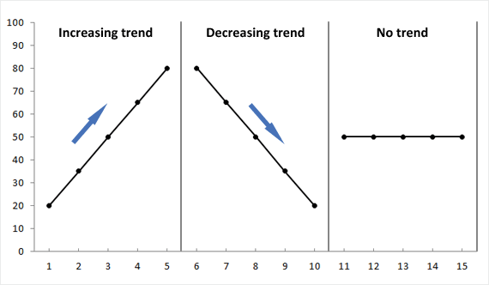

This graph displays the trend levels. If the data points are going upwards over time, it’s an increasing or “Accelerating trend”. If the data points are decreasing over time, it’s a “Decelerating trend”. If it’s hard to tell where the data points are going [due to lack of data or inconsistency in data or performance, it is a “Zero trend” or “No trend”.

# TEACHING LEVELS

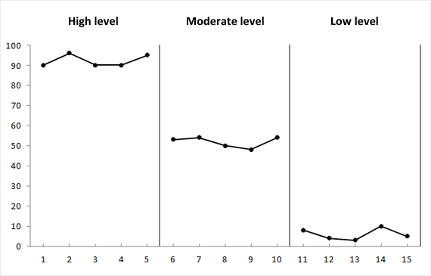

This graph displays a high level, moderate level or low level of performance. For target behaviors, our goal is to see low levels of occurrence. For skill acquisition programs or learning programs, our goal is to see high level of performance. The level can vary depending on the skill or behavior, environmental factors, life changes, and more.

# TEACHING VARIABILITY

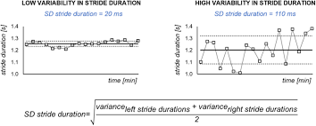

This graph displays “variability” In performance. This is used for both behavior graphs and skill acquisition graphs. The goal is to have low variability in the level of occurrence / performance. Often if there is “high variability” it is due to inconsistencies, not running the programs correctly, different therapists running the program differently or collecting data differently, or the need for additional supervision and training of therapists, teachers or parents. Additional variability can include medication changes, environmental changes such as moving or a death in the family, etc.

ASSIGNMENT

When submitting the assignment, the information should look similar to the examples below.

# EXAMPLE 1

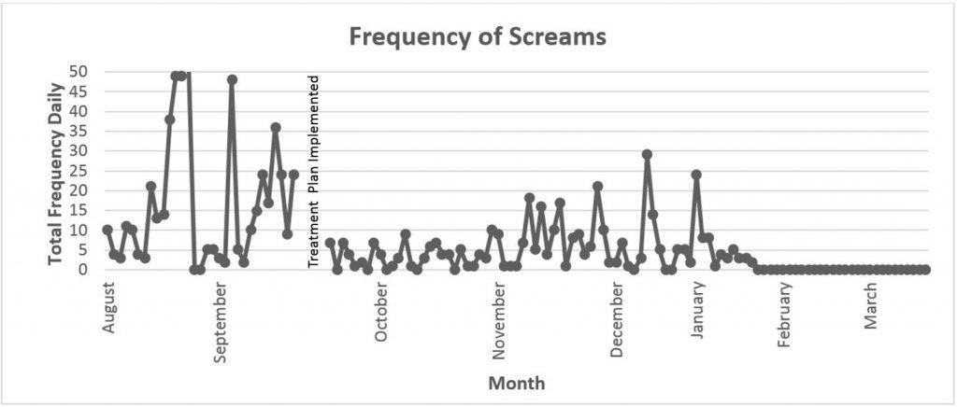

Behavior: Screaming

“Trend”: At the beginning of August, there was an Increasing trend, again in late September. However, the graph now displays a Decelerating trend.

“Level”: During August there were high levels of screaming. This could be due to starting school in a new classroom. During the end of November through January, there are mid levels of occurrence of screaming, this could be due to winter break from school, and the change in routine. Currently, in February and March, there is a low level of occurrence.

“Variability”: During August and September there was high variability. Through October to beginning of November there was low variability. During December and January there was some variability between the dates [some dates showed high occurrence versus the day before or after that showed zero to no occurrence]. In January, February and March, there is zero occurrence. This could be due to the increase in fidelity training of teachers and therapists.

[*Note – For high variability or “high levels”, The insurances want to know how we are going to change therapy to reduce high variability and improve the outcomes of therapy for the client over time. They want recommendations for the upcoming six months. The recommendation here would be to increase fidelity training across all staff, therapists and teachers to ensure everyone is implementing the same strategies, or collecting data in the same way*].

Template

# ASSIGNMENT: GRAPH ANALYSIS

Instructions: Use the following template to submit the information for review.

Name of Supervisee: ______

Date: ______

[Insert Graph]

# Summary:

Behavior: ______

Trend: _____

Level: _____

Variability: ______