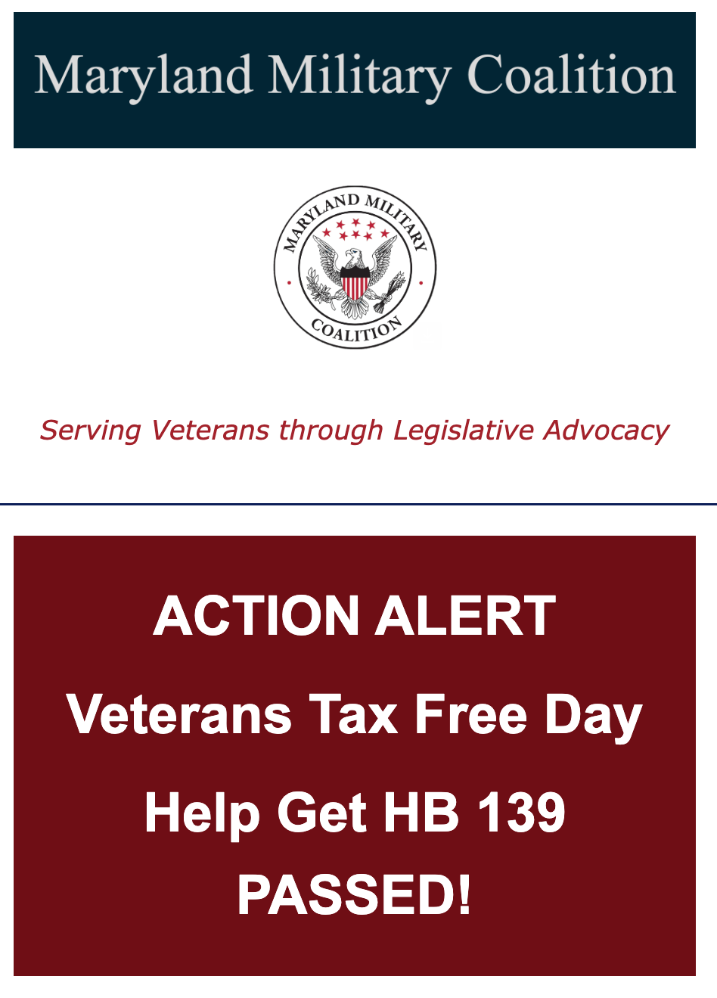

Dear MMC Member (and Friends of the MMC)

BLUF: The Senate will be taking a final vote on HB 139--Veterans Tax Free Day, which the Senate restored to a threshold of $2000 on a single item, in the next few hours. We need to let Senate members know that we want HB 139 PASSED as is.
SB 009, a bill to provide veterans with a one-day tax free day on Veterans’ Day, for an item up costing up to $2000, passed the Senate on March 13th. Its cross-file, HB139, heard in the House shortly after the Senate passed their version of the budget, was reduced from from a one-item threshold of $2000 to only $250. We believe the reduction was intended as a means to balance the budget and in response to intense lobbying by on-line businesses who say it is “too onerous” for them to determine who is (or is not) a Veteran and remove their tax.
Today, HB 139 was heard by Budget and Taxation, restored by amendment to the original $2000 threshold and passed 2nd reading as amended. We need to tell the Senate to pass HB 139.
So, we’ve got ONE opportunity. Let’s get HB139 across the finish line. Write and call your Senator and tell him/her that you want HB 139 passed as amended.
Follow these steps.
- Determine your Senator. Use this link; click on lookup and type in your address. RECORD THIS INFO...INCLUDE the telephone number. Let your Organization's Director know so we can better target emails in the future.
- Use the phrase "I am YOUR CONSTITUENT".
- Insert the needed info at the [XXX] and feel free to modify the email as needed. Remember to change the color of the font back to black.
- Copy MDMilCoalition@gmail.com (I'll be recording the number of letters by organization)
* * * *
#1 Email for your Senator
******************
Email Subject: HB139 - Veterans Tax Free Day - URGE A FAVORABLE Vote.
Dear [ Senator XXXX]
I am your CONSTITUENT, a veteran and a member of the (insert your Vet organization; e.g.VFW or MOAA). I am writing to ask for your FAVORABLE vote on HB139--Veterans Tax Free Day. This bill provides a tax-free day for Veterans on Veterans’ Day, where the price of the item for sale is less than $2,000.
In Maryland, parents have ONE WEEK of tax-free school shopping in August, where qualifying apparel and footwear $100 or less are exempt from state sales tax. There is no limit on the total expenditure.
Shouldn’t veterans, most on fixed incomes, have ONE day per year to buy a washer and dryer or a refrigerator tax-free? And should they make the tax-free purchase, won’t they invest those dollars saved in another purchase—hopefully from a Maryland small business? The estimated total cost per year of this bill is LESS than $50,000!
Members of the House cut the threshold significantly in response to the need to balance the state budget and lobbying by on-line businesses who don’t want to deal with the tax, “because it is too onerous” to determine who is (or is not) a veteran. Many business, including “big box stores” such as Lowes and Home Depot, as well as federal agencies including the Department of Veterans’ Affairs, currently use apps such as “ID Me” to verify the identity of veterans.The software is well known, widely available, efficient, cost-effective and well accepted. I don’t believe that on-line businesses, like Amazon, should have a say in this matter—they have a lot of flex in their bottom line, while most veterans like me don’t.
Please pass on my thanks to members of the Senate Budget and Taxation Committee for recognizing the merit of honoring the sacrifices of veterans and restoring the bill to it’s original value—Veterans need a break too!
Maryland is a high-cost state. I ask you to make a veteran’s life a little easier by granting a ONE DAY tax-free day on Veterans’ Day by voting FAVORABLY on HB139.
Thank you for your support on this important piece of legislation.
YOUR Name
YOUR Rank, Branch of Service
YOUR Address
YOUR Legislative District
#2 Telephone Calls...This is EASY and takes less than 5 minutes!
Call your Senator. Record who you talked to, the date of your call and and questions or comments that you received. Send an email with this information to MDMilCoalition@gmail.com.
Here's your script.
Hello...I'd like to speak to the Chief of Staff please.
Hello. My name is [Your Name]. I am Senator XXX”s constituent and I am a veteran who belongs to [your Vet organization]. I'm calling about HB139 which was heard by the Senate Budget and Taxation Committee yesterday, April 8th. The Committee restored the threshold for one tax-free item to $2000. I am so grateful. This bill would provide Veterans a tax-free day on Veterans’ day for an item that cost less than $2,000—a washer and dryer or a refrigerator. The fiscal note is less than $50,000. Maryland is expensive and HB139 would give Veterans a little break once a year. The bill is coming up for final vote and I would like Senator [xxx] to vote FAVORABLY on HB 139.
Thank you.
************************************
We are down to the wire and can’t make this happen without your help. Please act now by emailing and calling your Senator!
As always, we appreciate all you do!
Lynn

