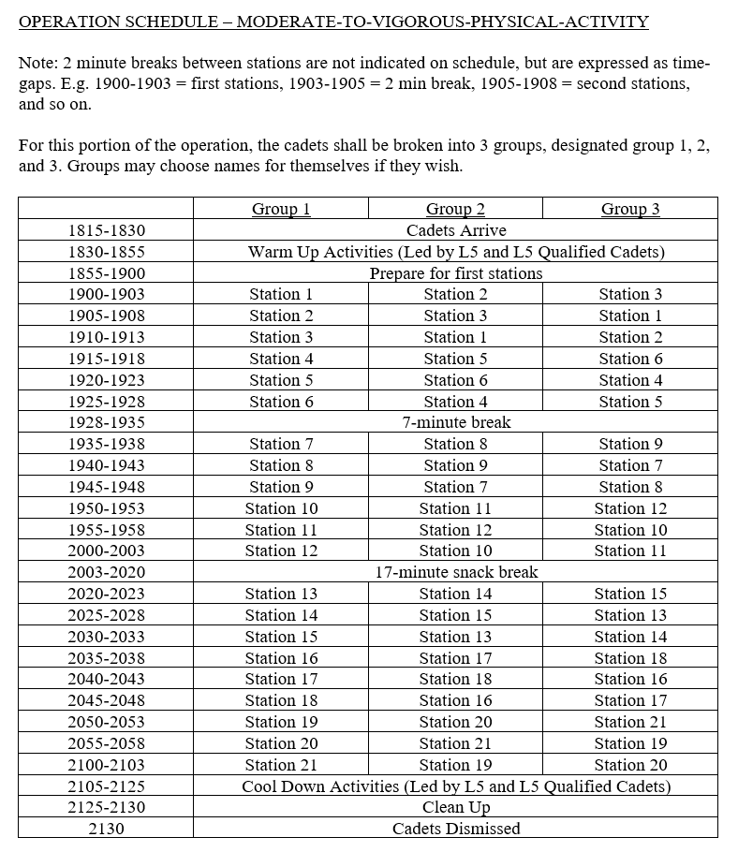

Station 1 – Bicycle Legs\*

Station 2 – Push Ups\*

Station 3 – Star Jumps

Station 4 – Curl Ups\*

Station 5 – Frog Jumps

Station 6 – Swimmers\*

Station 7 – Reaching Lunges

Station 8 – Seated Twists\*

Station 9 – Burpees\*

Station 10 – Mountain Climbers\*

Station 11 – Alternating Ts\*

Station 12 – Alternating Canoe Strokes

Station 13 – Front Kick Lunges

Station 14 – Jumping High Knees

Station 15 – Donkey Kicks\*

Station 16 – Flutter Kick\*

Station 17 – Alternating Bridge\*

Station 18 – Slalom Jumps

Station 19 – High Knee Smash

Station 20 – Squat Jumps

Station 21 – High Knee Bridge\*

\* indicates floor work

