**SERRA RACE #1**

**Race No. 1** of **2021-2022 SERRA Series** will be held **on Saturday, Sept 11th** at **Atlanta Slot Car Raceway**

1951 Canton Road Suite 60

Marietta, Ga. 30066

770 694 6458

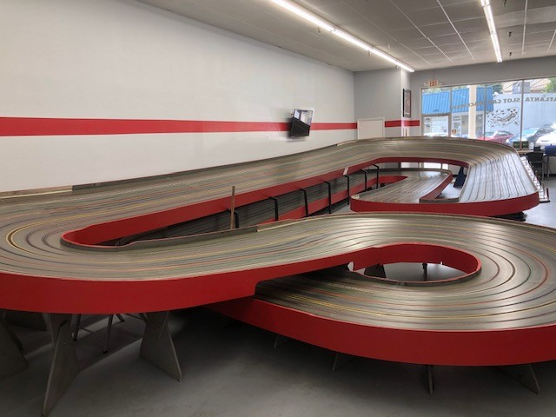 **Track 165’ Hill Climb**

**General Race Event Procedures**

**First up will be Coupes followed by Can-Am, F-1 and Stock Cars.**

**IRRA RULES WILL APPLY!**

**General Race Event Procedures**.

**Recommended set up for Coupes**

Braid Depth: Varies, set for .010 with no lift is a good compromise

Weight: 110 – 112 grams

**Recommended set up for Can-Am**

Braid Depth: Varies, set for .010 with no lift is a good compromise

Weight: 108-110 grams

**Recommended set up for F-1**

Braid Depth: Varies, set for .010 with no lift is a good compromise

Weight: 108-110 grams

**Recommended set up for Stock Cars**

Braid Depth: Varies, set for .010 with no lift is a good compromise

Weight: 125-135 grams

**SERRA General Race Event Procedures** **and Schedule:**

Track will be open for practice on**Friday** evening prior to the race from **5:00 pm to 9:00 pm**. Pit pass for the evening is **$12.00**

Track opens **Saturday morning** at **8:00 am.**

**Entry fees for each class will be $15 if you race all 4 classes $55 you save $5**

 .

 Tech opens at **9:00 am**, closes at **10:00 am** **or** when last car clears inspection if earlier than 10:00.

Cars in Tech shall be impounded and not handled by the car owner or other racers.

Track power will be shut off at **9:30 am.**

Qualifying starts **15 minutes** after close of tech.

Lane selection will be immediately after qualifying. Drivers who are not present during lane selection will be**assigned a lane at random** by the race director.

Racing begins **10 minutes** after qualifying.

Race heats will be **2 minutes in length** with two minutes between heats.

Prior to the start of each Main a one-minute warm-up will be provided. Sit-outs (if any) have the option of a one-minute warm-up.

Tech will open for next class **45 minutes** after conclusion of previous race **or** **as stated by the Race Director**--track power will be shut off **15 minutes** after tech opens.

**No Move ups One and Done**!