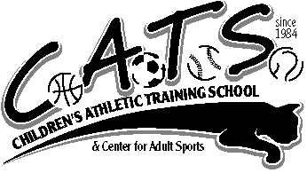
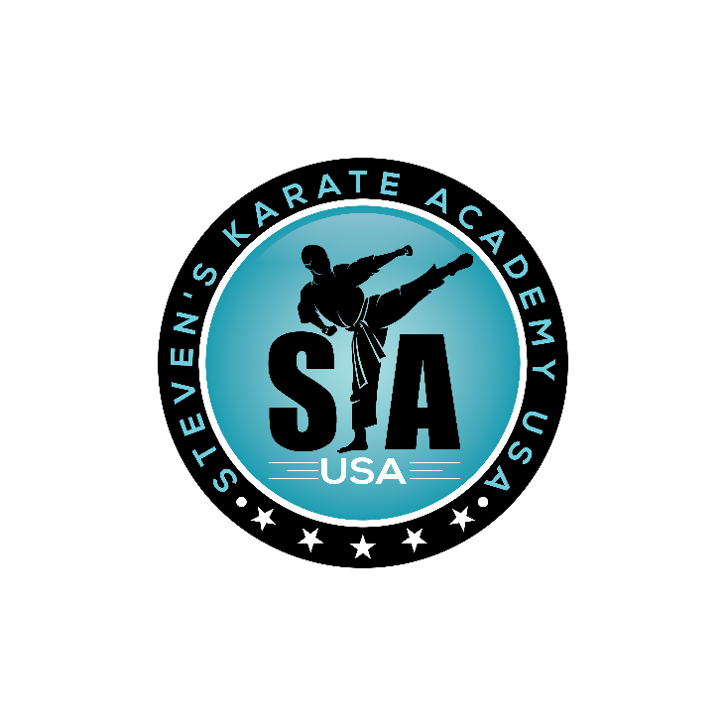
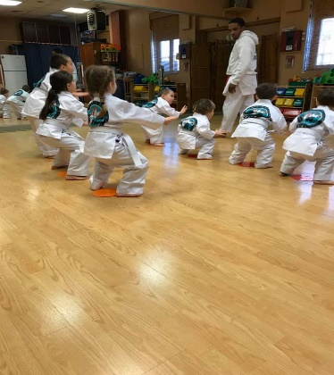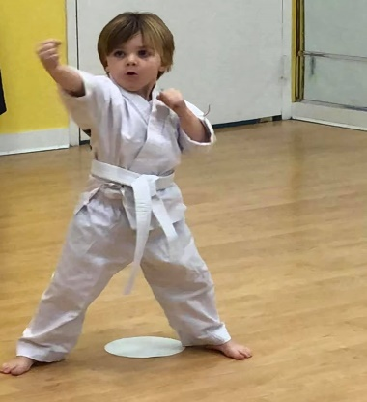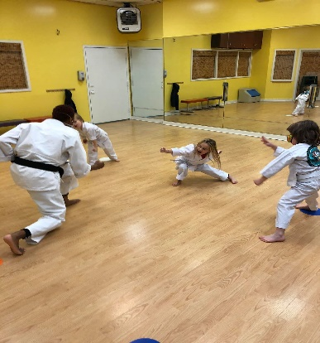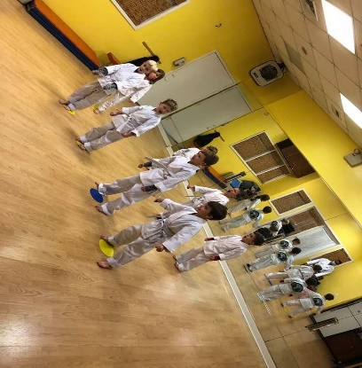
Come Join Us For
KIDS KARATE
WITH STEVEN’S KARATE ACADEMY

@ CATS (CHILDRENS ATHLETIC TRAINING SCHOOL)

188 MAPLE AVE RVC NY 11570 - CATSRVC@GMAIL.COM – 516-763-1299 – WWW.CATSRVC.COM

FRIDAYS 1:00-1:45 AGES 3-5 YRS
MONDAYS & WEDNESDAYS 4:15 AGES 4 & UP
SUNDAYS 9:30-10:15 AGES 4 & UP
10 Week Sessions
$270 INCLUDES UNIFORM FOR NEW STUDENTS
CHILDREN WILL LEARN SELF CONTROL, DISCIPLINE, RESPECT, BULLY PREVENTION & COORDINATION

