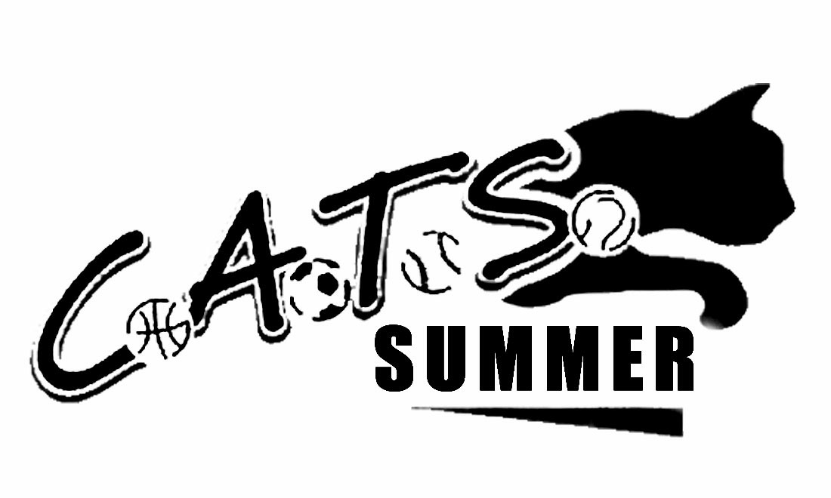
2019 SUMMER CLASS SCHEDULE
BEGINS WEEK OF JULY 1ST, 2019

MOMMY & ME MULTI SPORT
1 & 2 YR OLDS MUST BE WALKING

$230 FOR 10 WEEK SESSION - 45 MINUTES
MONDAYS 10:00
MON., TUES. & FRI. 3:15

JUNIOR CATS MULTI SPORT - 50 MINUTES
OLDER 2’S & 3 YR OLDS SEPERATION CLASS

$230 FOR 10 WEEK SESSION
MON. 2:15-3:05, THURS. & FRI. 2:15-3:05
3-6 YR OLDS
Separated by age
SPORT DEVELOPMENT MULTI SPORT - 60 MINUTES
$250 FOR 10 WEEK SESSION
MON. & Fri. 1:15, TUES. & WED. 2:15, WED. & THURS. 3:15

LEARN TO SKATE/INTO TO ROLLER HOCKEY – 50 MINUTES
3-7 YR OLDS

$170 10 WEEK SESSION
TUES., WED. & THURS. 1:15
AGES
3 YRS-ADULT

TENNIS – GROUP OR PRIVATE TENNIS LESSONS
$280 10 WEEK SESSION AVAILABLE WEEKDAYS
CALL FOR SCHEDULE OR TO ARRANGE YOUR OWN GROUP,
SEMI PRIVATE OR PRIVATE LESSONS!

ZUMBINI CLASSES - FOR MOM OR DAD & ME – AGES 0-4 YRS
AVAILABLE BEGINNING JULY 10TH & 12TH

WEDNESDAYS 3:00-3:45
HTTPS://WWW.ZUMBINI.COM/EN/CLASSES/7370
FRIDAYS 11:15-12:00
HTTPS://WWW.ZUMBINI.COM/EN/CLASSES/7371

188 MAPLE AVE. RVC, NY 11570 516-763-1299
WWW.CATSRVC.COM CATSRVC@GMAIL.COM

