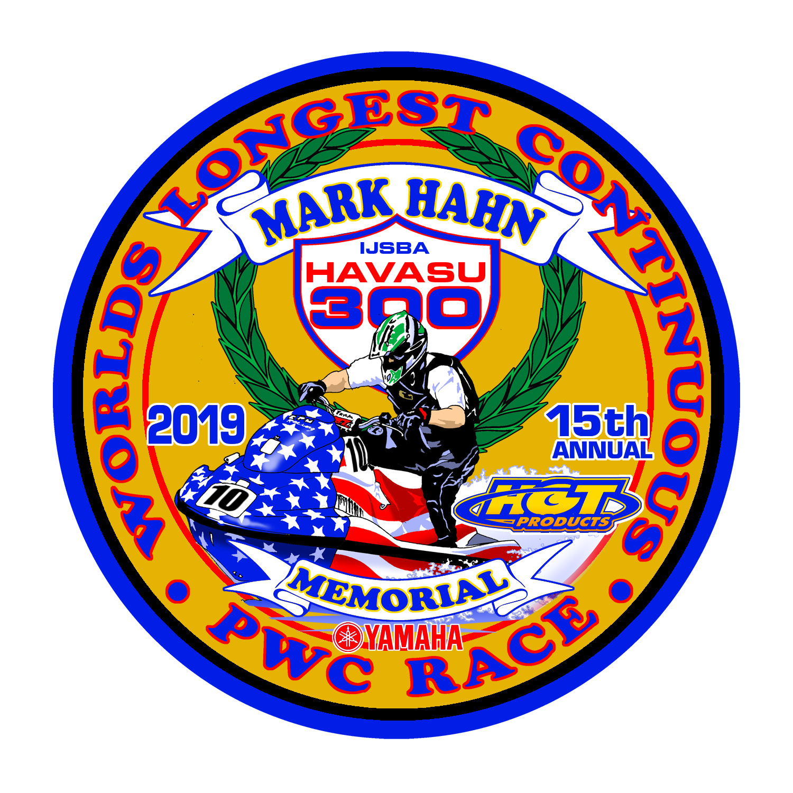



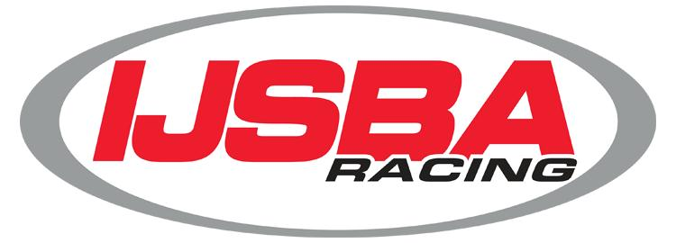


SATURDAY - February 23, 2019
1100 Vista Dr., Lake Havasu City, AZ 86404 ● Fax (928) 254-3695 ● Cell (928) 208-2252
● scan & email to jvrussell.jr@gmail.com Before February 1

Rider #1 Name __________________ _____________ DOB ____/____/____

DSM USE ONLY
(Do not write here.)
Team Entry Fee $ 400.00
Late Fee will apply
After Jan 10, 2019 $50.00
Extra Dinner tickets ea $ 25.00 Total received/charged $______
Entry # _____ Collect $
Total Paid $_________
Must be an APBA Member
* Charged for entries received after 2/10/07

Address ______________________________________________
City _ __CA_______________ Zip __ _________
Phone (_____)________________ IJSBA Member # ______________________
Mobile E-mail _

Emergency Contact ______________________________ Phone (_____)_____________
Rider #2 Name ________________________________________ DOB ____/____/_____
Method of Payment
□ Cash □ Check □ Visa □ M/C
CC # __________________
_______________________
Billing zip code__________
Security Code # ________
Expiration _____________
(DSM Events LLC will appear on bill)
Signature ______________

Address ___________________________________________________________________
City ___________________________State _________________ Zip __________________
Phone (_______)_________________ IJSBA Member # _____________________
Mobile ( ) E-mail @ _

Emergency Contact ________________________________ Phone (_____)_____________
Rider #3 Name ________________________________________ DOB ___/____/______

Address __________________________________________________________________
Entry Information

PWC Mfg _

- PWC Model

RACE # _

Sponsors:

_

_

_

-----------------------------------------------------

City ___________________________State _________________ Zip _________________
Phone (_______)________________ IJSBA or Member # _____________________
Mobile ( ) E-mail @ _

Emergency Contact _________________________________ Phone (_____)____________

Class Entered
Team = Runabout Up To 2 Riders, Stand-Up Up To 3
□ Pro/Am 4 Open □ 4 Stroke N/A Open
□ 4 Stroke Stock □ 4 Stroke Mod SU
□ Vet Masters Open □ Sportsman 2 Stoke SU
□ Manufacturers Stock □ 2 Stroke Mod Stand SU

Release and Waiver Must Be Read and Signed On-Site

