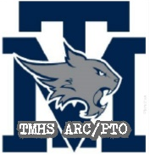
TMHS ARC/PTO – MEETING AGENDA
Tomball Memorial High School
(Academic Recognition Club/Parent Teacher Organization)
2021 Annual Meeting
May 28, 2021 9:15 AM Google Meet
Next Meeting: TBD
In Attendance: Dawn Rodriguez, Robin LaRue, Shannon Lewis, Cherie Creaney, Jen Riker, Jill Haywood, Dr. Mike Metz, Valerie Delafosse

Meeting began at 9:18 am

Slate of 2021-2022 Officers
President – Dawn Rodriguez
VP Concessions – OPEN
VP Rewards/Recognition – Amy Martin/Daisy Cone
VP Membership – Robin LaRue
Secretary – Jill Haywood
Treasurer – OPEN
Hospitality – Anne Miller
Spirit Nights – Tracy Fletcher
Volunteer Coordinator – Jennifer Riker
AP Testing Hall Monitor Coordinator – Daisy Cone

Motion to approve slate: Shannon Lewis
2nd: Cherie Creaney

Meeting ended at 9:24

