TMHS ARC/PTO – MEETING AGENDA
Tomball Memorial High School
(Academic Recognition Club/Parent Teacher Organization)
August 2, 2021 6:30pm Google Meet
Link: meet.google.com/wqt-ptyc-ood
Next Meeting: TBD
In attendance: Jill Haywood, Dawn Rodriguez, Robin LaRue, Shannon Lewis, Daisy Cone, Jen Riker, Cindy Burns
Called to order 6:34

Reading the Minutes of the previous meeting [and their approval]
- Minutes (Jill Haywood)
- Minutes from annual board meeting Friday, May 28, 2021
Motion: Jill 2nd Robin All Approved

Reports of Boards and Standing Committees
- 2020-2021 PTO Donation - $2,524.06
  - Check Presentation
Motion: Shannon Lewis 2nd Daisy All Approved
  - Presentation Date
Look into getting a big presentation check.
  - New meeting dates:
    - Monday or Thursday 9am best dates for Dr. Bailey – Majority can do Mondays
    - Change from first week to 2nd week for month end reconciliation
    - Next Meeting Date: Sept. 13th, October will be 18th (3rd Monday)
    - Location – in person at the school, possibility to google meet someone in.

- Membership (Robin LaRue)
  - Updating Membership Data Center – Cheddar Up
No monthly fees, 3.5% added to the customer & 45 cent transaction fee. The reports are really easy to read and sort data.
Cindy will set up cheddar up account and Robin will set up the collection/membership forms via google forms.
Motion to switch: Robin 2nd Cindy All Approved
  - Adding Family sponsorships opportunities for Teacher Membership- Table this

- Treasurer (Cindy Burns)
  - Change Accounting Book System
Motion to switch: Cindy Burns 2nd Robin LaRue All Approve
    - Currently Quickbooks $27/mo
    - Quicken Home & Business $62.39/1st year
  - Budget for 2021-2022

See attached budget
Motion to approve motion: Cindy 2nd Daisy All approve

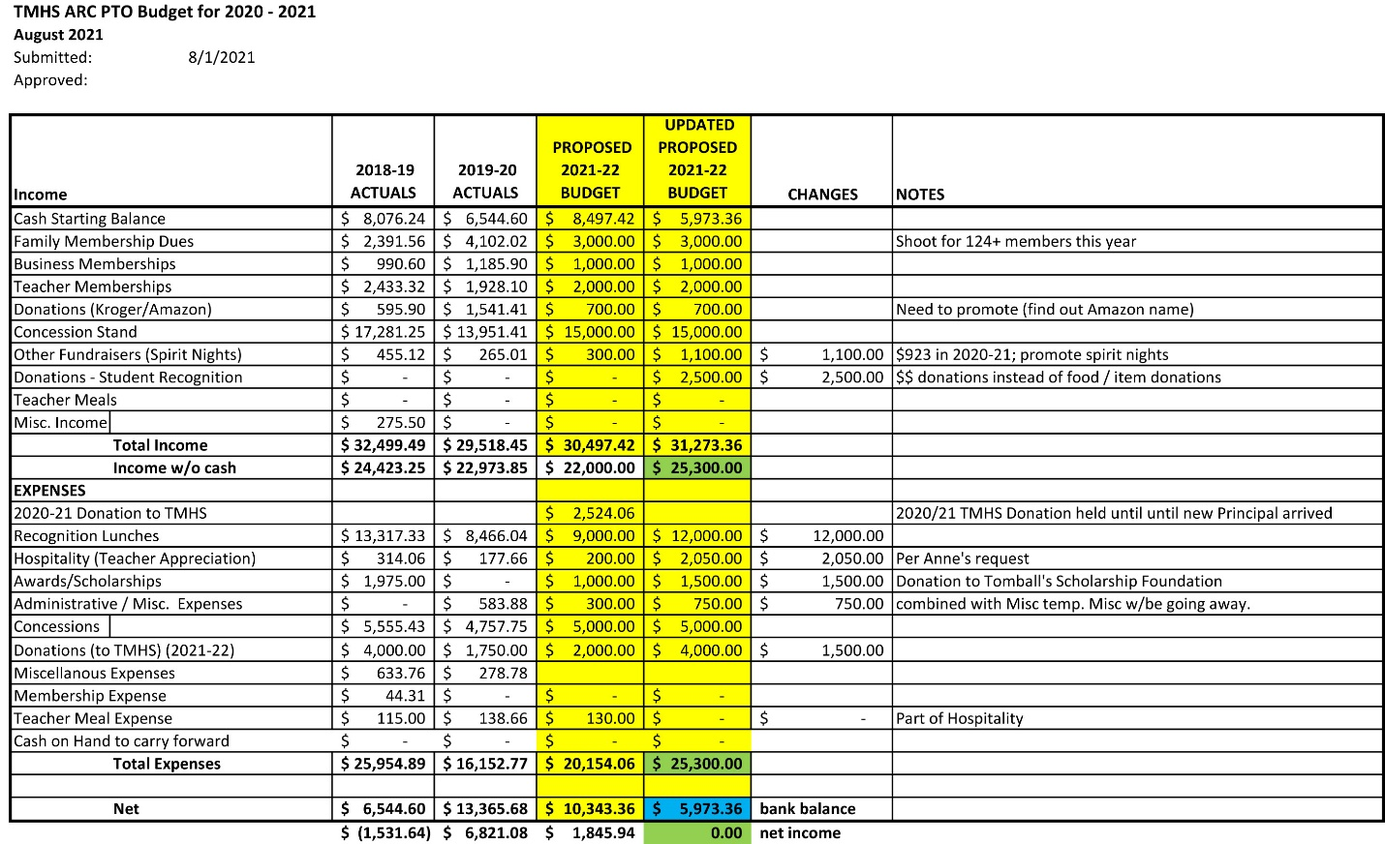
- Concessions (OPEN) Volunteer Coordinator (Jen Riker)
  - Upcoming Concession Date
    - 8/10, 8/13
  - Student Volunteer Signup Genius
  - Initial Concession Stocking
  - Spring Outdoor Athletic Concessions Opportunity

- PTO Officers
Welcome to our 2021-2022 Officers
President – Dawn Rodriguez
VP Concessions – OPEN
VP Rewards/Recognition – Amy Martin/Daisy Cone
VP Membership – Robin LaRue
Secretary – Jill Haywood
Treasurer – Cindy Burns
Hospitality – Anne Miller
Spirit Nights – Tracy Fletcher
Volunteer Coordinator – Jennifer Riker
AP Testing Hall Monitor Coordinator – Daisy Cone
Thank you to our 2020-2021 Officers
President – Dawn Rodriguez
VP Concessions – OPEN
VP Rewards/Recognition – OPEN
VP Membership – Robin LaRue
Secretary – Jill Haywood
Treasurer – Cherie Creaney
Hospitality – Michelle Seveney
Spirit Nights – Tracy Fletcher
Volunteer Coordinator – Jennifer Riker
AP Testing Hall Monitor Coordinator – Daisy Cone

- Approval to update bank signers
Motion to update signers: Shannon 2nd Daisy All approved
2020-2021 Bank Signers
VP Membership – Robin LaRue
Secretary – Jill Haywood
Treasurer – Cherie Creaney

2021-2022 Bank Signers
VP Membership – Robin LaRue
Secretary – Jill Haywood
Treasurer – Cindy Burns

Cherie Creaney, 2020-2021 treasurer will be removed and Cindy Burns, 2021-2022 treasurer will be added. Robin Larue and Jill Haywood will remain on the account.
- Other Business

Spring outdoor concessions
Teacher member sponsorships
Meeting ended at 8:28

