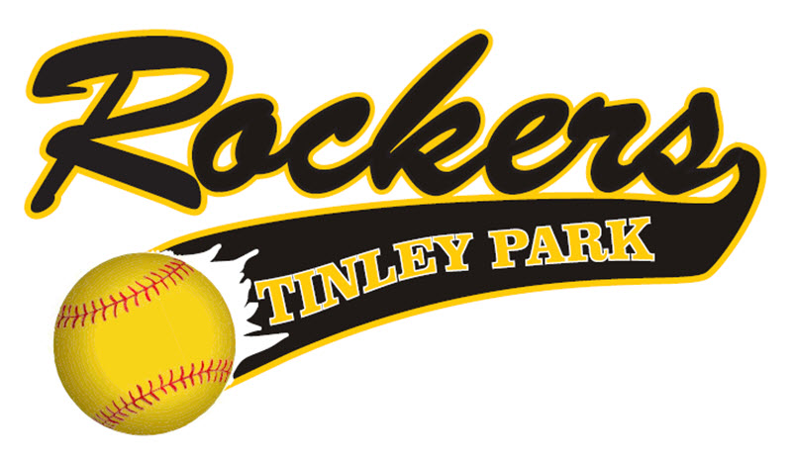

INFORMATIONAL PACKET
2019/2020

Tinley Park Rockers
Information
Updated on July 3, 2019
Note – This Information guide is designed to give you the latest information concerning the Tinley Park Rockers program.

2019-2020 Board of Directors
- Marty Metzger - President
- Paula Lenderink - Vice President, Spirit wear
- Don Mayo - Tournament Director
- John Beatty - Assistant Tournament Director
- Erin O’Brien - Webmaster

2019-2020 Coaches
- 12U - Dan Crespo
- 13U- Steve Ball/Ted Lavine
- 14U- Marty Metzger
- 16U - Michelle Alexander
- 16U- Jim Madrigal
- 18U - James Marcano
- Clinics/Camp Coordinator –
Jeff Lamb – University of Dubuque Head Coach
Michelle Alexander – Concordia University
- Organizational Pitching Instructors – Steve Ball, Marita Van Dyke
Coaching 2019/2020
All Tinley Park Rockers Managers, Coaches, and any additional bench personnel will take the Coaching Certification Test and pass all background checks.
The Tinley Park Rockers are planning to field teams in the 12U, 13U, 14U, 16U and 18U age brackets for the 2019-2020 softball season.

The Rocker program will now have 7 teams in its program in the upcoming year.

All Tinley Park Rocker teams’ costs are based on 12 players on the roster. If a Tinley Park Rocker team has less than 12 players on the roster, the families and coaching staff are responsible to cover the fees of the missing player’s roster spots. This money can be made up by collections or from the individual team’s sponsor money. However, the number of players are up to the coach’s discretion and board approval.

Preliminary Tournament Schedule

FALL 2019 – All age groups 12U-18U will participate in 3-5 tournaments in the months of September/October.
WINTER 2019 – Ages 12U – 14U will participate in one indoor winter tournament or round robin. In the past we have played in the Rosemont Dome, Bo Dome or Sparta Dome in the month of January/February (Coaches discretion).
WINTER 2019 – Ages 16U – 18U will participate in one winter tournament. In the past we have played at the Rosemont Dome, Bo Dome, or Sparta Dome in the month of February. We will utilize the month of January and February at the Lincoln Way North High School facility to prepare our High School players to be “Varsity Ready” and prepare our seniors for college.
SPRING/SUMMER 2020 - 12U Teams will participate in a total of five tournaments including World Series.
SUMMER 2020 - 14U-18U Teams will participate in a total of six tournaments including World Series.
The organizational budget calls for ten practice games that will start in the Fall and go through the Summer.

2019-2020 Payment Schedule
13U – 18U Teams - $2,250
- Payment #1 - $500 immediately upon your acceptance to a Rocker roster spot offering.
- Payment #2 - $500 due September 15, 2019
- Payment #3 - $500 due October 15, 2019
- Payment #4 - $500 due November 15, 2019
- Payment #5 - $250 due January 15, 2020
12U - $1,850
- Payment #1 - $500 immediately upon your acceptance to a Rocker roster spot offering.
- Payment #2 - $500 due September 15, 2019
- Payment #3 - $450 due October 15, 2019
- Payment #4 - $400 due November 15, 2019

Initial deposit must be paid by check/money order/cash upon signing the Rocker contract. Future payments can be made by check or the convenience of our website: www.tinleyparkrockers.com

Sponsorship Benefits
Bringing a sponsor into this Organization simply saves you money and is a great benefit for your player and your player’s team. The Organization does not benefit one penny from sponsor money you bring in.

The Rockers follow these rules when a player brings a sponsor into the Organization:
- 100% of the money brought in goes towards that player’s dues.
- Once the player’s dues are paid in full, 75% of the money brought in goes to pay for the player’s team.
- 25% of the money brought in goes to your player’s team’s budget so more tournaments, lessons, practice time, team parties, hotels, etc. can be purchased
If you bring a sponsor check in, the money that goes towards your player’s fees will be deducted from the player’s last payment. You still must make your payments on-time before your deductions kick in.
NOTE – Manager’s fees, as well as any paid College Coach, will be paid by the Organization.
Organizational Fundraiser
The Tinley Park Rockers will conduct ONE mandatory fundraiser that each family and team is obligated to participate in. The fundraiser is as follows:
Candlelight Bowl
The Candlelight Bowl will take place on Saturday Night, February 22, 2020.
Each Rocker family must sell four (4) tickets at $50 each to this event. This event has been a huge success in keeping annual fees/dues down compared to other organizations. It’s also a fun night out for Rocker Nation and it allows parents from other Rocker teams to get to know each other. More information will be provided by the Fundraising Team.
Team Fundraisers
The team fundraisers are not mandatory. They are designed by the manager of the team to get more budget money for their team so they can do more events for their girls that are not supported by the Rocker Organization…i.e. team parties, hotels, extra tournaments, etc. All parents from a team must agree to a “Team” fundraiser.
The Tinley Park Rockers DO NOT ALLOW any fundraising activity that is simply BEGGING (no Shaking the can).
NO TEAM FUNDRAISERS ARE ALLOWED UNTIL ALL PLAYER DUES ARE PAID UP TO DATE.

“Spiritwear”
The Rockers offer a complete list of adult and youth Rocker clothing line. Spirit Wear information and clothing will be on hand during tryouts and available online to purchase on our website: tinleyparkrockers.com
What is covered in my Uniform Cost?
- 3 jerseys (1 Jersey is Pink Breast Cancer jersey)
- 1 practice jersey
- 2 pair of pants
- 2 Belts
- 2 pairs of socks (Black and Gold)
- 1 Rocker practice pullover (Logo on front – player number on back)
- 1 Bat Bag...Catcher bag for catchers
- 1 Custom painted helmet (with mask)

Your fees also help pay for the following Organization costs:
- Manager/Assistant Coach fees
- Indoor Facilities (Mokena Future Stars/Diamonds Sports Academy/Lincoln Way North Field House, etc.)
- Website costs
- Insurance for all Associations
- PGF, ASA and/or USSSA team registrations
- All team equipment (Bow Nets, Softballs, Performance Balls, etc.)
- Tournament needs (Bases need to be replaced)
- Organizational Insurance
- Paid Coaches
- College Camp Instructors
- Umpire Fees
- Field permits (Tinley Park District/Frankfort Park District/Lincoln Way North Fields) and various other facilities

2019/2020 Fall/Winter Practice Facilities/Fields Information
- 18 Weeks of Winter training at the Lincoln Way North Field House (including practice games, College Camps given by various current/former College Coaches and Softball Players).
- Weekly indoor hitting sessions.
- 10 weeks of speed and agility (one session per week in the winter)
The Rockers will start the Fall Session the second weekend of September. This will allow all Rocker players to get back into the swing of school. We will also be avoiding the Labor Day weekend so families can spend the last weekend before the school year starts together. The Rocker Fall Session will end on the last weekend of October.
The Tinley Park Rocker Winter Session will end on April 1, 2020.
All 14U, 16U, and 18U Tinley Park Rocker players who are on their High School softball teams must stop practicing on the weekend of February 21, 2020 as per the Illinois High School Association rules.
No Rocker teams may practice or play on the following days:
- February 22, 2020 – Organizational Bowling Fundraiser
- April 12, 2020 (Easter Weekend)
Additional Rules
- NO REFUNDS WILL BE GIVEN – NO EXCEPTIONS
  - If a team folds, all athletes will be offered a spot on the roster of an existing Rocker team. If the athlete chooses to go elsewhere, no refund will be given.
- If a player or parent is unhappy and decides to leave the Rockers, no refunds will be given. It will be board approval to release a player from a roster.
- No player will be allowed to participate in any team activities unless fees are current. NO EXCEPTIONS
- All teams must be paid in full by each payment due date or it will impact overall team schedules.
- Each team roster will carry at least 12 paid players.
- No player will be allowed to play for another organization, at any time, while they are a Rocker!

