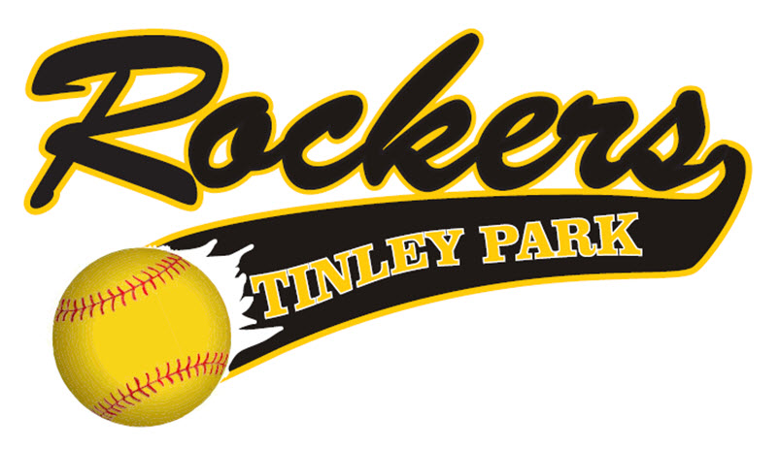

INFORMATIONAL PACKET
2021/2022

Tinley Park Rockers
Information
Updated on July 6, 2021
Note – This Information guide is designed to give you the latest information concerning the Tinley Park Rockers program.

2021-2022 Board of Directors
- Marty Metzger - President
- Paula Lenderink - Vice President, Spirit wear
- Don Mayo - Tournament Director
- John Beatty - Assistant Tournament Director
- Erin O’Brien - Webmaster

2021-2022 Coaches

- 13U – Kassie Guerrero/Olivia Marcano
- 14U – Dan Crespo/Jeff Jacklin
- 16U – Steve Ball/Ted Lavine
- 16U – Marty Metzger/Maddie Metzger
- 18U – James Marcano/Don Mayo
- Clinics/Camp Coordinator –
Jeff Lamb/Jamie Deering – University of Dubuque Head Coach
- Organizational Pitching Instructors – Kassie Guerrero, Steve Ball
- Organizational Catching Instructors – Emma Garcia, Kayla O’Brien
- Organizational Slapping Instructors – Maddie Metzger

Coaching 2021/2022
All Tinley Park Rockers Managers, Coaches, and any additional bench personnel will be required to take the Coaching Certification Test and pass all background checks.
The Tinley Park Rockers are planning to field teams in the 13U, 14U, 16U and 18U age groups for the 2021-2022 softball season.

The Rocker program will have 6 teams in its program in the upcoming year.

Preliminary Tournament Schedule

FALL 2021 – All age groups 13U-18U will participate in 3-5 tournaments in the months of September/October.
WINTER 2021 – In the past we have played at the Rosemont Dome, Bo Dome, Sparta Dome or Bettendorf, IA Dome in the month of February. We will utilize the month of January and February at the Midlothian Indoor facility to prepare our High School players to be “Varsity Ready” and prepare our high school seniors for college.
SUMMER 2022 - 13U-18U Teams will participate in a total of six tournaments including Nationals.
The organizational budget calls for ten practice games that will start in the Fall and go through the Summer.

2021-2022 Payment Schedule
14U – 18U Teams - $2,500
- Payment #1 - $500 immediately upon your acceptance to a Rocker roster spot offering.
- Payment #2 - $500 due September 15, 2021
- Payment #3 - $500 due October 15, 2021
- Payment #4 - $500 due November 15, 2021
- Payment #5 - $500 due January 15, 2022
13U - $2,250
- Payment #1 - $500 immediately upon your acceptance to a Rocker roster spot offering.
- Payment #2 - $500 due September 15, 2021
- Payment #3 - $500 due October 15, 2021
- Payment #4 - $400 due November 15, 2021
- Payment #5 - $350 due January 15, 2022

Initial deposit must be paid by check/money order/cash upon signing the Rocker contract. Future payments can be made by check or the convenience of our website: www.tinleyparkrockers.com. No partial payments. Any player that misses a payment will be suspended immediately until payment is received. Any player that is not paid in full by January 15, 2022 will be subject to expulsion. If a player pays their fees in full by November 1st, they will receive a $200 discount on their overall fees. A check cannot be postdated after November 1st and the online payment needs to be received before midnight on the 1st of November to receive this discount.

Sponsorship Benefits
Bringing a sponsor into this Organization simply saves you money and is a great benefit for your player and your player’s team. The Organization does not benefit one penny from sponsor money you bring in.

The Rockers follow these rules when a player brings a sponsor into the Organization:
- 100% of the money brought in goes towards that player’s dues.
- Once the player’s dues are paid in full, 75% of the money brought in goes to pay for the player’s team.
- 25% of the money brought in goes to your player’s team’s budget so more tournaments, lessons, practice time, team parties, hotels, etc. can be purchased
If you bring a sponsor check in, the money that goes towards your player’s fees will be deducted from the player’s last payment. You still must make your payments on-time before your deductions kick in.
NOTE – Manager’s fees, as well as any paid College Coach, will be paid by the Organization.

Organizational Fundraiser
The Tinley Park Rockers will conduct ONE mandatory fundraiser that each family and team is obligated to participate in. The fundraiser is as follows:
Rockers Raffle
The Raffle will take place on Sunday, February 20, 2022.
Each player will be required to sell 20 tickets at $10 each, for a total of $200. Families with multiple players will be required to sell a total of 30 tickets. This will be a pre-paid fundraiser, meaning you will pay for your tickets upfront when you receive them, and then any money you collect for tickets sold, you keep. This raffle is for cash prizes.
Team Fundraisers
The team fundraisers are not mandatory. They are designed by the manager of the team to get more budget money for their team so they can do more events for their girls that are not supported by the Rocker Organization…i.e. team parties, hotels, extra tournaments, etc. ALL parents from a team must agree to a “Team” fundraiser.
The Tinley Park Rockers DO NOT ALLOW any fundraising activity that is simply BEGGING (no Shaking the can).
NO TEAM FUNDRAISERS ARE ALLOWED UNTIL ALL PLAYER DUES ARE PAID UP TO DATE.
“Spirit wear”
The Rockers offer a complete list of adult and youth Rocker clothing line. Spirit Wear information and clothing will be available twice a year (fall and spring). The Spirit Wear Store will be posted online on our website: tinleyparkrockers.com
What is covered in my Uniform Cost?
- 3 game jerseys
- 1 practice jersey (Breast Cancer Jersey}
- 1 Practice T-shirt
- 2 pair of pants
- 2 Belts
- 2 pairs of socks (Black and Gold)
- 1 Rocker practice pullover (Logo on front – player number on back)
- 1 Bat Bag...Catcher bag for catchers
- 1 Custom painted helmet (with mask)

Your fees also help pay for the following Organization costs:
- Manager/Assistant Coach fees
- Indoor Facilities (Midlothian Park District, Mokena Future Stars/Diamonds Sports Academy/Lincoln Way North Field House, Pullman Center, GenuWin, etc.)
- Tournaments
- Website costs
- Insurance for all Associations
- PGF, ASA and/or USSSA team registrations
- All team equipment (Bow Nets, Softballs, Performance Balls, etc.)
- Tournament needs (Bases need to be replaced)
- Organizational Insurance
- Paid Coaches
- College Camp Instructors
- Umpire Fees
- Field permits (Tinley Park District/Midlothian Park District/Frankfort Park District/Lincoln Way North Fields) and various other facilities
2021/2022 Fall/Winter Practice Facilities/Fields Information
- Winter training at the Midlothian Park Field House (including practice games, College Camps given by various current/former College Coaches and Softball Players).
- Weekly indoor hitting sessions.
- 8 weeks of speed and agility (one session per week in the winter) – starting in December
The Rockers will start the Fall Session the second weekend of September. This will allow all Rocker players to get back into the swing of school. We will also be avoiding the Labor Day weekend so families can spend the last weekend before the school year starts together.
The Tinley Park Rocker Winter Session will end on April 1, 2022.
All 14U, 16U, and 18U Tinley Park Rocker players who are on their High School softball teams must stop practicing on the weekend of February 27th, 2022, as per the Illinois High School Association rules.
No Rocker teams may practice or play on the following day:
- April 17, 2022 (Easter Weekend)
Additional Rules
- NO REFUNDS WILL BE GIVEN AT ANY TIME – NO EXCEPTIONS!!
  - If a team folds, all athletes will be offered a spot on the roster of an existing Rocker team. If the athlete chooses to go elsewhere, no refund will be given.
- If a player or parent is unhappy and decides to leave the Rockers, no refunds will be given. It will be board approval to release a player from a roster.
- No player will be allowed to participate in any team activities unless fees are current. NO EXCEPTIONS
- All teams must be paid in full by each payment due date or it will impact overall team schedules.
- Each College Exposure team roster will carry 14 paid players.
- No player will be allowed to play for another organization, at any time, while they are a Rocker!

