BRIBIE ISLAND – Trip Report

**13/03/21 – 14/03/21**

Co-Ordinators: Jon and Kim Heales

**The week before:**

A call and much worshiping the weather Gods during the week saw our prayers answered with fabulous weather for the weekend!

The trip to Caloundra from Bongaree involves going through the passage between Bribie island and the mainland. About halfway along the journey the passage becomes very narrow, and shallow. We needed to go through there at high tide, preferably about an hour before high tide, just in case. We did a recce up as far as Roys boat ramp on Friday morning with two boats just to make sure we could navigate safely through the passage. We managed to get through and returned safely.

After telling everyone that it was an early start on Saturday, we relented somewhat because the high tide at the narrows where the shallows part is was at 12.04pm. So we decided in a 9.30am start from outside the Pacific Harbour canal entrance.

**Friday Evening:**

The weekend started off on Friday evening with a barbecue at Jon and Kim’s place. There was some strategic mooring to see just how many boats we could get around one pontoon. We managed five Whittleys all tied up to the pontoon, With one more parked out front. The BBQ was great with a wonderful variety of food and drinks!

**Saturday:**

9.30 start saw 11 boats, Ameena, Gypsea, Seduced, Jaskat, Olivier, Salty Kisses, Brisandy, Wild Koala (joining us at Caloundra), Aqua Bella, Happy Ours, and welcoming Fox Sea Lady and Espedaire on their first trip with the club – Welcome aboard!!

We cruised up as far as Mission Beach where we stopped for a few moments for a roll call before heading through the shallow part of the passage. Then it was a slow cruise up through The Narrows, The Skids, and The W’s to Roys boat ramp where we stopped to regather the group and do a roll call to make sure everyone made it through the passage for the final leg to Caloundra.

The third leg was a cruise down to the Pelican Waters Tavern for lunch. A couple of boats went straight to a mooring opposite the Caloundra Power Boat Club to give their furry friends some exercise.

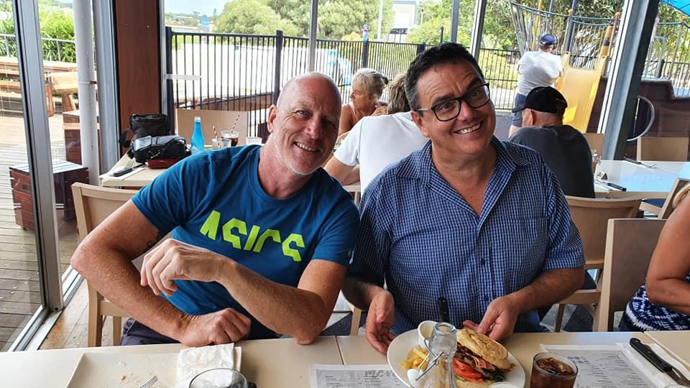

Lunch at the Pelican Waters Tavern ... yum!

After a relaxing afternoon and a swim on the beach, drinks and nibblies were held at the narrow part of the beach where it’s a short stroll across to the ocean. Pizza orders were taken, Brisandy kindly Ubered across to the Power Boat club to pick them up. Dinner was served on the beach! And after dinner the night time photography buffs displayed their talents.

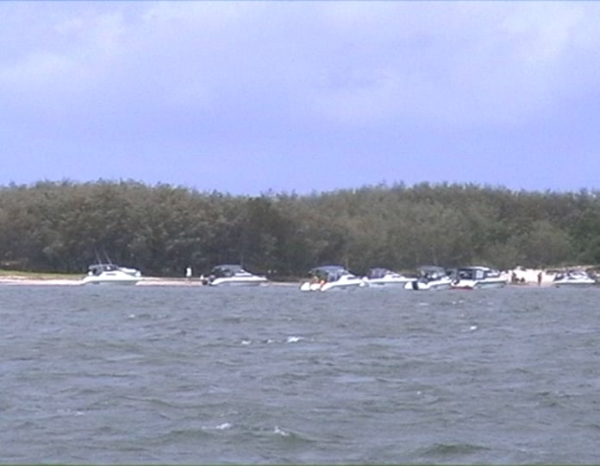

Afternoon on the Beach

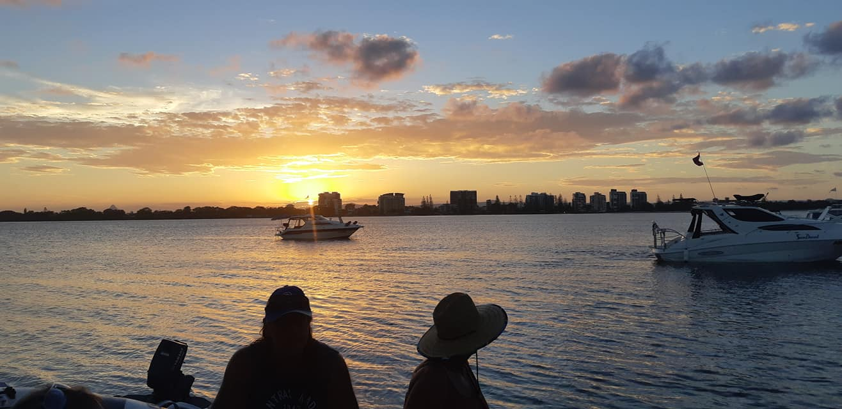

Sunset

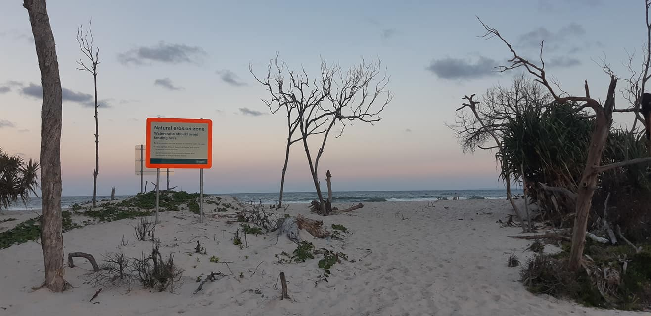

The Ocean

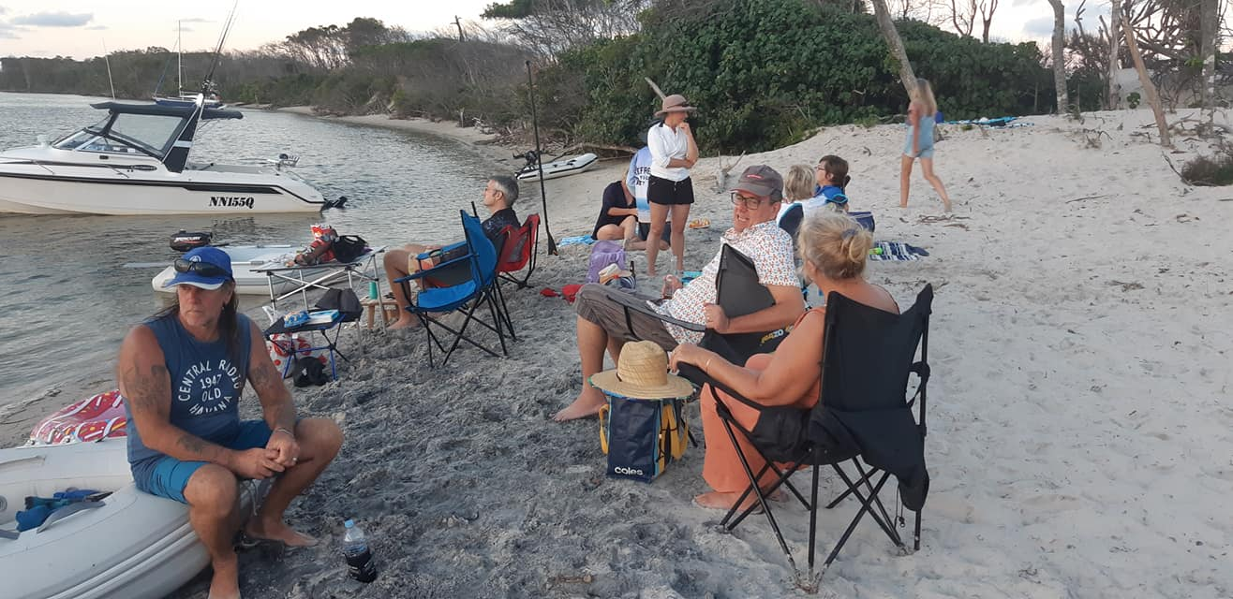

Drinks and Nibblies

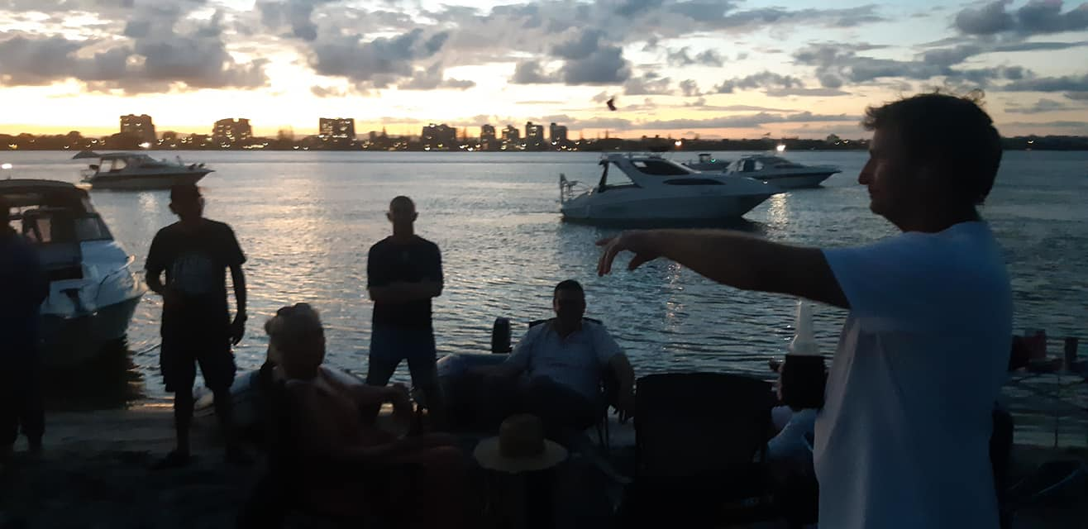

A briefing from the Commodore.

Welcome to our new members, Mark and Peta on board Fox Sea Lady

Welcome to our new members, Kylie, Kieron, and the kids on Espedaire

Dinner is Served!

After dinner the night time photography buffs displayed their talents.

Returning with Pizzas Night Time Photography – Trees on the Beach!

**Sunday:**

First up, our local guide, David, asked if we would like to attempt a bar crossing and have a look at the ocean. Five boats lined up to go over the bar, and after calling the Coast Guard for coverage David led us across the bar. How exciting that was!! All made it safely back in across the bar ready for a 10 am departure for Bongaree.

Again, we had three legs. The first one, to Roys ramp, led by our local guide, David, who bade us farewell as he returned to Caloundra. A slow cruise through the shallows to Mission Point was uneventful (although there were some reports of a Boat running a ground, was that Jaskat?). Of course there were the inevitable jetskis skimming through the shallows… but the arrival of Salty Kisses jetski at the Narrows was a welcome sight bringing Kim to join Jon on Seduced.

All boats were present and accounted for at Mission Point. A cruise then back to Bongarree to finish off with a well deserved lunch on the beach!

**The Golden Duck Award:**

The weekend was almost uneventful, however, the grounding of Jaskat on entering the W’s sees the Golden Duck award going to the Captain of Jaskat! Congratulations!

Thanks everyone for coming and making the trip a fantastic experience!!

All the best!

*Jon and Kim*

Remember there are three types of boaties.

1. **Those that have run aground (ask some of the guys from last trip !)**
2. **Those that haven’t (all of us !)**
3. **Those that have but won’t admit it ! (ask the guys from point 2 again !)**