CHRISTMAS IN JULY
11th-12th 2020

Friday Arrival is an option if you can get time off work. We’ll be launching Seaduction, approx. 1300 then heading to Marine Stadium. Drinks and nibbles on the beach @ 3.30pm. Dinner your choice on board your boat.
Breakfast at Paradise Point for those interested before heading to Millionaires row.
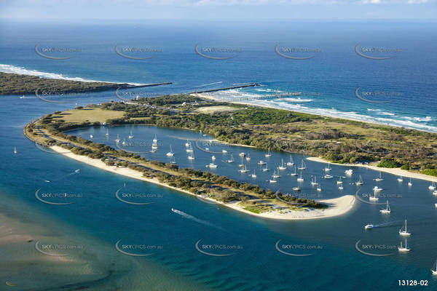

Waypoint: 27° 56.865 S 153° 25.425 E

Saturday 11th July
Meet up at Millionaires Row 11.am for some fishing or just sitting back and enjoy the surroundings. Lunch at your leisure on board before heading to Tipplers.

Christmas in July Dinner

Pre-dinner drinks. 5.00pm on beach (BYO)
Dinner @ Tipplers: 6.00pm Three course Meal. Menu attached.
Drinks from bar at your cost.
Please join us for an evening of fun laughter and great food. There will be lucky door prizes and secret Santa. Get your Christmas on and Join in the fun.

Cost: $30 per adult
$15 per child paid by club. (kids Menu)

Menu is multi choice. Please chose your entrée, mains and desert and forward to: kim.maree25@gmail.com or SMS 0421397028

Payment to be made to Club Whittley QLD.

Account:
BSB:
REF: Your boat name EG: Seaduction

For Secret Santa: Please purchase a $10 to $15-dollar present, 1 per adult in your group to be placed under Christmas tree. Children will be covered by Club. Please advise Childs name, age and gender to Kim Heales.
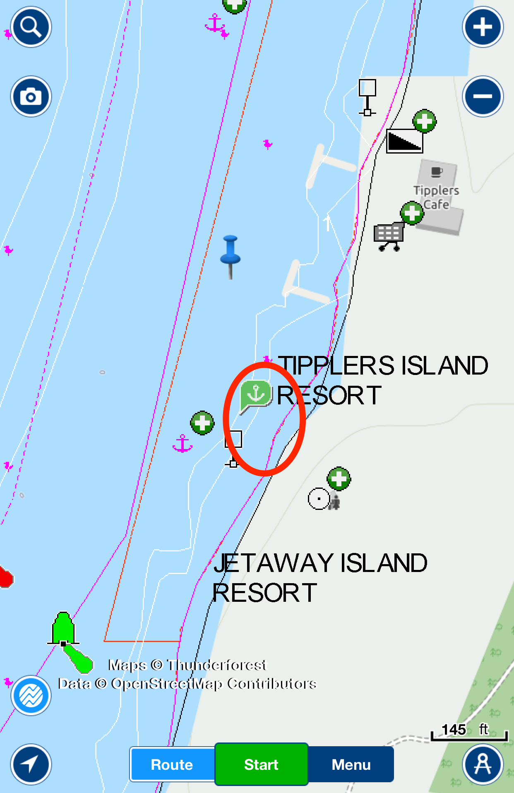

Tipplers Waypoint: 27° 59.569 S 153° 25.408 E
Launch Facilities
There is no organised launching or car and trailer storage for this event. Horizons is the suggested launching ramp but feel free to launch anywhere that is convenient to yourselves.
On-water fuel is available at Horizons, Southport Yacht Club (Credit Card)

Tides

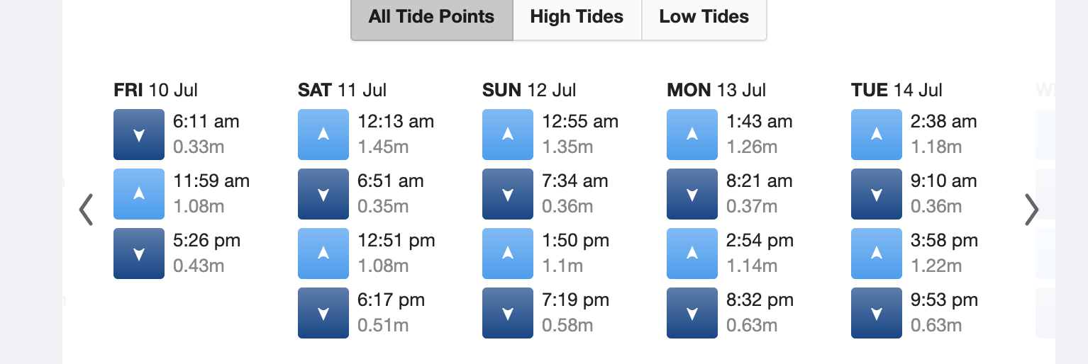

Tide times for South Stradbroke Island.

Sunday

Breakfast is available from Tipplers or do your own thing on boat. Let’s see how the weather is and decide on the day.

