Living Way Academy
7th Grade Book List
2020-2021
BJU Item # | Title | BJU Price $ (wholesale) | ISBN #
514109   | Explorations in Literature Student Text (4th ed. copyright updated) | $56.50 | 978-1-62856-442-6
278440   | Grade 7 Writing & Grammar Worktext (3rd ed.) | $29.50 | 978-1-60682-179-4
515882  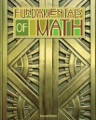 | Grade 7 Fundamentals of Math (2nd ed.) | $53.75 | 978-1-62856-072-5
515841   | Heritage Studies American Republic Student Text (4th ed.) | $57.50 | 978-1-60682-857-1
508655  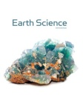 | Earth Science Student Text (5th ed.) | $64.00 | 978-1-62856-283-5

Please note: workbooks, worktexts, activity manuals and reviews may not be exchanged as they will need to be purchased in NEW condition. These items are consumables and are written in by your student.

Living Way Academy
8th Grade Book List
2020-2021
BJU Item # | Title | BJU Price $ (wholesale) | ISBN #
515866  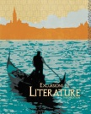 | Excursions in Literature Student Text (3rd ed.) | $56.50 | 978-1-60682-969-1
278432  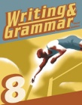 | Grade 8 Writing & Grammar Worktext (3rd ed.) | $29.50 | 978-1-60682-180-0
517060   516997  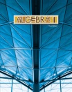 | Pre Algebra Student Textbook (2nd ed.)  -OR-  Algebra 1 Student Textbook (3rd ed.) | $53.75  *ask Mrs. Stott which math book your student needs | 978-1-62856-291-0  978-1-62856-562-1
515841 | Heritage Studies American Republic Student Text (4th ed.) | $57.50 | 978-1-60682-857-1
508655 | Earth Science Student Text (5th ed.) | $64.00 | 978-1-62856-283-5

Please note: workbooks, worktexts, activity manuals and reviews may not be exchanged as they will need to be purchased in NEW condition. These items are consumables and are written in by your student.

