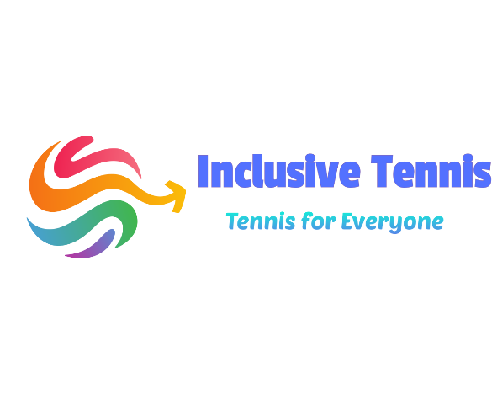
2021 REGISTRATION FORM
Name:

Address:

Phone #:

Birthdate:
Medical Conditions/Allergies:

E-mail:

Payment is due on day of attendance: Please pay to:
Inclusive Tennis CIC
Acc: 45119807
Sort: 608371

CONSENT AGREEMENT: I am fit to participate in the Tennis Activity. The Staff have my permission to act in any emergency in my best interest. Permission is also given for the use of photos and videos on the Company website, Facebook page, or other advertising. If there are concerns, please let us know.

Signature: Date:
Print Name:

