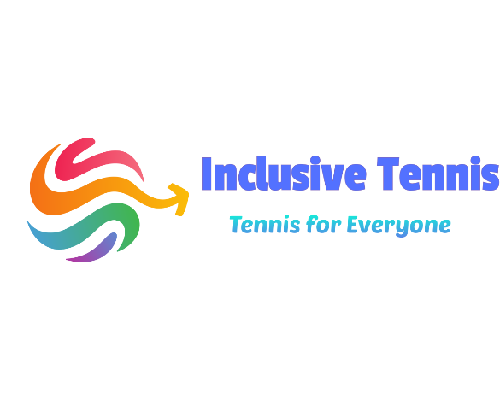
2021 REGISTRATION FORM
Name: Parent / Guardian(s) Name(s):

Address:

Phone #:

Birthdate:
Medical Conditions/Allergies:

E-mail:

Payment is due on day of attendance: Please pay to:
Inclusive Tennis CIC
Acc: 45119807
Sort: 608371

CONSENT AGREEMENT: My child has permission to participate in the Tennis Activity. The Staff has my permission to act in any emergency in the best interest of my child. Permission is also given for the use of photos and videos of my child on the Company website, Facebook page, or other advertising. If there are concerns, please let us know.

Signature: Date:
Print Name:

