TABLE OF CONTENTS
- Purpose & Design Philosophy
- Core System Principles (Non-Negotiable Rules)
- System Spine & Cross-Tool Coherence
- Canonical Folder Structure
- Tool Boundaries & Source-of-Truth Rules
- Project Lifecycle (End-to-End)
- Incident & System Change Control
- Governance, Roles, and Permissions
- Role Maturity Model
- Naming, Standards, and Conventions
- Continuous Improvement & Revision Process
- Glossary of Terms
- Revision Log

- PURPOSE & DESIGN PHILOSOPHY
This system is a structured learning and operations environment designed to develop independent, capable, and accountable individuals through real work rather than abstract coursework. It integrates multiple skills, knowledge bases, and core topics into a single project.
It uses project-based learning to build skills at three levels: execution, coordination, and decision-making (Executive, Middle, Floor). Each project requires planning, doing, reviewing, and improving, so habits of critical thinking, documentation, root cause analysis, and continuous improvement naturally form through use. Only cross-field skills are focused on for habit making.
All work is documented, traceable, and reviewable, with clear separation between planning, execution, evidence, and reflection. The system is designed to be transparent, auditable, and resilient, supporting academic readiness, professional development, and long-term skill growth without reliance on any single platform or tool. It is specifically designed to provide general experience, confidence, and the ability to navigate systems or software regardless of experience in specific application.
Put simply, it exists to help people learn how to think clearly, work systematically, and improve continuously in a way that scales from education to professional life.

- CORE SYSTEM PRINCIPLES (NON-NEGOTIABLE RULES)
Work does not exist unless it is:
Thought through in XMind
Tracked in Excel
Stored as artifacts in the file system
Every function has exactly one source of truth. Mixing tools or duplicating authority is prohibited.
Structure is fixed at the top level. Organization is based on purpose, not preference.
Decisions precede execution. No task, file, or commitment is created without an explicit decision.
Evidence is mandatory. Completion is proven with artifacts, not statements.
Changes are controlled. No structural, system, or process change occurs without documentation.
History is preserved. Nothing is silently overwritten or deleted.

- SYSTEM SPINE & CROSS-TOOL COHERENCE
The Holistic Program operates on a single enforced system spine. All work must remain coherent across thinking, execution, evidence, and time.
The system spine is defined as follows:
XMind defines decisions and intent
Excel defines execution state and measurable truth
File System defines evidence and artifacts
Outlook defines time commitments
Work is invalid if it exists in fewer than all applicable layers.

No task may be tracked without an originating decision.
No decision may be executed without producing evidence.
No evidence is meaningful without a linked decision and metric.
No time commitment exists without an approved task.

Cross-tool drift is a system failure and must be corrected through incident analysis.

- CANONICAL FOLDER STRUCTURE
All work exists under exactly four top-level directories with the Holistic Program Folder:
/archive
/user
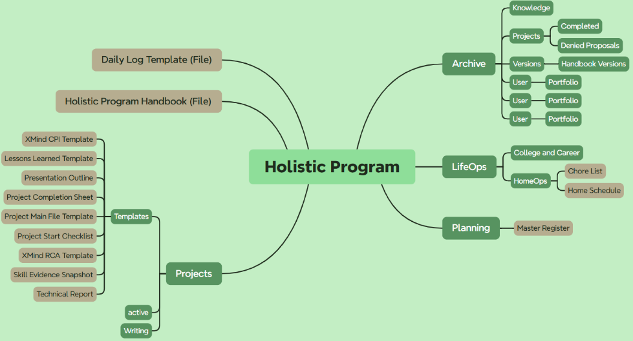
/portfolio
/knowledge
/projects
/completed
/Denied Proposals
/versions
/planning/
/projects/templates
/writing
/lifeops
/college and career
/homeops

Purpose definitions:
/planning
Pre-decision thinking, analysis, and design work that has not yet been approved for execution.
/projects
All active and completed projects. This is the permanent home of project work.
/lifeops
Chores, health, wellness, activities, or other daily wants and needs
/archive
Closed, superseded, or inactive material retained for traceability and reference.
No additional top-level directories are permitted. The Archive folder is where the Knowledge Library is located and maintained, within the Knowledge folder.

Project Proposal and Project Start:
Open a new Project Main File Template:
Project ID: dd/mm/yyyy Project Goal Proposal (E.G. 2/9/2026 Growing Opal Proposal)
Students: Your First and Last Name, Joined by (if group)
Start Date: Date started the new file
Status: Planning / Active / Testing / Complete (if Proposal is Planning)

- TOOL BOUNDARIES & SOURCE-OF-TRUTH RULES
Each tool has a single, enforced role.
XMind
XMind is the system’s decision authority.
All projects, changes, incidents, and improvements must originate in an XMind decision structure before execution is permitted.
A decision map must explicitly document:
Objective
Constraints
Assumptions
Risks
Success criteria
Approved actions
Execution artifacts or tracking entries that cannot be traced to an approved XMind decision are considered unauthorized work.
Once execution begins, XMind remains authoritative for intent but does not track status. Status authority transfers exclusively to Excel.
Excel
The system of record for metrics, tracking, registers, and execution status.
Excel never contains undecided analysis.
Every tracked item traces back to an approved decision.
Outlook
Used only for time commitments.
Contains deadlines, time blocks, reviews, and reminders.
No logic, files, or tracking reside in Outlook.
FileBrowser / Server Storage
Used only for files, evidence, and artifacts.
Contains the physical proof of work: documents, data, logs, exports, and media.
No task tracking or decision logic resides here.
Website / Domain
Used only for navigation, explanation, and public documentation.
Stores no active work and no system of record.
Serves as a read-only interface to understand and navigate the system.
No tool may be used outside its assigned role.
- PROJECT LIFECYCLE (END-TO-END)
There is exactly one project lifecycle.
Step 1: Initiate (XMind)
A project begins with a decision map defining objective, constraints, assumptions, components, risks, success criteria, and initial actions.
The map is saved inside the project proposal folder.
Step 2: Register (Excel)
The project is entered into the project register with owner, status set to Planning, metric of success, and links to XMind and the project folder.
Step 3: Create Project Structure
A project folder is created under /projects using the mandatory naming format:
dd-mm-yyyy-projectname
Internal structure supports maps, documentation, data, configuration, logs, and outputs.
Step 4: Plan Execution (Excel)
Approved actions from XMind are converted into tasks.
Every task has an owner, produces evidence, and links back to the project.
Time commitments are added to Outlook when required.
Step 5: Execute
Work is performed using appropriate tools.
All outputs are stored in the project folder.
No work products are stored on desktops or unmanaged locations.
Step 6: Verify
Tasks are completed only when metrics move, evidence is attached, and results align with the decision intent.
Step 7: Close
Project status is updated in Excel.
Reusable outputs are standardized.
One-off projects are archived according to retention rules.
Projects are never moved to indicate status. Status lives only in Excel.

- INCIDENT & SYSTEM CHANGE CONTROL
Incidents (Failures, Errors, Unexpected Outcomes)
Incidents are logged in Excel, analyzed in XMind, and resolved through documented corrective and preventive actions.
An incident is closed only after verification evidence is attached and prevention is implemented.
System Changes (Infrastructure, Software, Configuration)
All system changes are logged in Excel with risk level and rollback plan.
Medium and high-risk changes require decision analysis in XMind.
A dedicated change folder stores before-and-after evidence.
Changes are validated, then standardized or archived.
No system change is performed without a rollback plan.

- GOVERNANCE, ROLES, AND PERMISSIONS
Standard Users
Execute work within assigned projects.
Create and update files inside project folders.
Update tracking data in Excel for their work.
Cannot alter structure, templates, or system rules.
Administrators
Own system integrity and continuity.
Approve structural and process changes.
Maintain templates, registers, and documentation.
Ensure this handbook is followed and updated.
Permissions are enforced by role, not trust.

- ROLE MATURITY MODEL
Roles within the Holistic Program are maturity-based, not trust-based.
Access and authority expand only as demonstrated capability increases.
Indicative maturity levels include:
Level 1 – Executor
Follows existing structure
Produces evidence
Updates assigned tracking only
Level 2 – Planner
Creates project structures
Proposes decisions for approval
Identifies risks and metrics
Level 3 – Improver
Conducts root cause analysis
Proposes system or process improvements
Participates in standardization
Level 4 – Governor
Approves changes
Maintains templates and registers
Audits system integrity
Advancement requires demonstrated performance, not tenure or permission.

- NAMING, STANDARDS, AND CONVENTIONS
Project folders use the format dd-mm-yyyy-projectname.
Names are lowercase, descriptive, and stable.
System folders are never renamed.
Files are linked, not duplicated.
Templates are copied, never edited in place.
Decisions are documented once and referenced everywhere else.

- CONTINUOUS IMPROVEMENT & REVISION PROCESS
This handbook is a living document.
All improvements are initiated through documented decisions.
Changes follow the same lifecycle as any system change.
Revisions are additive and logged.
Historical versions are preserved.
Silent edits are prohibited.

- GLOSSARY OF TERMS
Action
A discrete, approved step derived from a decision and tracked to completion in Excel.
Artifact
A file or physical output that provides evidence of work performed.
Baseline
The documented current state against which change and improvement are measured.
Change Control
The formal process for requesting, approving, executing, and validating system or process changes.
Continuous Process Improvement (CPI)
A structured method of identifying, implementing, verifying, and standardizing improvements over time.
Decision
A committed choice made after analysis, recorded in XMind, and executed through tracked actions.
Evidence
Objective proof that work was completed and outcomes achieved, stored as artifacts.
Incident
An unplanned event that causes failure, degradation, or unexpected results requiring RCA.
Metric
A measurable indicator used to verify progress, performance, or success, tracked in Excel.
Milestone
A significant checkpoint or deliverable scheduled in Outlook and verified with evidence.
Owner
The individual accountable for execution and completion of a task, project, or action.
Project
A time-bound effort with a defined objective, executed through the standard project lifecycle.
Register
An Excel-based log that serves as the system of record for projects, incidents, decisions, or changes.
Root Cause Analysis (RCA)
A structured method used to identify the underlying systemic cause of an incident.
Source of Truth
The single authoritative location where specific information is defined and maintained.
Standardization
The act of converting a successful solution into a repeatable process, template, or rule.
Task
An executable unit of work tracked in Excel and linked to a project and evidence.
Verification
The confirmation that an action or change produced the intended result, supported by metrics and artifacts.
XMind Map
A visual decision and analysis structure used to clarify thinking and define approved actions.
Outlook Commitment
A scheduled time block, deadline, or review that reflects an approved task or milestone.

- REVISION LOG
Version: 1.2
Date: 02/14/2026
Description: 3rd Version, Updated Directories and Methods

