Calico Cut-Ups - Scallop Edges (January 2022)
The Sewing Channel No Math No Ruler Scallops
  - Draw a circle such as 7 ½ inch. Use a magic marker to draw the edges of the circle so they will be dark.
  - Keep two full circles for the corners. Copy additional circles for the edges. Fold and cut circles in half.
  - Place on the quilt edge overlapping the circles. Measure the overlap so all of the circles are spaced evenly. Adjust as necessary and pin in place.
  - Trace the fabric around the curve and stay stitch the curves. Cut to each point.
  - Sew on bias binding. You can even use a zipper foot. Cut remaining curved fabric.
Quilt in a Day Scallops, Vines, and Waves #2019 Template
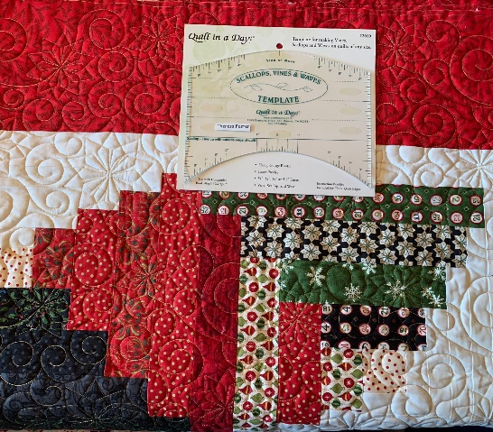
This is my favorite technique. The template comes with clear instructions on how to determine how many scallops are required based on the side measurements of your quilt. Three quilt edges are included.
- Measure the sides of your quilt. Subtract 4 inches. Example: 84 inches – 4 inches.
- Divide the measurement by 7, 8, 9, or 10 or look at the chart in the instruction booklet to determine the length of the scallop. In this example, 10 scallops will be used with a length of 8 inches. Place tape on the inch marking. If possible, select the same size scallop for both length and width.
- Mark diagonal lines on the corners.
- Make a dry run. Knowing the length of your scallops and width of the template, place the scallop template on the diagonal line. Line up selected size on the diagonal line, and outside edge of quilt with the solid straight line on the ruler. Place a pin in each of the V’s across the entire length of the edge.
- Once you are sure of the place, use a marker around the template. You may need to make a few adjustments.
- Top stitch on the line with a long stitch 3.5.
- Cut ¼ inch away from the guide line. You may want to make a cut into the V’s.
- Sew on bias binding.

T. Foster

