

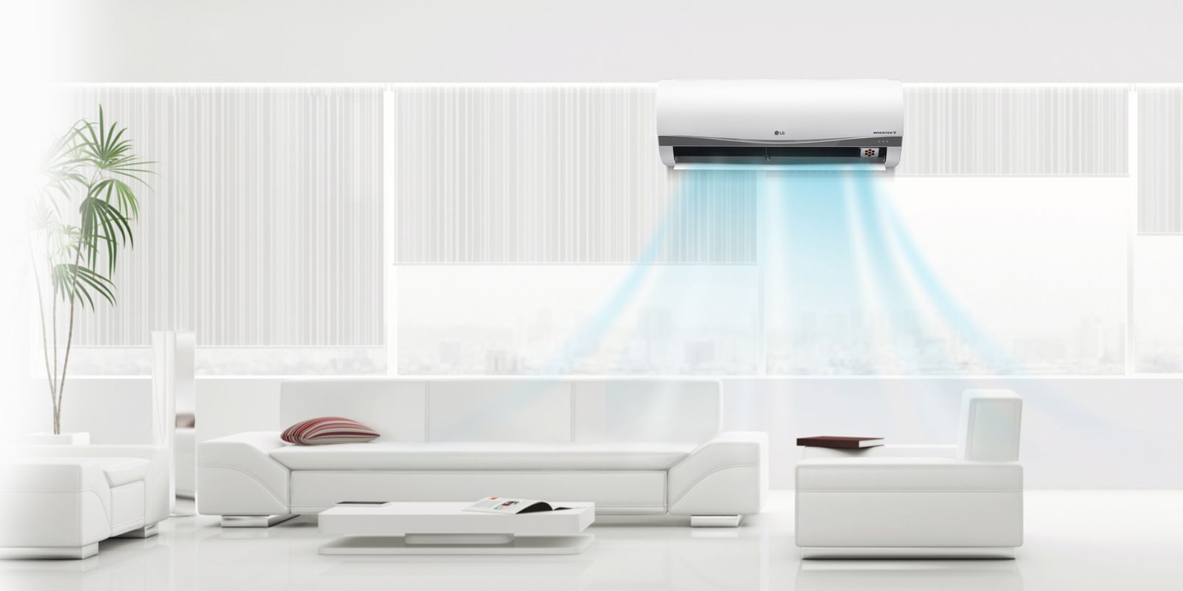

**CAPABILITY STATEMENT**

**THE LIGHT LLC**

**COMPANY OVERVIEW**

**THE LIGHT**

**Phone Number:** (671)682-8844

**Email:** info@thelightguam.com

**Website:** www.thelightguam.com

Address: 290 Taigigao RoadAgana nnvvvvvmHeights, GU 96910 US

CAGE: 970Y1

THE LIGHT is a woman owned, family operated business. Our licensed, certified, and highly trained team offers top-of-the-line services to ensure your property stays safe and comfortable year-round. As a local and family-owned small business, we are familiar with the specific needs of beautiful people in the island of Guam, and our team works tirelessly to solve every one of your cooling, and electrical concerns.

Our technicians and staff are highly trained with knowledge in air conditioning, indoor air quality, and electrical and always strive to provide our customers with friendly and professional service.

**SERVICES**

**LICENSES**

**A/C Services**

* Whether you’re installing a system from scratch including ductwork, or just swapping out an older unit for one that is more energy efficient, THE LIGHT A/C professionals have the experience to get the job done right.

**Electrical Services**

* Whether it’s a new construction, renovation or expansion project. THE LIGHT's team of highly trained, certified electrical contracting personnel can design, build and complete your project to your specification.

**Lightning Protection Services**

* Lightning Protection & Ground Grid System Installation - Protect your structures and equipment from mechanical or fire destruction caused by Lightning strikes

**C13:** Electrical Work

**C40:** Hvac / Refrigerant

**C51:** Hvac / Refrigerant

**NAICS CODES**

**238210:** Electrical, electrical wiring & NNNNNlow voltage electrical work

**238220:** Hvac Contractors

**PAST PERFORMANCE**

**CORE COMPETENCIES**

**Teamwork**

* Our team of professionals take great pride in its work and improves productivity.

**Innovation**

* We value ideas over hierarchy and took great pride in ensuring positive overall customer experience.

**Quality**

* We provide best quality in reasonable prices and friendly service to customers as well as building strong relationships with them.

**Cost**

* We focus on the cost leadership approach and it ensures that our clients get benefited.

**Response Time**

* Our response time is very quick and it requires minimal efforts from the customer.
* APRA Medical/ Dental Faculty Caddell-Nan JV
* Ambros INC
* Carbras Marine Corporation
* Pacific Island University
* Reflections Centre
* Flora Pago
* Perez Acres
* Leo Palace
* Starts Golf Course
* Docomo Pacific
* Guahan Baptist Church
* Agana Heights Baptist Church
* Guam Legislature
* Saint Fidelis Friary
* Andersen Air Force Base
* Naval Base Guam

When you're looking for reliable A/C and electrical services, THE LIGHT offers you the perfect balance of price and quality. You can be sure that we are polite, hard-working and professional. We use modern tools to improve our effectiveness as well as accuracy.

**DIFFERENTIATORS**