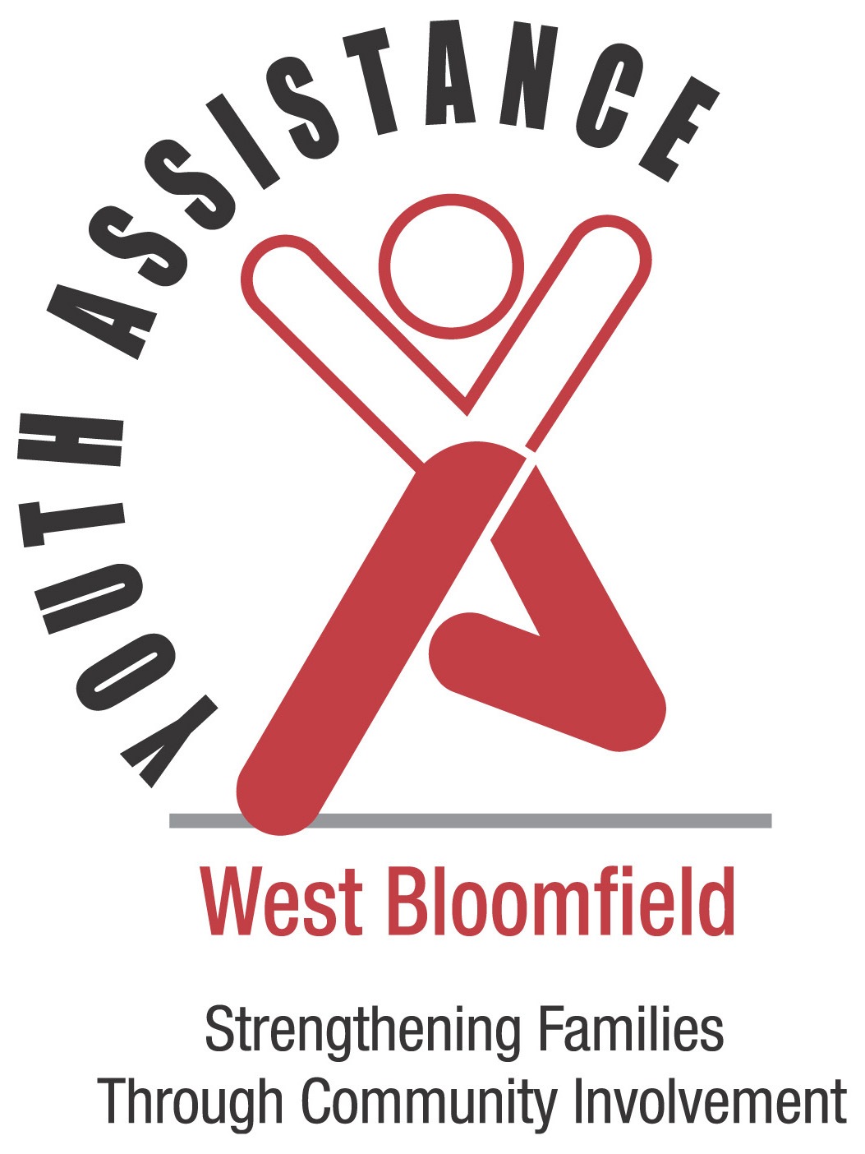
WEST BLOOMFIELD YOUTH ASSISTANCE
YOUTH RECOGNITION AWARDS
Eligibility and Nomination Instructions
2019

- Nominees must reside within the boundaries of the West Bloomfield School District or be a West Bloomfield School District student.

- All school age youth are eligible.

- A youth may receive only one award as an elementary student, one as a middle school student and one as a high school student. A recognition letter will be sent to all nominated students who have received an award previously and are ineligible for recognition this year due to the aforementioned rule.

- Nominations must be typed and received by Friday, March 22, 2019.

- A nominator may be any adult or organization that wishes to submit the name of a deserving youth(s) for performing volunteer services, not related to school or court requirements. A student required to perform volunteer service for academic credit or court ordered community service may be nominated if the student personally chooses to continue service beyond the required hours.

- Nominees are judged on the basis of:

- Volunteer Service - to an individual, organization or the community. Some examples of Volunteer Service are:
  - Hospital or nursing home volunteers
  - Beautification activities exceeding 15 hours of personal time
  - Tutoring other students
  - Service to vulnerable populations
  - Volunteer service with local non-profit organizations

- Personal acts of heroism

- Self-improvement through personal and/or academic achievement

- Additional forms may be copied or obtained at the West Bloomfield Youth Assistance office.

- The decision of the Youth Recognition Committee is final.

Completed forms must be received no later than Friday, March 22nd, 2019
Nominations may be emailed to wbyouthassistance@yahoo.com
Questions? Call: 248-592-1278

West Bloomfield Youth Assistance, 4925 Orchard Lake Road, West Bloomfield, MI 48323
WEST BLOOMFIELD YOUTH ASSISTANCE
YOUTH RECOGNITION AWARDS
2019 NOMINATION FORM

Must be received by Friday, March 22nd, 2019
Please return forms to wbyouthassistance@yahoo.com

Date: Click to enter a date.

Nominee’s Name: Age: ☐ Male ☐ Female
Address: City: Zip:
School: Grade:

Parent’s Name(s): Parent Email: Phone:

Nominator’s Name: Organization:
Email: Phone:
Address: City: Zip:

IN 150 WORDS OR LESS, PLEASE DESCRIBE NOMINEE’S ACCOMPLISHMENT AND/OR SPECIAL ACHIEVEMENT – TIME INVOLVED, ETC. Please take special care when composing remarks. We make every effort to use and publish nominations as written but will make necessary edits as needed.
~Please Print or Type~
______________________________________________________________________________________________
_______________________________________________________________________________________________
_______________________________________________________________________________________________
_______________________________________________________________________________________________
_______________________________________________________________________________________________
_______________________________________________________________________________________________
_______________________________________________________________________________________________
_______________________________________________________________________________________________
Use additional sheet if necessary.

West Bloomfield Youth Assistance, 4925 Orchard Lake Road, West Bloomfield, MI 48323

