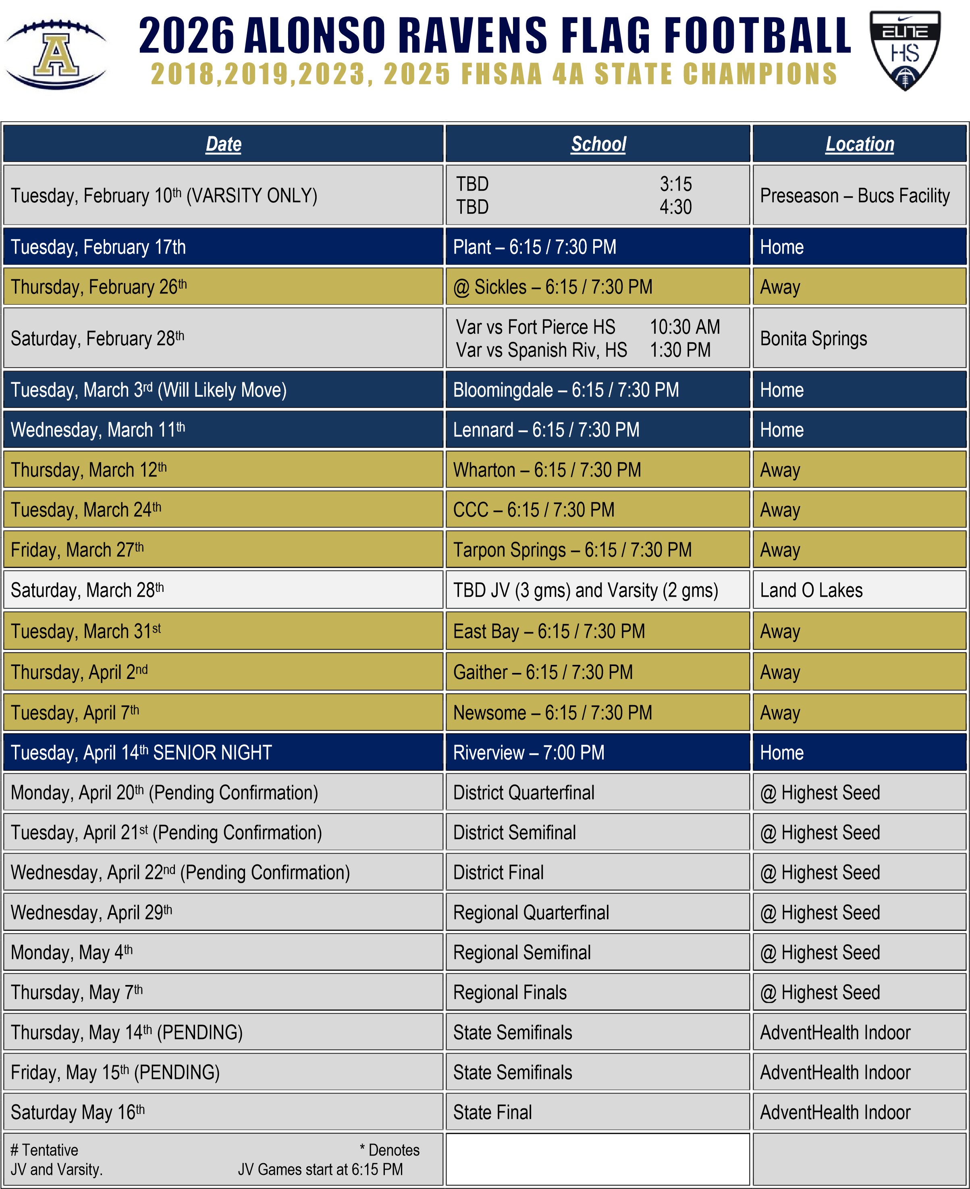

January/February 2026
Sunday | Monday | Tuesday | Wednesday | Thursday | Friday | Saturday
25 | 26  FLAG TRYOUTS  ALL –3:45-5:30 | 27  FLAG TRYOUTS  ALL –3:45-5:30 | 28  Practice  ALL –3:45-5:30 | 29  Practice  ALL –3:45-5:30  Parent Meeting  6:00 – 7:00 | 30  MORNING  Practice  ALL-6:15-7:45 | 31
1 | 2  Practice  ALL-3:45-5:45 | 3  MORNING  Practice  ALL-6:15-7:45 | 4  Practice  ALL-3:45-5:45 | 5  Practice  JV-3:45-5:30  V-4:45–6:15 | 6  MORNING  Practice  ALL-6:15-7:45 | 7
8 | 9  Practice  JV-3:45-5:30  V-4:45–6:15 | 10  Bucs Preseason  (Varsity Only) | 11  Practice  JV-3:45-5:30  V-4:45–6:15 | 12  MORNING  Practice  ALL-6:15-7:45 | 13  Practice TBD | 14
  NON-STUDENT
  DAY
15 | 16  Practice  ALL-4:00-5:45 | 17  JV/VAR vs Plant | 18  Practice  JV-3:45-5:30  V-4:45–6:15 | 19  MORNING  Practice  ALL-6:15-7:45 | 20  NO PRACTICE | 21
  NON-STUDENT
  DAY
22 | 23  Practice  JV-3:45-5:30  V-4:45–6:15 | 24  MORNING  Practice  ALL-6:15-7:45 | 25  Practice  JV-3:45-5:30  V-4:45–6:15 | 26  JV/VAR at  Sickles | 27  MORNING  Practice  ALL-6:15-7:45 | 28  Fort Pierce Ct. 10:30AM  Spanish River  1:30 PM

March 2025
Sunday | Monday | Tuesday | Wednesday | Thursday | Friday |  | Saturday
1 | 2  Practice  JV-3:45-5:30  V-4:45–6:15 | 3  JV/VAR vs Bloomingdale | 4  Practice  JV-3:45-5:30  V-4:45–6:15 | 5  Practice  JV-3:45-5:30  V-4:45–6:15 | 6  MORNING  Practice  ALL-6:15-7:45 |  | 7
  THIS GAME
  WILL MOVE
8 | 9  Practice  JV-3:45-5:30  V-4:45–6:15 | 10  Practice  JV-3:45-5:30  V-4:45–6:15 | 11  JV/VAR vs.  Lennard | 12  JV/VAR @  Wharton | 13  MORNING  Practice  ALL-6:15-7:45 |  | 14
15 | 16 | 17 | 18 | 19 | 20 |  | 21
15 |  | SPRING | BREAK - Pra | ctice TBA |  |  | 21
22 | 23  Practice TBD | 24  JV/VAR at  Clearwater  Central  Catholic | 25  Practice  JV-3:45-5:30  V-4:45–6:15 | 26  Practice  JV-3:45-5:30  V-4:45–6:15 | 27  VAR/JV at  Tarpon Springs |  | 28  Games at  Land o Lakes  - Varsity  - JV
  NON-STUDENT
  DAY

April 2026
Sunday | Monday | Tuesday | Wednesday | Thursday | Friday | Saturday
29 | 30  Practice  JV-3:45-5:30  V-4:45–6:15 | 31  JV/VAR @  East Bay | 1  Practice  JV-3:45-5:30  V-4:45–6:15 | 2  JV/VAR vs  Gaither | 3  Practice TBD | 4
  NON-STUDENT
  DAY
5  Easter Sunday | 6  Practice  JV-3:45-5:30  V-4:45–6:15 | 7  JV/VAR @  Newsome | 8  Practice  JV-3:45-5:30  V-4:45–6:15 | 9  Practice  JV-3:45-5:30  V-4:45–6:15 | 10  Practice  JV-3:45-5:30  V-4:45–6:15 | 11
12 | 13  Practice  JV-3:45-5:30  V-4:45–6:15 | 14  VAR vs  Riverview | 15  Practice  JV-3:45-5:30  V-4:45–6:15 | 16  Practice  JV-3:45-5:30  V-4:45–6:15 | 17 | 18  MORNING  Practice  VAR-7:45-9:15
  NON-STUDENT
  DAY
19 | 20  FLAG District  Quarterfinal | 21  FLAG District  Semifinal | 22  FLAG District  Final (Possible) | 23  FLAG District  Final (Possible) | 24 | 25  MORNING  Practice  VAR-7:45-9:15

May 2026
Sunday | Monday | Tuesday | Wednesday | Thursday | Friday | Saturday
26 | 27  Practice  JV-3:45-5:30  V-4:45–6:15 | 28  MORNING  Practice  VAR-6:15-7:45 | 29  FLAG  Regional  Quarterfinals | 30  Practice  JV-3:45-5:30  V-4:45–6:15 | 1  MORNING  Practice  VAR-6:15-7:45 | 2  MORNING  Practice  VAR-7:45-9:15
3 | 4  FLAG  Regional  Semifinals | 5  MORNING  Practice  VAR-6:15-7:45 | 6  Practice  VAR-3:45-5:45 | 7  FLAG  Regional  Finals | 8  Practice  Film Review  7:15 – 8:15 | 9  MORNING  Practice  VAR-7:45-9:15
10 | 11  Practice  JV-3:45-5:30  V-4:45–6:15 | 12  Practice  JV-3:45-5:30  V-4:45–6:15 | 13  Practice  JV-3:45-5:30  V-4:45–6:15 | 14  FLAG State  Semifinal  Tampa, FL | 15  FLAG State  Semifinal  Tampa, FL | 16  FLAG State  Final  Tampa, FL

