Grade XII – Computer Science

Worksheet: SQL Commands

Saman has been entrusted with the management of Law University Database. He needs to access some information from FACULTY and COURSES tables for a survey analysis. Help him extract the following information by writing the desired SQL queries as mentioned below.

Table: FACULTY

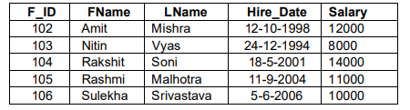

1. Display all the details of faculty whose salary is more than 10000.
2. Display the FName and LName of all Faculty.
3. Display the Salary of Faculty with F_ID as 105.
4. Display the F_ID and Hire_Date of Faculty whose salary is between 15000 and 20000.
5. Display all the details of Faculty whose FName is ‘Rakshit’.

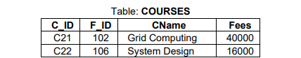

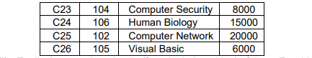

1. Display the Course name of all courses with Fees less than 10000.
2. Display all the details of Courses with ID as C25.
3. Display the details of all the courses.
4. Display the Course Name of all the Courses.
5. Display the F_ID of courses with Course Name as ‘Grid Computing’ or ‘Visual Basic’.