**City of Hamlet Façade Improvement Grant Program**

**APPLICATION**

APPLICANT INFORMATION

FOR OFFICE USE ONLY

Name: Application Date:

Phone: Approval Date: Amount:

Referred by: Tax ID number:

**PROPERTY OWNER INFORMATION**

Name: Years Owned:

Address: Phone:

City: State: Zip:

Type of Ownership: Owner’s Signature-Improvements Approved:

BUSINESS AND / OR PROJECT INFORMATION

Name of Business: Business / Project Owner’s Name:

Address: Phone:

City: State: Zip:

Type of Business: Upper floor use:

PROPOSED IMPROVEMENTS

Storefront Improvements:

Upper Façade Improvements:

Other Improvements: Estimated Cost of Improvements:

Check appropriately:

I own the property in consideration I lease the property in consideration

I have read the City of Hamlet Façade Improvement Grant Program and Design Guidelines. I understand that if the proposal is approved, I will make the above improvements to the property within the specified time allowed.

APPLICANT’S SIGNATURE:________________________________________________________

DATE:__________________________________________________________________________

**ELIGIBILITY REQUIREMENTS**

Please check each item to indicate acceptance of the eligibility requirement. Work that does not comply with the eligibility requirements is subject to reduction or retraction of award.

___ All work must be done on an individual storefront or commercial building side which faces a public right-of-way or is otherwise visible to the general public from the street.

___ Commercial buildings must be zoned Central Business (B1) or General Business (B2), and located within the designated Main Street Project Area (see attached map).

___ Owner or tenants are eligible to apply; however the owner must sign the application.

___ All work must meet the North Carolina State Building Code and Zoning Ordinance requirements of the City of Hamlet. All applicants must consult with the City’s Zoning Administrator prior to completing an application.

___ Applicants are encouraged to Follow the U.S. Secretary of the Interior’s Standards for Rehabilitation if applicable (see attached).

**APPROVED TYPES OF REHABILITATION INCLUDE:**

* 1. Safe cleaning of brick/stone fronts or wall surfaces. This includes chemical stripping, water wash or scraping. No sand blasting is allowed. Chemical striping is not appropriate for historic properties (please see item seven U.S. Secretary of The Interior's Standards for Rehabilitation).
  2. Masonry repair, mortar joint repair, re‐pointing of brick.
  3. Re‐painting and patching of façade walls.
  4. Repair/replacement of windows and/or doors.
  5. Removal of siding and exterior false facades and metal canopies.
  6. Repair, reconstruction, and/or replacement of original architectural details.
  7. Installations of canvas‐type awnings.
  8. Structural and cornice repair and/or replacement.
  9. Railings, ironwork repair or addition.
  10. Historic reconstructions, rehabilitation or compatible reconstruction of a store front.
  11. Landscaping including sidewalks and plantings.
  12. Murals.
  13. Installation/replacement/repair of exterior lighting and appropriate signage including structures or frames that contain or hold a sign.

**INELIGIBLE PROJECTS INCLUDE**

* 1. Improvements made prior to grant approval.
  2. Interior rehabilitation/improvements
  3. Construction of false fronts.
  4. Blocking up of windows or installing storm/vinyl windows and doors.
  5. Demolition of historic features.
  6. Roof and chimney repair and construction of mansard roof.
  7. Materials inappropriate to the original structure or nearby structures.
  8. Tax Delinquent properties
  9. Property whose owner has any other tax delinquent property
  10. Property in litigation
  11. Property in condemnation
  12. National Franchises or Retail Stores

# INTENT AND GUIDANCE

1. Rehabilitation of structures in the downtown district should respect and reflect the architectural integrity of the entire building and retain those elements that enhance the building.
2. Priority is given to rehabilitation projects that notably and visibly improve downtown facades.
3. This program is to aid substantial investments to improve the aesthetic qualities of a building as well as protect it for the future.
4. Façades should be in harmony with the character of the Downtown and in coordination with the shape, color and design of adjacent facades.
5. Use colors that are compatible with other buildings and that are true to the style and age of the structure.
6. The City reserves the right to withhold the approval of a grant application if the color, design, sign design or other façade component is not deemed appropriate to the historic integrity of the structure and/or the Downtown as a whole.

# GRANT AWARD

1. Grant award amounts are at the discretion of the City.
2. Decisions may be based upon, but not limited to, size, project cost and amount of available funds.
3. Qualifying projects are eligible for a grant at a minimum of five hundred dollars ($500) but not more than two thousand five hundred dollars ($2,500) per building on a fifty/fifty (50/50) matching, reimbursement basis. At the discretion of the City and based on applications received, larger grants may be considered on a case by case basis.
4. At least two (2) project cost estimates must be submitted with the application. If both estimates are deemed equal (in regards to quality of materials used, etc.) only fifty percent (50%) of the lowest estimate will be granted, regardless of which bid is accepted by the building owner.
5. The grant amount shall be determined at time of application approval and paid when the project is completed.
6. The work must be completed within three (3) months of application approval, but the owner may request one extension for two (2) months based upon compelling valid reasons for the delay. Extensions are discouraged.
7. The façade improvement must stay in place for three (3) full years from the date of completion. If not, the grant amount for that project must be repaid in full.

# DECISION PROCESS

1. Applications will be reviewed for completeness and compliance with the criteria above by either the City Manager, Zoning Administrator, or the City Manager’s designee. Incomplete applications will be returned to the applicant. Complete applications will be reviewed by a committee consisting of the City Manager or his/her designee and a representative on and appointed by the City Planning Board.
2. If the application is not approved, a meeting can be scheduled with the applicant and City staff to refine the proposal to enable it to qualify if possible. If other, more appropriate applications are pending, they will take precedence; however, efforts will be made to help applicants succeed.
3. A notification letter or email will be sent to applicants explaining approval or denial.

a. Denied applications may be improved/corrected and re-submitted for consideration. If the revised/corrected application is also denied, the applicant can appeal the denial of the grant award to City Council via the City Manager.

1. If awarded, the applicant and owner must accept the contract/grant agreement before work begins.
2. Applicant must obtain necessary zoning and building permits if applicable.
3. Applicant may then begin work.
4. Upon completion of work, applicant must submit any documents evidencing payment required by the City including, but not limited to, receipts of payment, canceled checks, contractors’ payment receipts and lien waivers, to the City of Hamlet.
5. City Staff will inspect work for conformance with the approved application.
6. If the work is accomplished in accordance with the agreement and grant requirements, then the City shall reimburse the applicant for 50% of the actual project costs or the approved grant amount, whichever is less.

**Application Package**

Application packages must include enough documentation to illustrate the visual impact of the project and its costs. ***Failure to provide required information will delay the review process***. The items submitted should include:

* A completed application form
* Written consent from property owner giving permission to conduct façade improvements.
* Color photographs of existing conditions
* Samples of materials and colors to be used
* Any other documentation necessary to illustrate the visual impact of the proposed project completion schedule.
* ***Submit two competitive proposals from licensed and bonded contractors***. These proposals should give detailed information about the work to be done, the costs, and the project completion schedule. Any contractor that has submitted a competitive detailed estimate may be used. ***Contractors cannot be changed unless new proposals have been submitted and approved by the Façade Grant Committee.***
* Owners or merchants who are in contracting business and intend to perform work on their own properties or businesses, must furnish at least one proposal other than their own to be done.
* Owners and merchants may also perform work on their own buildings; however, they will not be reimbursed for time while acting as contractor and/or installing material. ***Material costs and labor of employees are reimbursable; however, documentation must be produced for the number of hours worked on the project by the employees, the rate of pay of the employees’ social security numbers etc.***

**Required Materials for Reimbursement**

Reimbursement can be expected in approximately **three (3) to six (6) weeks** after all of the following documentation has been submitted and project(s) inspected for completion.

**Copies of all paid invoices and canceled checks**

Submit application and attachments (paper and/or digital copies) to:

* mwebb@hamletnc.us; or
* City Hall (201 Main Street – to deliver in person); or
* City of Hamlet, PO Box 1229, Hamlet, NC, 28345 (by mail)

*I understand the limits and requirements of this program and if approved, agree to complete the project according to plan. I understand that failure to comply with the approved application may result in the termination of the grant.*

Applicant Signature: _____________________________________ Date: ___________

Owner Signature: _______________________________________ Date: ___________

**DESIGNATED PROJECT AREA MAP: B1 and B2 Zoned Properties**

*Only properties highlighted above, and zoned B1 or B2 on the map above are eligible participants. If unsure of eligibility, City staff can confirm eligibility. For any additional information, please contact City Hall at (910) 582-2651.

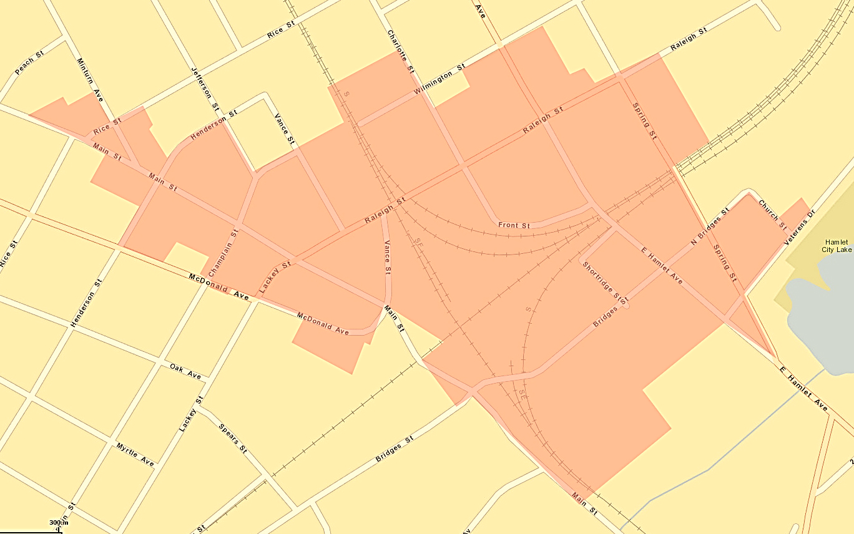

# U.S. SECRETARY OF THE INTERIOR'S STANDARDS FOR REHABILITATION

1. A property shall be used for its historic purpose or be placed in a new use that requires minimal change to the defining characteristics of the building and its site and environment.
2. The historic character of a property shall be retained and preserved. The removal of historic materials or alteration of features and spaces that characterize a property shall be avoided.
3. Each property shall be recognized as a physical record of its time, place, and use. Changes that create a false sense of historical development, such as adding conjectural features or architectural elements from other buildings, shall not be undertaken.
4. Most properties change over time; those changes that have acquired historic significance in their own right shall be retained and preserved.
5. Distinctive features, finishes, and construction techniques or examples of craftsmanship that characterize a historic property shall be preserved.
6. Deteriorated historic features shall be repaired rather than replaced. Where the severity of deterioration requires replacement of a distinctive feature, the new feature shall match the old in design, color, texture, and other visual qualities and, where possible, materials. Replacement of missing features shall be substantiated by documentary, physical, or pictorial evidence.
7. Chemical or physical treatments, such as sandblasting, that cause damage to historic materials shall not be used. The surface cleaning of structures, if appropriate, shall be undertaken using the gentlest means possible.
8. Significant archeological resources affected by a project shall be protected and preserved. If such resources must be disturbed, mitigation measures shall be undertaken.
9. New additions, exterior alterations, or related new construction shall not destroy historic materials that characterize the property. The new work shall be differentiated from the old and shall be compatible with the massing, size, scale, and architectural features to protect the historic integrity of the property and its environment.
10. New additions and adjacent or related new construction shall be undertaken in such a manner that if removed in the future, the essential form and integrity of the historic property and its environment would be unimpaired.