Board
Recognition
All India Board for Education & Training has succeeded internationally as recognised Private School Education Board international for secondary and post secondary education. By individual and institutional membership of institutions of the Globe, Governmental and non-Governmental. AIBET India have obtained legitimate global status as education provider international. Membership and Accreditation bodies like IACET (USA) and CASE (USA) college board are such international organizations that are Government recognised or government supported. CASE is one of important accrediting body for private schools enlisted by the Council for Higher Education Accreditation (CHEA) recognised by the U.S. Department of Education. Besides, Non-Governmental institution, International Council for Open & Distance Education (ICDE) have provided institutional membership. On national front, being on School Education Board of DACSSS Bihar (registered with Govt. of Bihar), AIBET Bihar is further admitted in professional institute category by the Quality Council of India (QCI), Govt. of India, New Delhi. DACSSS Bihar also is registered as Non-Government organization by the QCI, New Delhi.
DACSSS (Acronym) is a registered society with full name “Dr. Ambedkar Chintan Samajik Sodh Sansthan” has validity and autonomy through registration in 2001 with Department of Excise Prohibition and Registration, Govt. of Bihar, Patna and autonomy in working through the letter no. 1236 dated 29.06.2009 issued by the Deputy Registrar General of the same department.
College Board: The College Board, USA
The College Board is a mission-driven not-for-profit organization that connects students to college success and opportunity.
Founded in 1900, the College Board was created to expand access to higher education. Today, the membership association is made up of over 6,000 of the world’s leading educational institutions and is dedicated to promoting excellence and equity in education.
Each year, the College Board helps more than seven million students prepare for a successful transition to college through programs and services in college readiness and college success — including the SAT and the Advanced Placement Program. The organization also serves the education community through research and advocacy on behalf of students, educators and schools.
CASE: Council for Advancement of School Education, USA
The Council for Advancement and Support of Education is a membership association serving educational institutions and the advancement professionals who work on their behalf in alumni relations, communications, development, marketing and allied areas. CASE helps its members build stronger relationships with their alumni and donors, raise funds for campus projects, produce recruitment materials, market their institutions to prospective students, diversify the profession, and foster public support of education.
To fulfill their missions and to meet both individual and societal needs, colleges, universities and independent schools rely on-and therefore must foster- the good will, active involvement, informed advocacy and enduring support of alumni, donors, prospective students, parents, government officials, community leaders, corporate executives, foundation officers and other external constituencies. CASE helps its members build stronger relationships with all of these constituencies by providing relevant research, supporting growth in the profession and fostering support of education.
CASE also offers a variety of advancement products and services, provides standards and an ethical framework for the profession, and works with other organizations to respond to public issues of concern while promoting the importance of education worldwide.
Key facts about CASE:
- Founded in 1974 as the result of a merger between the American Alumni Council and the American College Public Relations Association
- Maintains headquarters in Washington, D.C., with offices in London (CASE Europe, 1994), Singapore (CASE Asia-Pacific, 2007) and Mexico City (CASE América Latina, 2011)
- Is one of the world's largest nonprofit educational associations in terms of institutional membership
- Includes more than 3,670 colleges and universities, primary and secondary independent and international schools, and nonprofit organizations in more than 82 countries around the globe
- Serves nearly 81,000 advancement professionals on the staffs of member institutions
- Led by volunteers with more than 4,850 advancement professionals serving as board members, speakers, authors, conferences planners and more

IACET Mission to train a global workforce means that providers across the world have been able to achieve the IACET Accreditation. With providers across the globe, IACET maintains an internationally recognized standard for continuing education & Training. AIBET Bihar is admitted as individual member of international Association for continuing Education & Training (IACET), USA.
ICDE: The International Council for Open and Distance Education (ICDE) is the leading global membership organization for open, distance, flexible and online education, including e-learning, and draws its membership from institutions, educational authorities, commercial actors, and individuals.
ICDE has consultative partner status with UNESCO and shares UNESCO’s key value – the universal right to education for all. ICDE further derives its position from the unique knowledge and experience of its members throughout the world in the development and use of new methodologies and emerging technologies.
ICDE was founded in 1938 in Canada as the International Council for Correspondence Education and today has members from over 60 countries worldwide.
ICDE's Permanent Secretariat is in Oslo, Norway, and has been hosted by this country on a permanent basis since 1988. ICDE is supported by the Norwegian Ministry of Education and Research and by membership fees.
About ICDE
- Enabling change to technology enhanced quality education across the globe.
- Advocating for access, equity and quality learning through online, open and flexible learning.
- A dynamic platform for cooperation on innovation and development, featuring key regional actors and leading experts.
- Access to thousands of higher education institutions, networks and systems.
- A key partner for UNESCO.
- Part-funded by the Government of Norway.

International Status
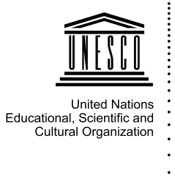
ICDE has a number of collaborative partnerships and memorandum of understandings with organizations around the world.

Consultative Status

UNESCO
ICDE is an NGO (non-governmental organization) having consultative status with UNESCO, and works together with UNESCO in the service of international cooperation and development.
This status grants ICDE’s members a voice at UNESCO, while obliging ICDE to acquaint its members with UNESCO programmes activities and achievements pertaining to open and distance education. ICDE has been formally affiliated to UNESCO since 1967.
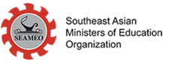
“Consultative partnership is designed to enable UNESCO to establish and maintain flexible and dynamic partnerships with any organization of civil society that is active in UNESCO’s fields of competence at whatever level, and to benefit from its expertise, the representativeness of its networks for the dissemination of information and, if appropriate, its operational capacities in the field.” (Source: UNESCO)

SEAMEO

ICDE also has a highly active membership base in Asia, and the organization is duly proud of its status as affiliate member of the Southeast Asian Ministers of Education Organization (SEAMEO), recognizing ICDE’s willingness to promote cooperation among Southeast Asian nations through education, science and culture.

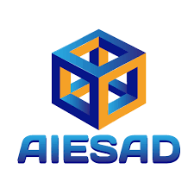
Memorandum of understanding

Asociación Iberoamericana de Educación Superior a Distancia (AIESAD)

The purpose of the AIESAD is to contribute to the academic life of the directors, professors and students of the AIESAD member universities, through various projects of democratization of relevant and quality information in Distance Higher Education (EAD), as well as the exchange of leading experiences in this area of ​​knowledge.

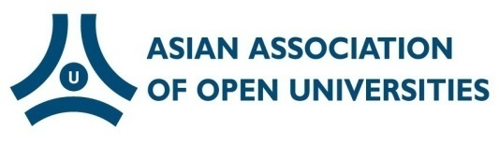
Asian Association of Open Universities (AAOU)

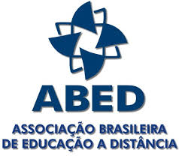
Founded in 1987, the Asian Association of Open Universities (AAOU) is a non-profit organization of higher learning institutions that are primarily concerned with open and distance education.

Brazilian Association for Distance Education (ABED)

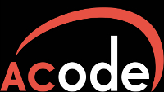
The Brazilian Association for Distance Education - ABED, is a non-profit society, which, since 1995 has promoted the diffusion of open, flexible and distance education. It was founded by a group of academics interested in distance education and new learning technologies.

Australasian Council on Open, Distance and e-Learning (ACODE)
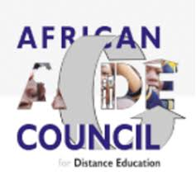
The Australasian Council on Open, Distance and e-Learning (ACODE) is the peak Australasian organisation for universities engaged or interested in technology enhanced learning and teaching.

African Council for Distance Education (ACDE)

The African Council for Distance Education (ACDE) is a continental educational organization comprising African universities and other higher education institutions, which are committed to expanding access to quality education and training through open and distance learning. The mandate of the ACDE, as a unifying body of ODL providers in Africa, is primarily to promote research, policy and quality in open and distance learning to increase access to education and training in Africa. We do this by building capacity, fostering collaboration and partnership, and advocacy.

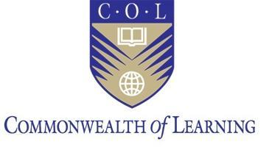
The Commonwealth of Learning (COL)

The Commonwealth of Learning (COL) is an intergovernmental organisation created by Commonwealth Heads of Government in 1987 to promote the development and sharing of open learning and distance education knowledge, resources and technologies.
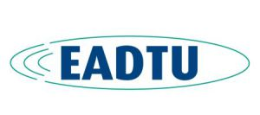

European Association of Distance Teaching Universities (EADTU)

The European Association of Distance Teaching Universities (EADTU) is Europe's leading institutional association in online, open and flexible higher education, and is at the heart of the modernisation agenda of European universities. Growing from its eleven founding members in ten European nations.
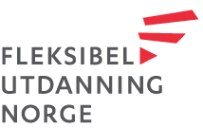
Fleksibel utdanning Norge (FuN)

FuN is an acronym for “Fleksibel utdanning Norge” which translates to “Flexible Education Norway”. FuN organizes 50 Norwegian providers of flexible education; including independent distance education institutions, public universities and colleges, private institutions and training centers for business and industry. Our members provide an extensive range of subjects, courses and study programs from primary to university level, and customized courses for professionals.
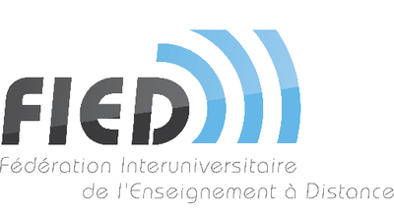

Interuniversity Federation of Distance Education (FIED)

The Interuniversity Federation of Distance Education (FIED), recognized by the French Ministry of Higher Education and Research) and ICDE have a Memorandum of Understanding on FIED supporting the representation of ICDE at the UNESCO headquarters in Paris.

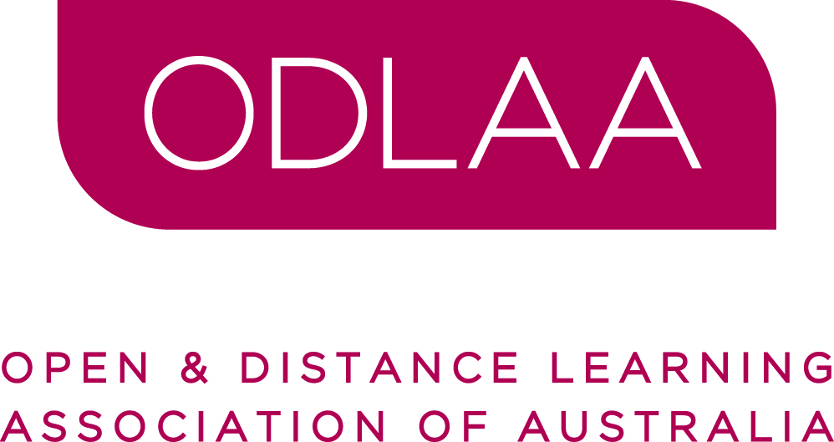
Open and Distance Learning Association of Australia (ODLAA)

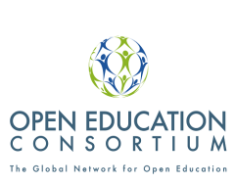
ODLAA connects professionals in order to share experiences and disseminate information with respect to open and distance learning. Our members come from all educational sectors plus commercial training providers and training units in the corporate sector. They are involved in management, administration, design, development, research and teaching in multiple modes that may best be described as ‘outside the traditional classroom’.

Open Education Consortium

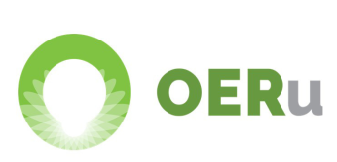
Open Education Consortium (former OpenCourseWare Consortium) is a worldwide community of hundreds of higher education institutions and associated organizations committed to advancing open education and its impact on global education. ICDE and Open Education Consortium share a Memorandum of Understanding, where the two organizations agree to collaborate with each other.

OERu

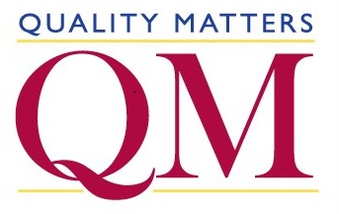
The OERu is a virtual collaboration of like-minded institutions committed to creating flexible pathways for OER learners to gain formal academic credit. The OERu aims to provide free learning opportunities to all students worldwide using OER learning materials with pathways to gain credible qualifications from recognised education institutions.

Quality Matters

Quality Matters is a nonprofit organization comprised of a dedicated staff that works together virtually—from cities all over the United States—to support everyone's quality assurance goals.

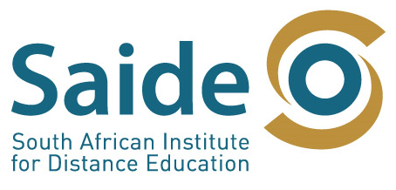
South African Institute for Distance Education (SAIDE)

Saide is committed to the process of transformation of education and training so to increase equitable and meaningful access to knowledge, skills and learning through the adoption of open learning principles, distance education methods and educational technology.


Virtually Inspired

Virtually Inspired serves as a repository for knowledge-sharing; a place where educators facing the unique opportunities and challenges of the digital age can come for inspiration. This website’s high-quality videos provide a quick and easy way to see how creative professionals around the globe are infusing learning with technology.

