FEBRUARY 1st, 2026
Welcome to another Not Boring month. Summer is definitely in it’s peak now so we would encourage you all to ensure you’re being sun smart while out and about; hats, sun cream, water bottle… particularly if you’re out in the sun. And if it’s too hot, there’s always the Not Boring Kitchen to pop down and visit… what better than an icy cold frappe on a hot day!

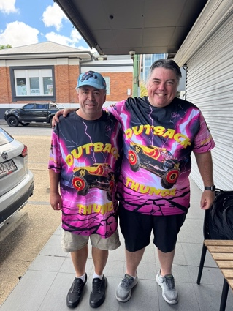
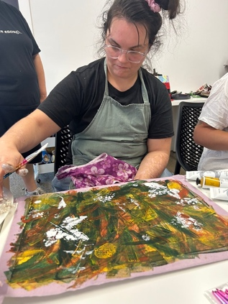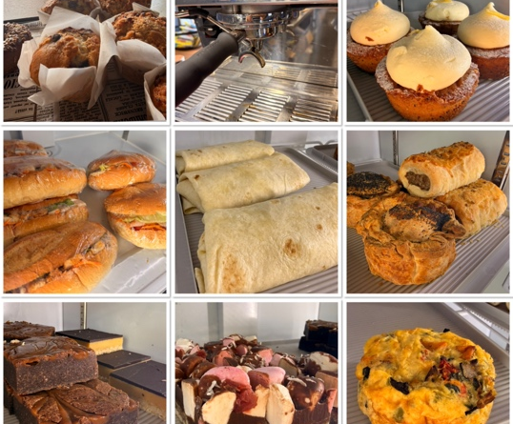

January re-cap!
January was a bit of a slow start with everyone still in holiday mode. Our office opened back up on the 5th, and all programs back up and running from the 6th… it was a little quiet to begin with, while people are still on holidays, but by the end of the month, we were back in the full swing of things. Our Cooking with Confidence program has been so successful that it turns out some of our clients have gained so much confidence and are now wanting to manage cooking at home on their own for a while – how fabulous is that?! It does mean there are a few available spaces but get in quick as they won’t last. Stay tuned for details as we are aiming for a ‘Cam’s Shout’ dinner and a few arty workshops in the coming weeks… we’ll text you details once they are locked in.
‘IF I CANNOT DO GREAT THINGS, I CAN DO SMALL THINGS IN A GREAT WAY!’

This month’s recipe… SPINACH & FETA CANNELLONI.
Ingredients: 1 cup tomato passata, 600g ricotta, 250g frozen spinach (thawed), 2 tbsp parsley & basil, ¼ cup grated parmesan, cannelloni tubes, ¾ cup tomato passata (extra), 1 cup grated mozzarella, 1/3 cup grated parmesan.
Method: Preheat oven to 190 degrees and grease an oven proof dish. Place ricotta, spinach, parsley, basil, parmesan, salt & pepper in a large bowl; mix to combine. Pour the 1 cup of passata over the base of your oven proof dish. Stuff the mixture into the cannelloni tubes (pipe in via a zip lock bag or use a spoon). Lay each stuffed tube in the dish, side by side. Spoon over the extra passata to coat the top of the tubes, then sprinkle with mozzarella & parmesan. Bake for 25 minutes or until golden. Serve with salad and enjoy.

What’s on in FEBRUARY?
Tuesday’s is Create and Connect at the hub – morning tea and craft items are supplied.
Tuesday, Wednesday & Saturdays are Cooking with Confidence classes – reach out if you’d like more info on these.
Thursday’s, we alternate Men’s Club, a Music Jam Session, & from Feb 5th, will be adding a women’s club into the mix with the first 2 sessions being lead by a local artist.
Friday afternoons are for socials – rotating between BBQ, pizza night, Mexican or Italian themed dinners. A great social afternoon, with dinner and good company.
Tuesday February 10th we’ll be having a ‘Cam’s Shout’ dinner, but trying somewhere new… North Devils Leagues Club!
Weekend group activities depend on demand – it could be just you and a support worker, or a small group of others that are keen to join in. This month we’re aiming to get to The Butterfly House on Bribie Island, a visit to City Hall to do the clock tour, a walk out at Redcliffe and a visit to the Redcliffe markets, and an afternoon of Ten Pin Bowling fun at Aspley Bowl – let us know if you’re keen on anything and we can work out the details from there!

Some activities come with a cost and others are covered by us – if you have questions, just call the office and we can discuss details with you.
We also always welcome new suggestions, so if there is somewhere you’d like to go, let us know and we’ll aim to get a group together.
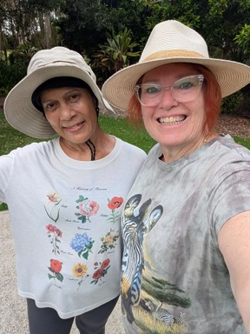
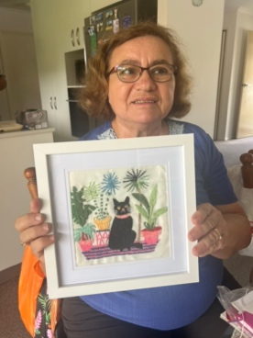
Don’t forget that you can pop down to the Not Boring Kitchen while with your supports from Tuesday – Saturday between 6am – 12pm, and if you are a client, Cam will shout you a free coffee!
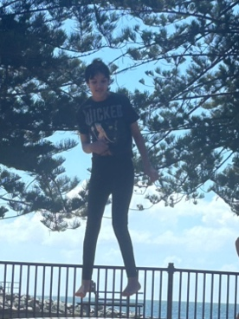
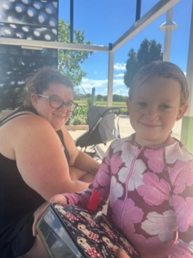

Contact us…
Web: Not Boring Website
Email: carmela@notboring.com.au
Phone: 0451 675 120

