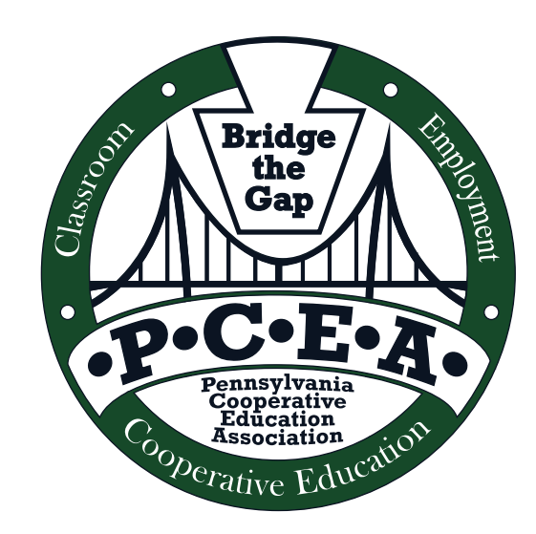

August 27, 2019

Dear Future and Current Pennsylvania Cooperative Education Association (PCEA) Members:

The PCEA Executive Committee is reaching out to clarify a point of understanding that we believe occurs in regards to membership. PCEA believe that many conference attendees are under the impression that when they attend the conference they automatically become members of PCEA. However, this is not the case. In order to become a paid member you must pay dues in the amount of twenty-five dollars, $25.00, yearly.

The PCEA Executive Board organizes the conference, which is all done voluntarily by the officers and members. The fees you pay for the conference are for the administrative costs for the use of the The Nittany Lion Inn, the use of the facilities and to PACTA for the coordination with The Nittany Lion Inn.

Your PCEA dues pay for:
- Recognition of outstanding PCEA Educator
- Scholarship Program open to students of active PCEA members
- E-mail updates
- Collective voice to PDE and PSEA
- Provide direct connections to PA and US Dept. of Labor
- Connection with Workforce Development Centers
- Free information on our website
- Networking with colleagues

Thus, we are reaching out to you in the first membership drive of the school year to confirm your membership.

Sincerely,

Amy K. DeLellis

Amy K. DeLellis
Membership Chairperson

