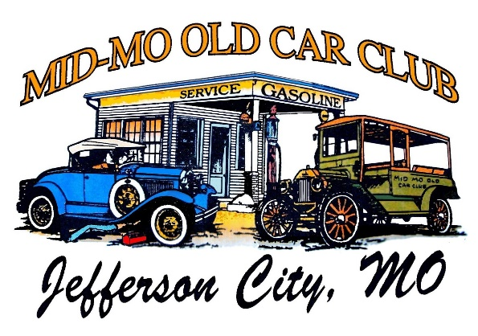
53rd Annual Old Car Round Up and Show

Pre-Registration Form – MUST BE RECEIVED BY 09/17/2022

Completing and mailing this form will help us speed up the registration process, as all paperwork will be completed and waiting for you at the registration desk.

You are still required to pay the entry fee of $20.00 cash at the gate on 09/24/2022 and must report to the pre-registration desk by 10:00 am CT for pickup of your completed packet.

Please print, complete, sign/date the waiver, and return the form to the following.

Mid-Mo Old Car Club
P.O. Box 1594
Jefferson City, MO 65102

Name(s) to be Listed on Registration: _

Address: _

City: _ State: _ Zip: _

Phone: _ E-mail: _

Entrant’s Car/Vehicle Information (separate forms should be provided for each registered vehicle):

Year: ________________ Make: ________________________ Model: ___________________________

Stock (up to 3 safety mods allowed) or Modified: _

Requested Vehicle Class Number (see Car Show Flyer for classes): _

Judged or Display Only ($5 will be returned at registration for Display Only): _

I hereby assume full and complete responsibility for any personal injury to myself or others in my party, or for any loss or damage to my automobile(s), equipment, and personal property whether by accident, vandalism, acts of God, or any other cause which may occur during my participation in this event, and hereby indemnify, release, and hold harmless from any and all claims the entity known as the Mid-Mo Old Car Club, its officers, and volunteers. By signing I agree that I have read this document in its entirety.

Entrant Signature(s): ______________________________________________ Date: _______________

