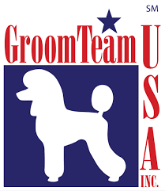
GROOMTEAM USA, Inc® CODE OF CONDUCT
The GroomTeam USA, Inc® code of conduct establishes expectations for professional behavior and actions of all GroomTeam USA, Inc® point holders. Adhering to these policies protects the reputation and perception of the groomers on an individual level as well as the entire organization.
As a member in good standing of GroomTeam USA, Inc®, I promise to:
- aspire to the highest professional standards
- treat all team members and industry professionals with respect, honesty, and kindness
- treat all pets with kindness, patience, and respect and provide for their health and safety while they are entrusted to my care
- continue to pursue education and skill development
- encourage unity among pet stylists by promoting professionalism, the highest ethical standards, education, and creativity
- exhibit conduct befitting these standards in my actions, whether it be in writing, in person, or through online communications
- discourage unprofessional behavior toward others in my industry community
- Adhere to the Standards of Conduct and Sportsmanship Rules

I understand that failure to adhere to the Code of Conduct may result in the elimination of honors and privileges awarded by GroomTeam USA,Inc®.

Signature |  | Date

