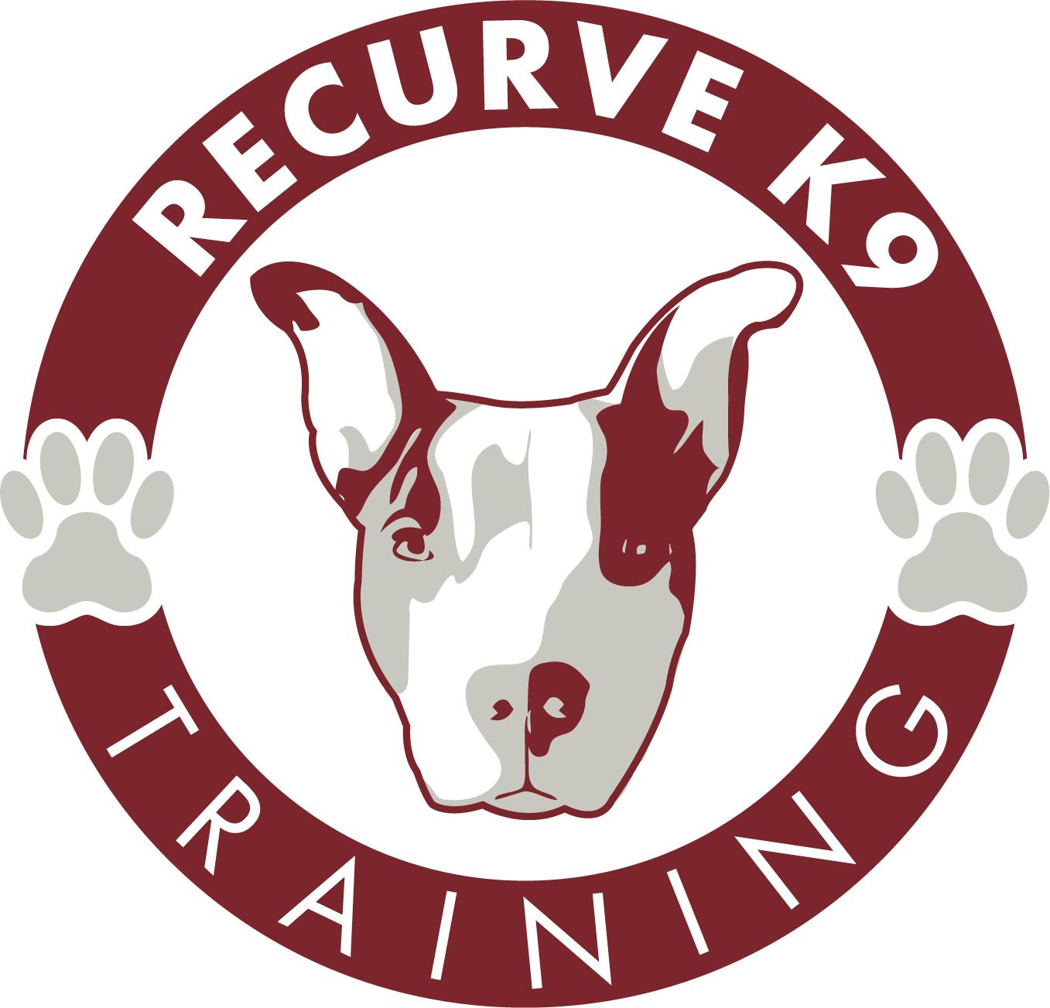

Recurve K9 LLC
Daycare/ Boarding/ Training/ Group Activities
Agreement and Release of Liability

For myself, my heirs and any assigns, I hereby release Recurve K9 LLC, its owners, agents, officers, subcontractors, employees, animal parents, volunteers, customers, heirs, assigns and potential customers of Recurve K9 LLC from any and all liabilities that result in the loss of my dog, any and all injuries to myself, my dog, or any other property of mine which arises in any way out of services and / or products provided by or as a consequence of my association with Recurve K9 LLC. I acknowledge and understand that every dog reacts differently and that animals, by nature, are unpredictable.

PLEASE READ EACH PAGE BELOW:
Dogs and animals may, without warning, bite or cause injury to humans and other dogs. I acknowledge and understand that there are certain risks involved in participating in the Daycare, Boarding, Group Activities, Group Class, Private Training, Bathing and Nail Trim/Dremel including but not limited to slipping, falling, dog fights, dog bites to humans and other dogs, illness, death, cuts, scrapes, theft, collisions with other vehicles, natural disasters, and the transmission of disease. I hereby assume all risks related to Recurve K9 LLC in its entirety.
In the case of emergency or for the use of pet taxi services, I recognize the risk of injury that accompany said transportation and acknowledge that this RELEASE is being relied upon Recurve K9 LLC to permit transport of my pet to and from Recurve K9 LLC or any other necessary location. Furthermore, I accept any and all conditions, rules, and regulations promulgated by Recurve K9 LLC, associated with the activities, use of the facility and transport, and hereby agree to comply with them.
I agree to indemnify, at my sole expense, Recurve K9 LLC, its owners, agents, officers, subcontractors, employees, animal parents, volunteers, customers, heirs, assigns and potential customers of Recurve K9 LLC from any and all losses, liability, damages, injury, or costs to my pet, myself, and any person who accompanies me onto the Recurve K9 LLC premises that may incur due to my presence or the presence of my pet in or upon Recurve K9 LLC, premises and while my pet(s) is under the care of Recurve K9 LLC.
The undersigned for and in consideration of the Daycare, Boarding, Group Activities, Group Class, Private Training, Bathing and Nail Trim/Dremel services at Recurve K9 LLC: agrees to save and hold harmless Recurve K9 LLC and its owners, operators, employees, officers, volunteers, and directors from any damage, loss or claims, accidental death of pet of the nature of pre-existing health condition, stress or natural disasters (Fire, Storm, Floods, Etc.).
The undersigned for and in consideration of the Daycare, Boarding, Group Activities, Group Class, Private Training, Bathing and Nail Trim/Dremel services at Recurve K9 LLC will not be held responsible for clipper burns and / or minor nicks, cuts, scratches, bites resulting from bathing matted, neglected coats or for irritation caused by bathing coats from pets possessing mild to severe skin allergy, nor will we be held responsible for stressful effects bathing may have upon your pet, whether they be young or elderly.
Dogs not familiar with Recurve K9 LLC may experience brief separation anxiety when apart from their human companions. Dogs not regularly exposed to the level of activity at Recurve K9 LLC may feel the discomfort of sore muscles, sore joints, and fatigue.
Dogs not regularly socialized do not necessarily know how to behave politely with other dogs. These dogs are a higher risk of incidents including, but not limited to bites, fights, fear aggression, object guarding, behavior problems and or / acting out.
Dogs at play during the regular Group Activities/Daycare/Boarding do get dirty and stinky. Dogs with longer hair can get matted from the level of activity at the Group Activities/Daycare/Boarding. Baths can be requested and scheduled.
Excessively long toenails may cause injury. You will be notified if your dog’s toenails are too long. If, at your next visit, the nails have not been trimmed, Recurve K9 LLC will have them trimmed at owner’s expense.
I understand the extra risks my puppy has of contracting disease or illness by entering the Group Activities/ Group Classes/ Daycare program without being fully vaccinated.
Water is available at all times: however, your dog may still be thirsty after Group Activities/ Group Classes/ Daycare. Be aware that if their water intake is in excessive amounts it may cause stomach upset or other problems.
-Dramatic changes in food and / or food quality may cause upset stomach, diarrhea, and / or colitis.
-Any behavior deemed dangerous or inappropriate by Recurve K9 LLC may result in dismissal from the program and there will be NO REFUND.
I agree to pay for all services due at the time they are rendered / and or prepaid package. All Non – sufficient fund checks for boarding and or daycare will be assessed a $40.00 handling fee.
I understand and agree that in admitting my dog (s) into Recurve K9 LLC, Recurve K9 LLC has relied on my representation that my dog (s) have not harmed or shown aggressive or threatening behavior towards any person or any other dog.

I certify that my dog (s) is / are in good health and has / have not been ill with any communicable disease within the last 30 days.
I have read and understand Recurve K9 LLC “Terms and Conditions” and “Policies and Procedures” and agree to abide by them.
I understand Recurve K9 LLC staff gives all pets involved in any type of incident a cursory examination, however, Recurve K9 LLC is not liable for the location, treatment or diagnosis of any injuries incurred on the premises. I understand that it is recommended that I check my dog further or seek treatment for my pet by a licensed veterinarian at my discretion and cost.
I understand that should a medical emergency arise for my dog (s) while in the care of Recurve K9 LLC and / or its selected agents will make every effort to contact us or our emergency contact by phone, should we not be available than Recurve K9 LLC and / or its agents will seek veterinarian services of their choosing.

I grant Recurve K9 LLC and/ or its selected agents full power of decision concerning the care and well being of my/our dog (s). Should any medical emergency arise, it is agreed that Recurve K9 LLC or its selected agents can and will make any needed decision concerning temporary medical treatment and choice of caregiver.
This agreement shall be governed by, and construed in accordance with, the laws of the State of Massachusetts.
This agreement contains the entire understanding between the parties and supersedes any prior understandings and agreements between them concerning the within subject matter. There are no representations, agreements, arrangements or understandings, oral or written, between the parties hereto relating to the subject matter of this Agreement which are not described herein.
I understand that during group activities/daycare/boarding, my dog may be exposed to dirt, mud, snow, water or other naturally occurring elements and may not return home as clean as they were to begin with. Recurve K9 LLC may not be held responsible for any cleaning/bathing/grooming my dog may require after group activities/daycare/boarding.
Recurve K9 LLC will be notified of any claims by owner regarding compensation for medical attention given as a result of alleged negligence on Recurve K9 LLC, part within 24 hours. I agree that if I do not notify Recurve K9 LLC within 24 hours that I will not be reimbursed or compensated. In the event Recurve K9 LLC disputes the owner's claim, Recurve K9 LLC will personally consult the attending veterinarian prior to settling any claim. However, this section in no way obligates Recurve K9 LLC to reimburse me for any such claim.

Should either party bring legal suit or action to enforce any provisions, or terms of this contract, the prevailing party shall be entitled to recover from the other party such sum as the court may adjudge as reasonable attorney’s fees and cost of trial or on appeal of such legal suit or action.

I agree that should a court determine that any provisions waiving liability is deemed unenforceable,
Recurve K9 LLC liability shall be limited to funds paid by me, for my pet(s) or for my usage of Recurve K9 LLC. This amount is accepted by me as satisfactory liquidated damages and will satisfy any legal suit or action I may have against Recurve K9 LLC, its owners, agents, officers, subcontractors, employees, animal parents, volunteers, customers, heirs, assigns and or potential customers.
This Agreement is intended to be performed in accordance with, and only to the extent permitted by all applicable laws, ordinances, rules and regulations of the State Of Massachusetts. If any provisions of this Agreement or its application to any person or circumstances shall, for any reason and to any extent, be found to be invalid or unenforceable, the reminder of this Agreement or the application of such provision to other persons or circumstances shall not be affected thereby, but rather shall be enforced to the greatest extent permitted by law.

All parties, by signing below, certify that any necessary corporate authority and principal authority has been obtained prior to entering into this agreement.
THIS Agreement may be executed in counterpart, by E-mail or by facsimile, copy or electronic signature and shall be binding as if executed in person on the same original document.
With my signature below, I accept exclusive and sole responsibility for these and all other risks and release Recurve K9 LLC of all liability, no matter the cause.
I ACKNOWLEDGE THAT, BEFORE SIGNING THIS AGREEMENT, I WAS GIVEN AN ADEQUATE OPPORTUNITY TO READ IT, EVALUATE IT AND UNDERSTAND IT. I ALSO ACKNOWLEDGE THAT I WAS ADVISED TO SEEK ADVICE FROM AN ATTORNEY, IF I SO DESIRED.

__________________________________________________________
Owners Signature Date

__________________________________________________________
Print Signature Date

