Emerald Lake Regional Park Meeting  
Tuesday, January 18, 2022 @ 5:00 p.m.  
Special Meeting Minutes

Call to Order Special Meeting – January 18, 2022 @ 5:00 p.m.

Proposal for 2022 Wages for Park Manager and Staff presented by Darcy Van Meter.

* Motion: To accept the 2022 wages for Park Manager and Staff as presented. Lee/Faye. Carried.

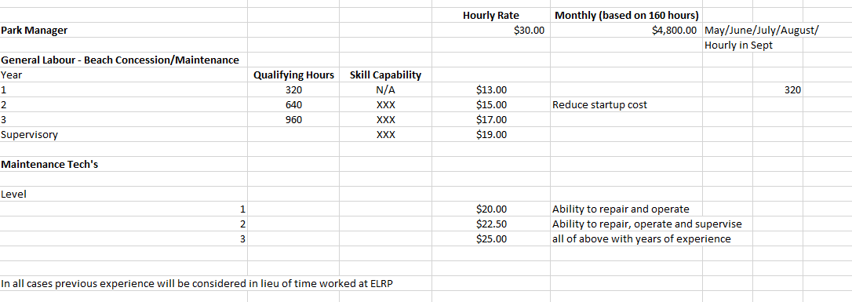

Motion: To start paying the Park Manager hourly immediately to start winter duties. The Park Manager will be paid monthly for submitted off-season hours. Faye/Lee. Carried.

Darcy Van Meter has removed himself from the meeting at 5:18 p.m.

Motion: To hire Damen Van Meter as 2022 Parker Manager. Faye/Lee. Carried.

Meeting Adjourned.