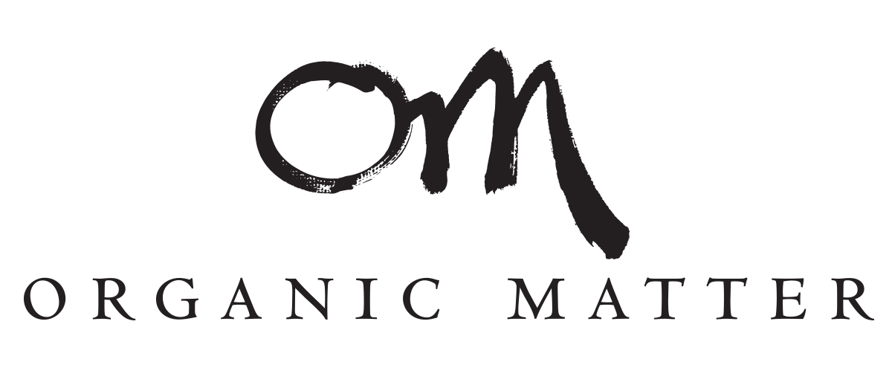
Organic Matter Frequently Asked Questions, How To and Ingredients Lists.
Our story:
Finally Organic Hair Care That Performs!
We were challenged with the impossible - organic and performance, from the same bottle.
Most hair care companies do one of these right – but few do both of these really well.
It took a lot of dedication, but fueled by our beliefs and a lot of passion, we found a way to remove unwanted, toxic ingredients like sulfates, phthalates, parabens, and synthetic fragrances while delivering professional results.
We also wanted to keep it simple.
Organic Matter is made with Organic ingredients and zero toxins. It is free of all harmful ingredients that you’ve come to expect in hair care. It is color safe for all hair types and is gentle on the scalp (and skin). Our blends of pure, 100% Organic essential oils complete the mix with gentle and beautiful smells that are safe for the whole family.
If you value performance but will settle for nothing less than completely clean, Organic Matter is your “Go-To” brand. Customize one of our shampoo’s and conditioners for your hair type and finish with one of our styling aids. Finally, keep our Hand and Body lotion close because you never know when your skin will need a moisture boost throughout the day.
One Brand is All You Need. And oh yeah, you can feel good about it too! Simple.
FAQ’s
- How does Organic Matter Perform?
Simple – like main stream professional hair care. Organic Matter was created by scientists passionate about performance.
What’s Important – Organic Matter includes zero harmful toxins and therefore doesn’t clean and condition the hair by stripping it. It replaces any oils (sebaceous oils for example) that is removed through the cleaning and conditioning process. Organic Matter is founded on the belief that everyone’s hair needs some nourishment while ensuring hair is not harmed during this process.
- How ‘Clean’ is Organic Matter?
Simple – it is made with the finest Organic ingredients possible. There are NO toxins or chemicals. And it is preserved with a natural preservation system that is also free of toxins and from 100% natural sources. Organic Matter is scented with a special blend of Organic Essential Oils, no synthetics, period. All of our ingredients are sources from plants or vegetable.
Organic Matter is free of:
PARABENS, SULFATES, SILICONES, PHTHALATES, PROPYLENE GLYCOL, PVP’S, PETRO-CHEMICALS, MEA/TEA/DEA’S, SYNTHETIC FRAGRANCES, COLOURS/FILLERS.

Organic Matter is:
- Made with Organic Ingredients.
- PH Balanced.
- Cruelty Free.
- Vegan.
- Color Safe.
- GMO Free.
- Gluten Free.
- Packaged with Type 2 recyclable packaging.
- Family Safe.

- What is the source of Organic Matter ingredients?
Organic Matter uses Organic ingredients sources from either plants/botanicals or vegetables. Our essential oils are organic. Our products are preserved with a vegan-based preservation system that contains zero toxins, supplemented by our Organic Essential Oils that also boost the preservative power of our products. Also, our essential oils are excellent sources of antioxidants and anti-inflammatories.

- What is the shelf life of Organic Matter?
Our shelf like is a minimum of two years, supplemented by our Organic essential oils that also provide excellent preservation power.
- How do you store Organic Matter?
  - Organic Matter should be stored at a cooler room temperature away from direct sunlight. Although the packaging protects the product, direct sun light for prolonged period of time will affect product performance.
- Is Organic Matter colour safe?
Yes all of our hair care products are colour safe. They will not strip or degrade colored hair. Shelter Leave In Protector will boost colour, highlighting your hairs natural colour.

- Is Organic Matter the cleanest products in Canada?
It is absolutely the cleanest product in Canada that performs.

- Ingredients Cheat Sheet:
What is?
  - Hydroxypropyl Guar hydroxypropyltrimonium chloride is an organic compound that is a water-soluble derivative of guar gum.
  - Myristic Acid is an organic acid which is an organic fatty acid.
  - Cetearyl Alcohol is a blend of Cetyl and Stearyl long chain organic alcohols that come from 100% vegetable and plant sources and is not synthesized.
  - XX
  - YY

HOW-TO
- How To Use Organic Matter:
  - Shampoos & Conditioners:
    - Level 1 – Perfect for Normal hair in need of a daily confidence boost; organic ingredients used to stabilize and balance your hair.
    - Level 2 – Perfect for dry/damaged hair in desperate need of moisture; moisture hit that repairs and re-balances your hair.
    - Level 3 – Weak over-stressed hair in need of a resurrection; organic nutrition for hair punished by toxins, heat, colour and the elements. Like a fitness regiment, get your hair back into shape.
Daily Use:
      - Dispense a dollop size of Organic Matter into palm.
      - Break down well into the hand.
      - Shampoo & Rinse.
      - Repeat
  - Shelter Leave In Protector – Perfect for blow dry and iron protection, weightless styling and anti frizz; apply after your Organic Matter Shampoo & Conditioner, wet or dry.

Daily Use
      - Dispense a dollop size of Organic Matter into palm.
      - Mix in the hand.
      - Wisp through the hair and leave; dry if necessary.
      - Voila – your daily protection is complete.

  - Paste – Matte Finish Manipulator – Perfect for exploring multiple personalities; whether you are looking great hold, finishing your fopock or manipulating your hair into any shape, our Paste performs perfectly to create a Matte finish.

Daily Use
      - Dispense a dollop size of Paste into the hand.
      - Mix in the hand.
      - Manipulate your hair.
      - For more hold, use more Paste.
      - Paste can be re-activated with water to re-shape your hair on the fly.

  - Hand & Body Lotion – Perfect for skin that craves weightless moisture; Hand and Body Lotion with Hair Care? It made sense for one reason – you asked for it? Make our hand and body lotion your go-to place for moisturizing on the fly or at home. Moisture penetrates your skin effortlessly and leaves behind nothing but soft and silky skin.

Daily Use
      - Dispense a dollop size of Organic Matter into palm.
      - Mix in the hand and apply to the body as required.
      - For more moisture, use more lotion.
      - Dry’s quickly with no greasy residue left behind.
      - Repeat as often as you like. Keep multiple bottles in important places.

- Organic Matter is free of:
PARABENS, SULFATES, SILICONES, PHTHALATES, PROPYLENE GLYCOL, PVP’S, PETRO-CHEMICALS, MEA/TEA/DEA’S, SYNTHETIC FRAGRANCES, COLOURS/FILLERS.

- Claims:
  - Made with Organic Ingredients:
  - PH Balanced:
  - Cruelty Free
  - Vegan
  - Color Safe
  - GMO Free
  - Gluten Free
  - Recyclable Packaging

Ingredients Lists:
Shampoo level 1, 2, 3

Water (Aqua), Decyl Glucoside, Myristic acid, Hydroxypropyl Guar Hydroxypropyltrimonium Chloride, Organic Coconut (Cocos Nucifera) Oil, Organic Grape (Vitis Vinifera) Seed Oil, Glycerine, Pro-Vitamin B5 (Panthenol), Sodium Citrate, Organic Essential Oil Blend (prunus amygdalus dulcis,vanilla planifolia, prunus dulcis, citrus medica limonum, rosmarinus officinalis, cananga odorata, citrus bergamia,citrus sinensis, citrus grandis, prunus avium kernel), Glucose & Glucose Oxidase & Lactoperoxidase.

Conditioner 1,2,3

Water (Aqua), Cetearyl Alcohol, Myristic Acid, Glycerine,1-Dodecanol, Organic Olive Oil (Olea Europaea) or Organic Grape (Vitis Vinifera) Seed Oil, Organic Coconut (Cocos Nucifera) Oil, Sodium Citrate, Organic Essential Oil Blend (prunus amygdalus dulcis,vanilla planifolia, prunus dulcis, citrus medica limonum, rosmarinus officinalis, cananga odorata, citrus bergamia,citrus sinensis, citrus grandis, prunus avium kernel), Glucose & Glucose Oxidase & Lactoperoxidase.

Leave In Conditioner

Water (Aqua), Myristic Acid, Olive Squalane, Coconut (Cocos Nucifera) Oil, Hydroxypropyl Guar Hydroxypropyltrimonium Chloride, Sodium Citrate, Organic Essential Oil Blend (prunus amygdalus dulcis,vanilla planifolia, prunus dulcis, citrus medica limonum, rosmarinus officinalis, cananga odorata, citrus bergamia,citrus sinensis, ctrus grandis, prunus avium kernel), Glucose & Glucose Oxidase & Lactoperoxidase.

Hair Paste/Wax

Water (Aqua),Euphorbia Cerifera (Candelilla) Wax, Polysorbate 85, Cetearyl Alcohol, Dicetyl Phosphate, Organic Olive Oil (Olea Europaea), Organic Essential Oil Blend (prunus amygdalus dulcis,vanilla planifolia, prunus dulcis, citrus medica limonum, rosmarinus officinalis, cananga odorata, citrus bergamia,citrus sinensis, ctrus grandis, prunus avium kernel), Glucose & Glucose Oxidase & Lactoperoxidase.

Hand & Body Lotion

Water (Aqua), Organic herbal blend of Aloe Barbadensis Leaf Juice (Aloe Vera), Organic herbal Blend of Calendula Officinalis (Marigold) and Matricaria Recutita (Chamomile Flowers), Coconut Fatty Acid, Liposomes, Organic Sunflower (Helianthus Annuus) Seed Oil, Organic Citrus Grandis (Grapefruit) Seed Extract, Organic Rosmarinus Officinalis (Rosemary) Leaf Extract, Organic Meadowfoam Seed Oil (Limnanthes Alba), Organic Avocado (Persea Gratissima) Oil, Organic Macadamia (Macadamia Ternifolia) Seed Oil, Ceratonia Siliqua (Locust Bean) Gum, Shea Butter (Butyrospermum Parkii), Organic Aloe Barbadensis Leaf Juice (Aloe Vera), Organic Theobroma Cacao (Cocoa) Seed Butter, Organic Citrus Limonum (Lemon Peel) and Organic Lippia citriodora (Verbena) Oil, Glucose & Glucose Oxidase & Lactoperoxidase.
Organic Matter Essential Oil Blend:

