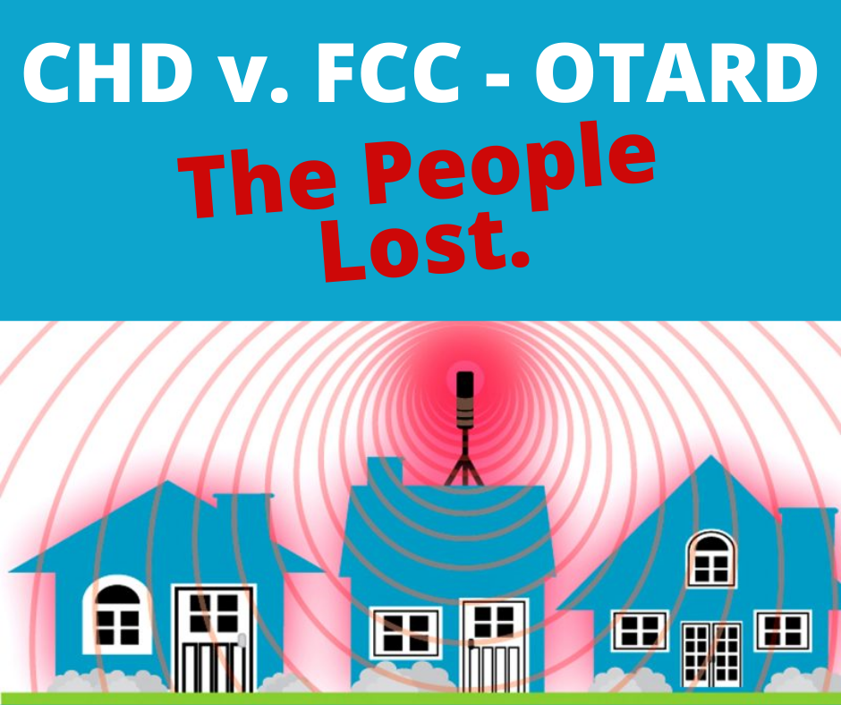

LEMONT CELL TOWER ALERT #1
May 8, 2022

College Township Council Public Hearing on
Wireless Communications Facilities Ordinance
Please Attend on July 21, 2022
College Township Bldg, 2nd floor Meeting Room, 7 pm

SMALL CELL TOWERS & 5G HARM US

The last time we in Lemont faced the threat of a cell phone tower was in 2016 when Verizon applied for a permit to build a tower on Cortland Drive. Though our Township lost the battle after a two year standoff, Verizon never picked up its permit. The tower was never built.

Verizon and other telecoms could soon be back with applications for hundreds of “small cell towers”, placed up and down our streets in close proximity to our homes and yards. “Small cells” broadcast high frequency Electromagnetic Microwave Radiation into our yards, through our walls, and along the street as we walk.

On August 13, 2021 the Environmental Health Trust won a significant victory against the FCC in the Washington D.C. Federal District Court. It added to the legal record thousands of studies in 26 volumes showing the harms caused by RF-EMR (Radio Frequency Electromagnetic Microwave Radiation).
PRSRT STD
ECRWSS
U.S. POSTAGE
PAID
EDDM RETAIL

Local
Postal Customer

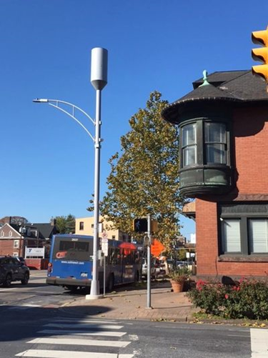
College Township, along with municipalities throughout the country, are being forced to accommodate these hazardous wireless facilities due to heavy lobby pressure by telecoms, first with the FCC and then through almost identical legislation introduced in state legislatures throughout the country. With only 3 dissenting votes, the PA Assembly passed its own law, Act 50, in only 9 days – without allowing any testimony from citizens or experts other than telecoms, in violation of the PA Sunshine Law.

The FCC order, Act 50, and by extension the Township’s Draft Wireless Communications Facilities Ordinance do not protect the health, safety, and welfare of residents in our homes and neighborhoods.

THE OTARD RULE MAKES THINGS WORSE

OTARD is the FCC designation for Over The Air Reception Devices. The Rule was used to protect the rights of owners and tenants to install and use devices to receive broadcast signals from satellites and radio and television broadcasters. Satellite dishes and antennas are examples of these.

Recently the FCC updated this rule to allow these devices to transmit as well – that is, to have all the properties of a cell tower or small cell. This permits an end run around regulations and limitations because placement on private property represents a contract between the homeowner and the installer.

Such installations create a legal nuisance for homeowners who do not want to be bombarded by yet another set of RF-EMR banging through their walls and into their yards. Such nuisances create the grounds for discord and legal nuisance suits.

WIRELESS DEVICES & TWO CASES OF HARMS

Pennsylvanians for Safe Technology estimates that 640,000 Pennsylvanians suffer from EMS – Electro Magnetic Sensitivity – arising from the proliferation of wireless devices: cell phones, routers, laptops, I-pads, baby monitors, Alexa and associated wireless consumer devices, Blue Tooth hearing aids, Fitbit watches, wifi television screens, smart appliances and utility smart meters for electricity, water, and gas.

From her electric smart meter, Lexi, a veterinary radiologist and mother, suffered: muscle and abdominal pain, headaches, insomnia, memory loss, cognitive impairment, mood alterations; cardiac arrhythmias; and impaired ability to function. Remediation of their home to reduce RF-EMR cost over $30,000.

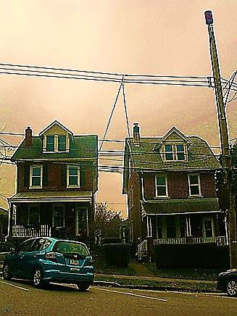
In Conshohocken (left), one telecom used Act 50, signed into law on June 30, 2021, to install an antenna 39 feet from the residence on the left. Homeowners did not learn about this permit until after Thanksgiving, when the installation was imminent. The antenna was activated on December 9, 2021 and now strongly irradiates nearby residents at levels known to be biologically harmful. At 1 foot from the antenna, the power density (or intensity) would be 100 times the FCC’s safety guidelines (It’s a 4G tower).

KEY SOURCES OF INFORMATION ABOUT RF-EMR
Pennsylvanians for Safe Technology:
https://pasafetech.org/cell-towers

PO Box 24, Lemont, PA 16851
Email: CTOrdinance@gmail.com

July 21, 7 pm: Put date in your calendar for Public Hearing on Wireless Communications Facilities Ordinance. Send someone from your household. This is a really big deal.

