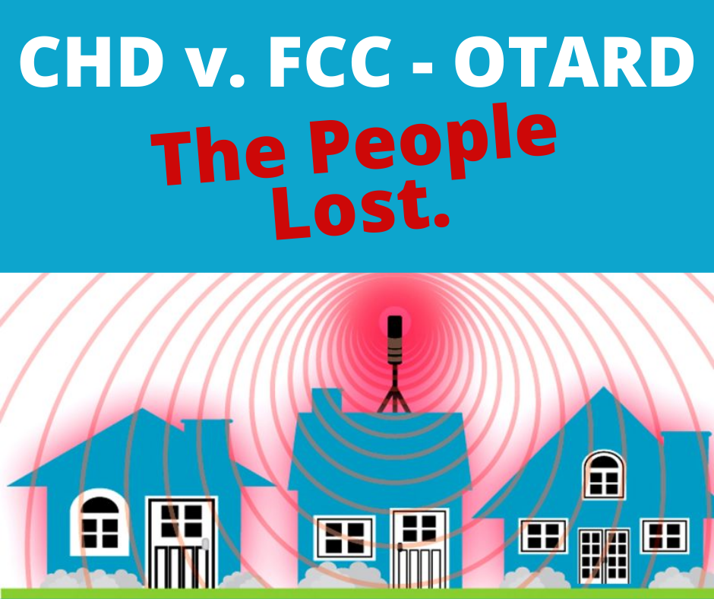

LEMONT CELL TOWER ALERT #2
June 15, 2022

CELL TOWERS, SMALL CELLS and AFIB

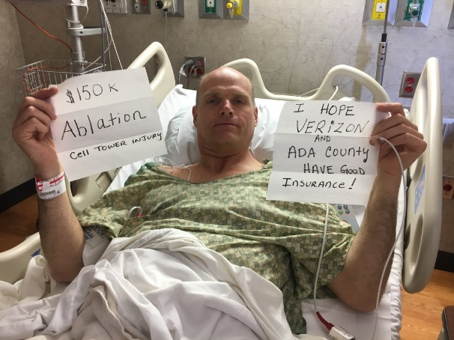
Within a week of Verizon switching on a cell tower in Eagle, Idaho on April 2021 Hank Allen went to the ER with his first bout of debilitating atrial fibrillation. His heart rate was 145 bpm. After suffering his 17th bout, he underwent ablation surgery ($150k).

By keeping track of where and when his A-fib episodes occurred and mapping these, he was able to conclude that the A-fib episodes occurred at specific times of the day, and at the intersect of where he was during the attack and a straight line between a specific cell tower and a specific small cell, which were communicating with each other (see his map next column).
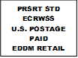

Local
Postal Customer

Hank reached out to fellow residents in Eagle and determined that others had similar time and place experiences.

Hank also noticed his bees died. The population of Eagle, Idaho is just under 20,000. College Twp’s is just over 10,000.
Hank’s AFib episodes are one of many symptoms consequent to our exposure to the proliferation of devices emitting RF-EMR (Radio Frequency Electromagnetic Microwave Radiation). These include cell and smart phones, “smart” electric and utility meters, routers, laptops, baby monitors, televisions, Fitbit watches, Alexa and increasingly the vehicles we drive.

These devices transmit and receive pulse-modulated and spiked information signals on top of a carrier wave. The pathogenic effect resides in the spiked signals, which are like continuous pin pricks on our bodies.
PITTSFIELD, MA BOARD OF HEALTH vs VERIZON

After two years of listening to and investigating complaints from the ill effects residents experienced living near a cell tower, the Board of Health of Pittsfield, Massachusetts (population 41,000) issued a Cease and Desist Order on April 11th to Verizon Wireless.

From this Order we read that “The negative health symptoms the affected residents have reported include complaints of headaches, sleep problems, heart palpitations, tinnitus, (ringing in the ears), dizziness, nausea, skin rashes, and memory and cognitive problems, among other medical complaints.” Children were vomiting in buckets put by their beds at night.

In response, Verizon sued the Board of Health. On June 1, the Board of Health, lacking the money itself, and unable to secure funding from the City Council, withdrew its Cease and Desist Order. Verizon then withdrew the suit.

What both examples show is the wisdom of that old adage: an ounce of prevention is worth a pound of cure.

NH COMMISSION REPORT ON 5G TECHNOLOGY

By contrast the New Hampshire Legislature created a commission to study 5G health effects. Thirteen months later they issued their report containing 15 recommendations to reduce public exposure to wireless radiation including moving forward with deploying fiber-optic cable connectivity rather than 5G.

To protect residents from RF-EMR damage, the Commission recommended increasing the distances for cell towers from 200 feet to 1,500 feet, close to the 500 meters recommended by a key Brazilian study on cancer and distance from cell towers. This distance has been taken up by several municipalities across the country. Here is the graph from that study:

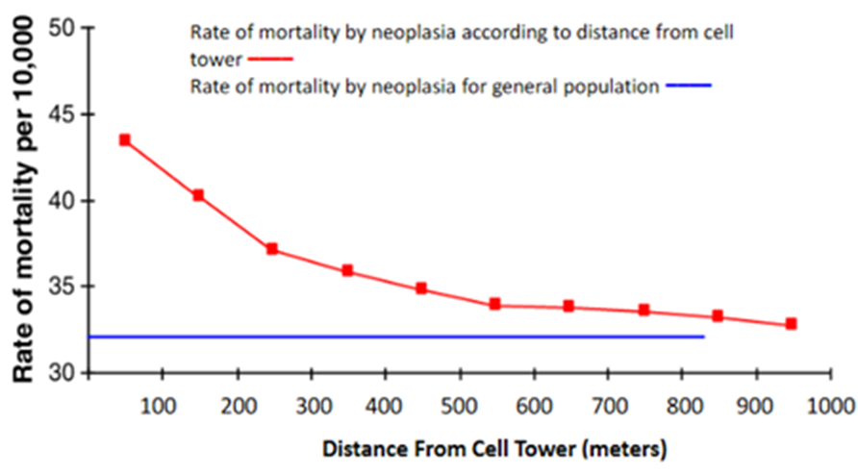

KEY SOURCES OF INFORMATION ABOUT RF-EMR
Pennsylvanians for Safe Technology:
https://pasafetech.org/cell-towers

PO Box 24, Lemont, PA 16851
Email: CTOrdinance@gmail.com

Alert #3 will focus on the Draft College Township
Ordinance

July 21, 7 pm: Put date in your calendar for Public Hearing on Wireless Communications Facilities Ordinance. Send someone from your household. This is a really big deal.

https://idahoansforsafetechnology.org/5g-cell-tower-in-eagle-causes-life-threatening-injure/ . His analysis of A-fib episode data starts at ~ 11:00 minutes.
https://ehtrust.org/key-issues/cell-phoneswireless/5g-internet-everything/20-quick-facts-what-you-need-to-know-about-5g-wireless-and-small-cells/ .
https://ehtrust.org/wp-content/uploads/Pittsfield-Health-Board-Cell-Tower-Order-to-Verizon-April-11-2022-FINAL-REDACTED.pdf
http://emfsafetynetwork.org/landmark-5g-study-by-new-hampshire-legislative-commission-recommends-reducing-wireless-exposure/

