KEYSTONE ROD & GUN CLUB OF HANNASTOWN
MERCHANDISE ORDER FORM
112 McGrath Ln. • PO Box 127 • Hannastown, PA 15635 • (724) 836-3536
keystonerodandgunclub@gmail.com • www.krghannastown.com
Name: ________________________ Phone: ________________________ Date: _________________
Item | Price | Color | Size | Qty | Total | Notes
T-Shirt w/ Pocket | $20
T-Shirt No Pocket | $20
Long Sleeve T-Shirt | $25
Large Logo T-Shirt | $20
Hoodie | $35
Orange Camo Hat | $20
Solid Orange Hat | $20
Custom Engraved Knife | $40

Subtotal: ______________________ XXL or larger Fee (+$5 each): __________________ GRAND TOTAL: __________________
Note: XXL and larger sizes are $5 additional per item. Orders processed upon payment receipt. All items are custom made. Please allow time to order the materials and design your items.
Colors Available: Black, Charcoal, Graphite Heather, Navy, Orange, Red, Royal, Safety Green, Sport Gray and White
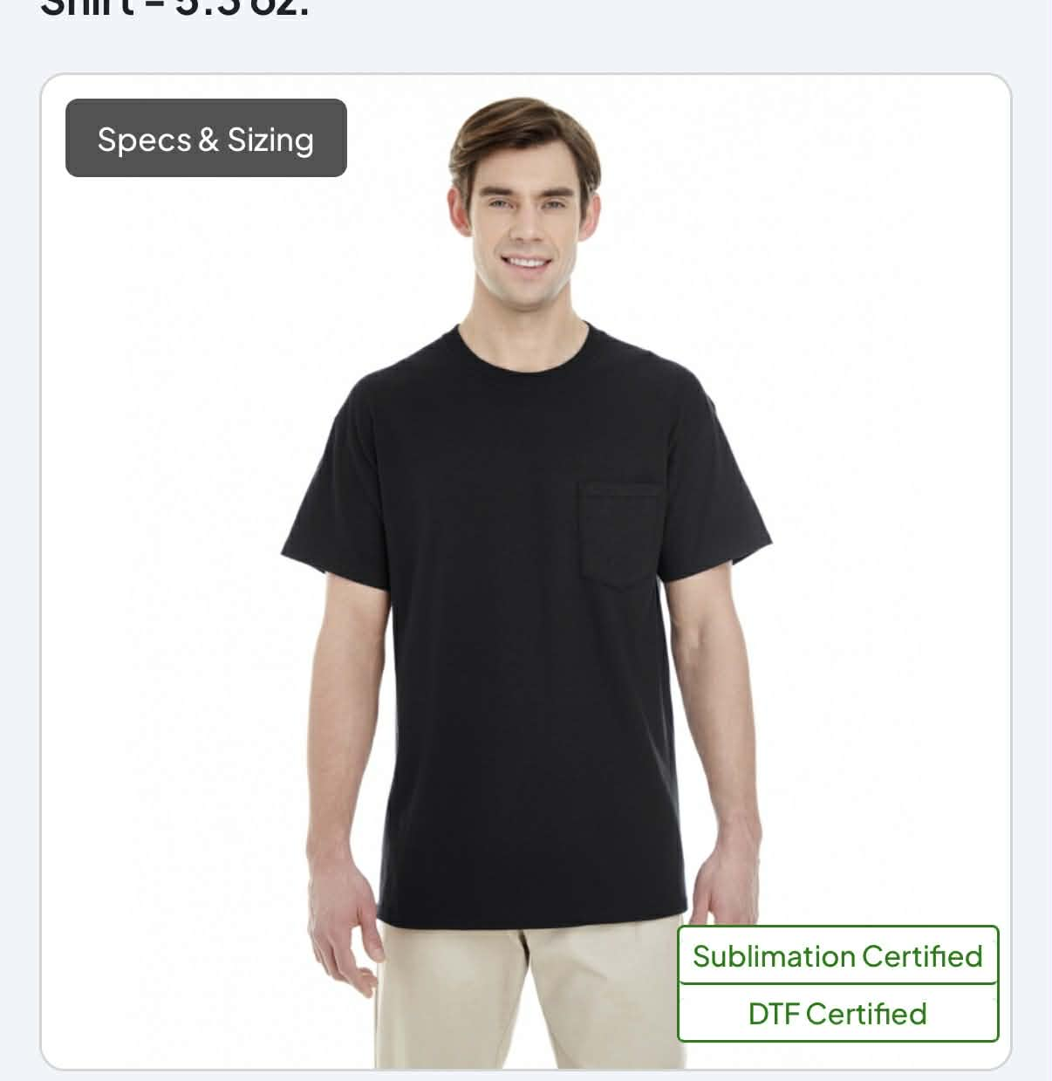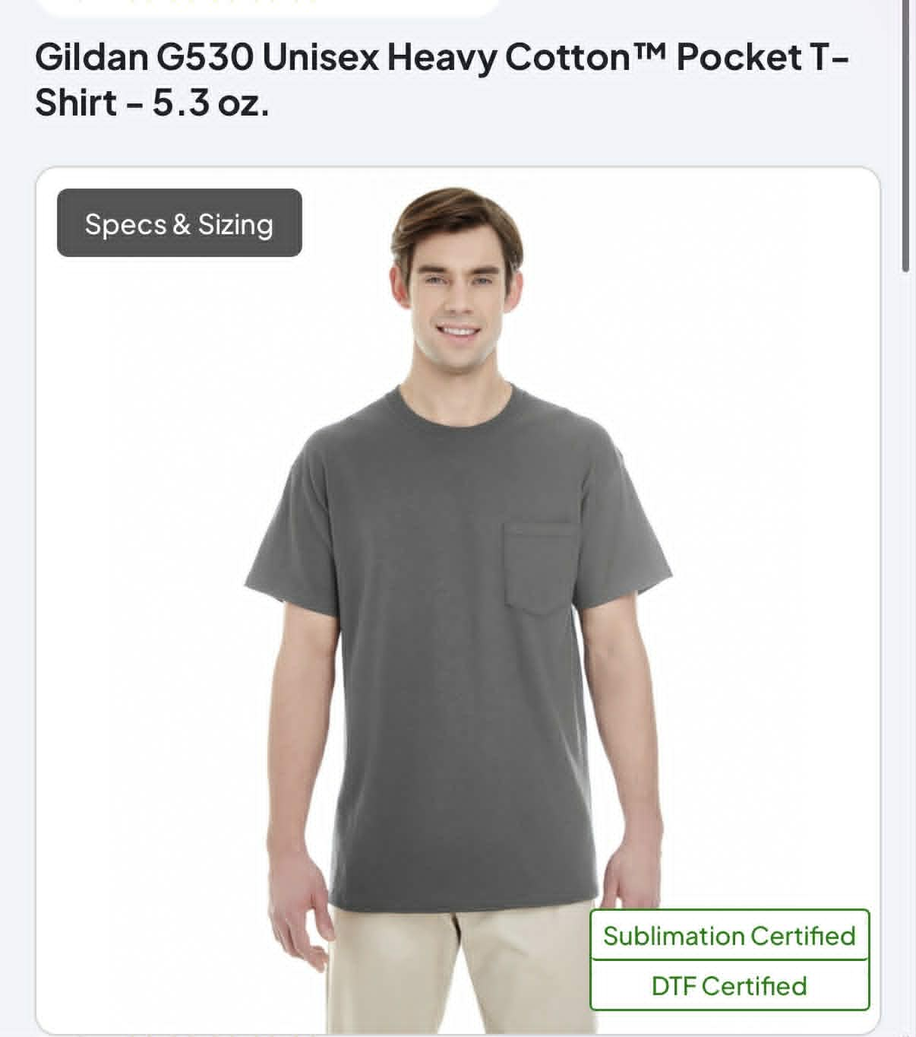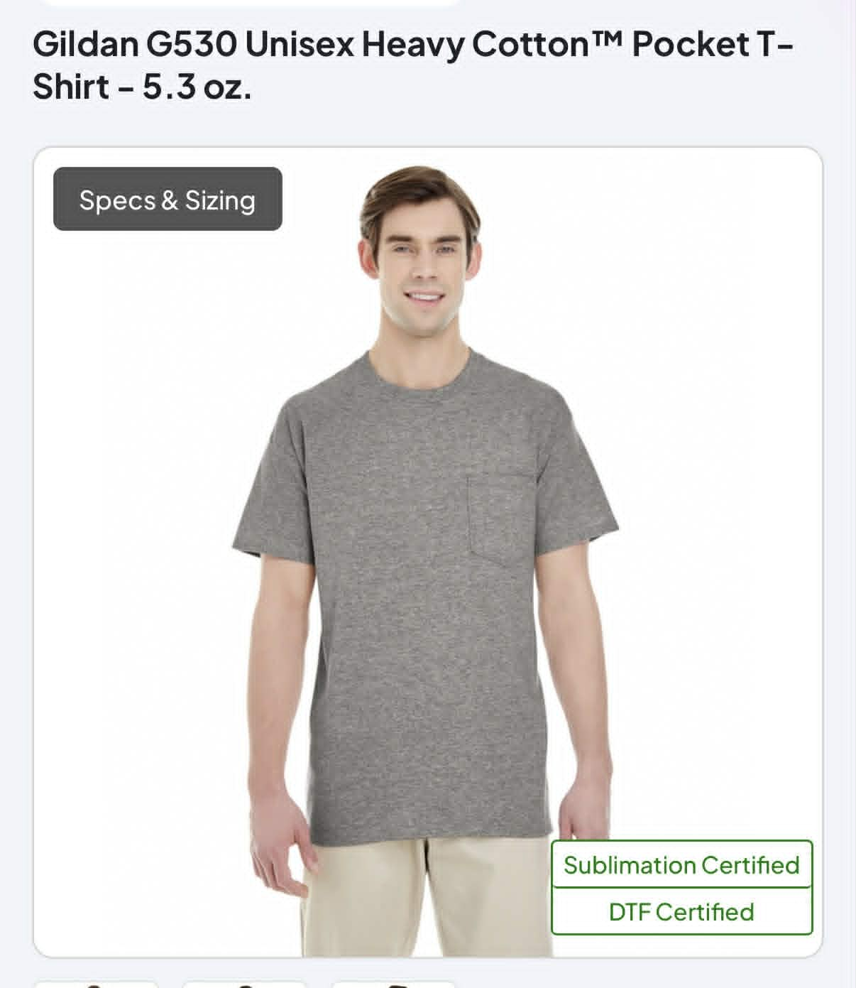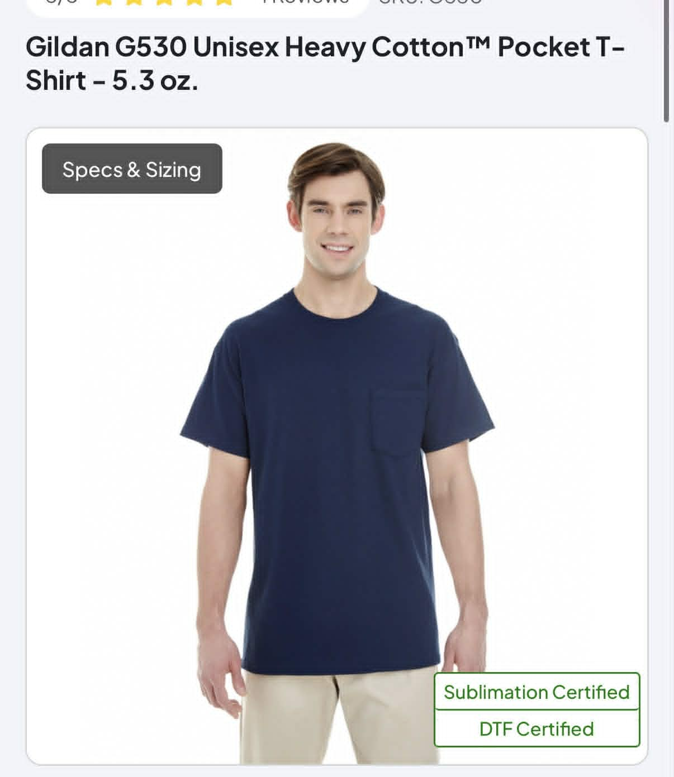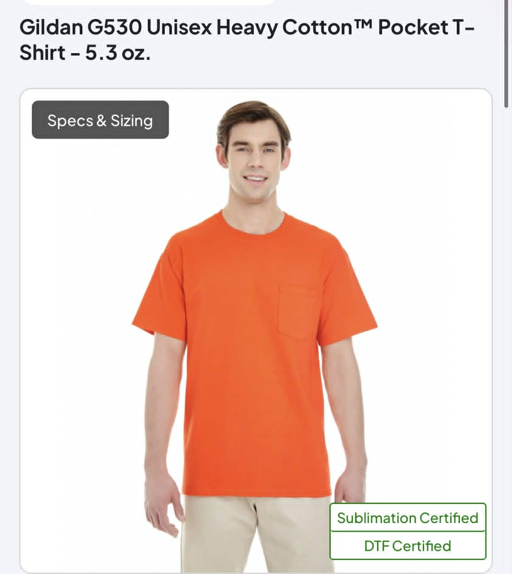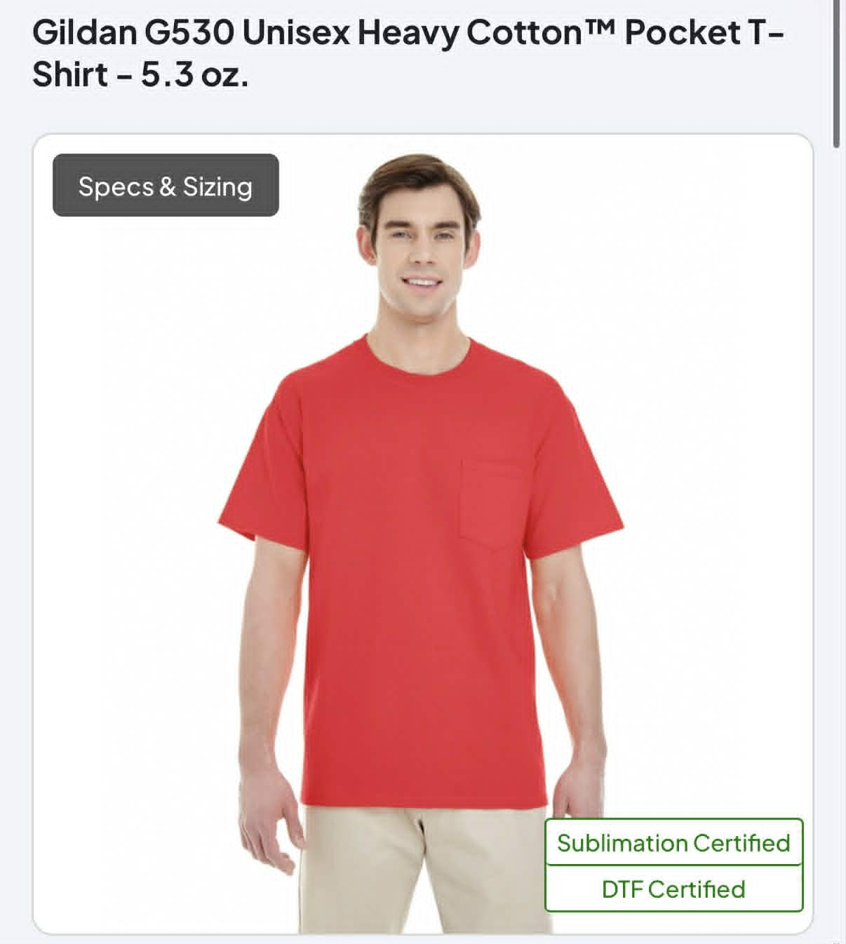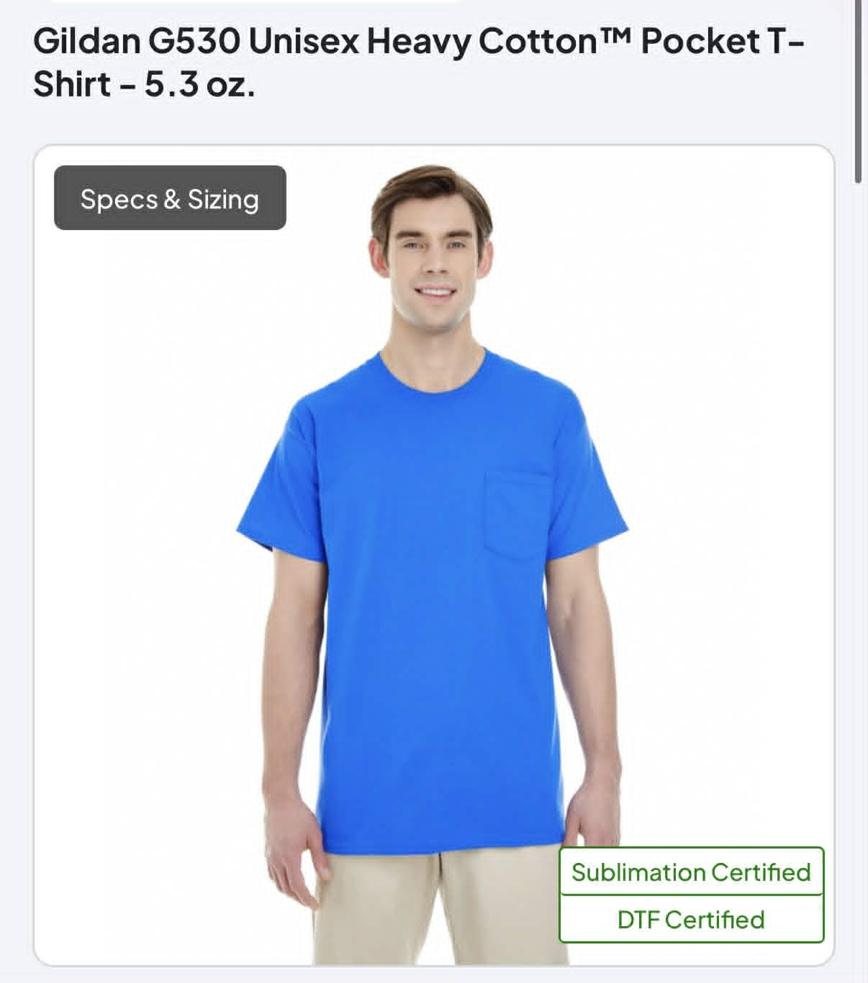
Black Charcoal Graphite Navy Orange Red Royal
Heather
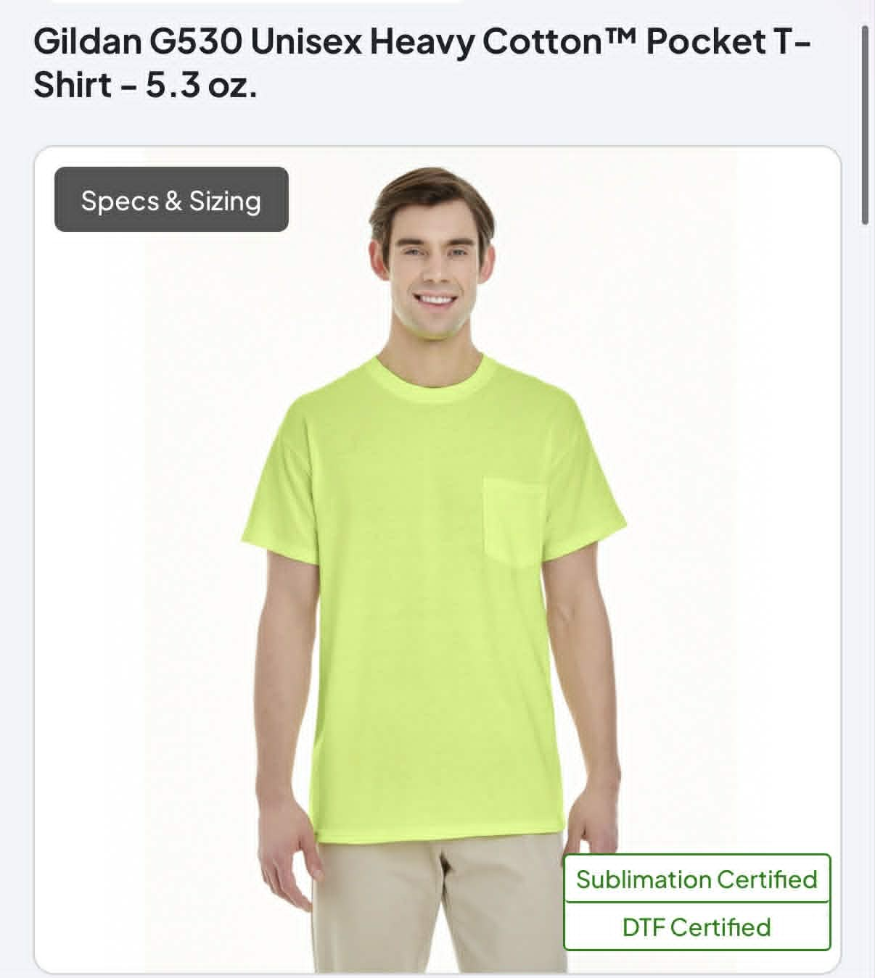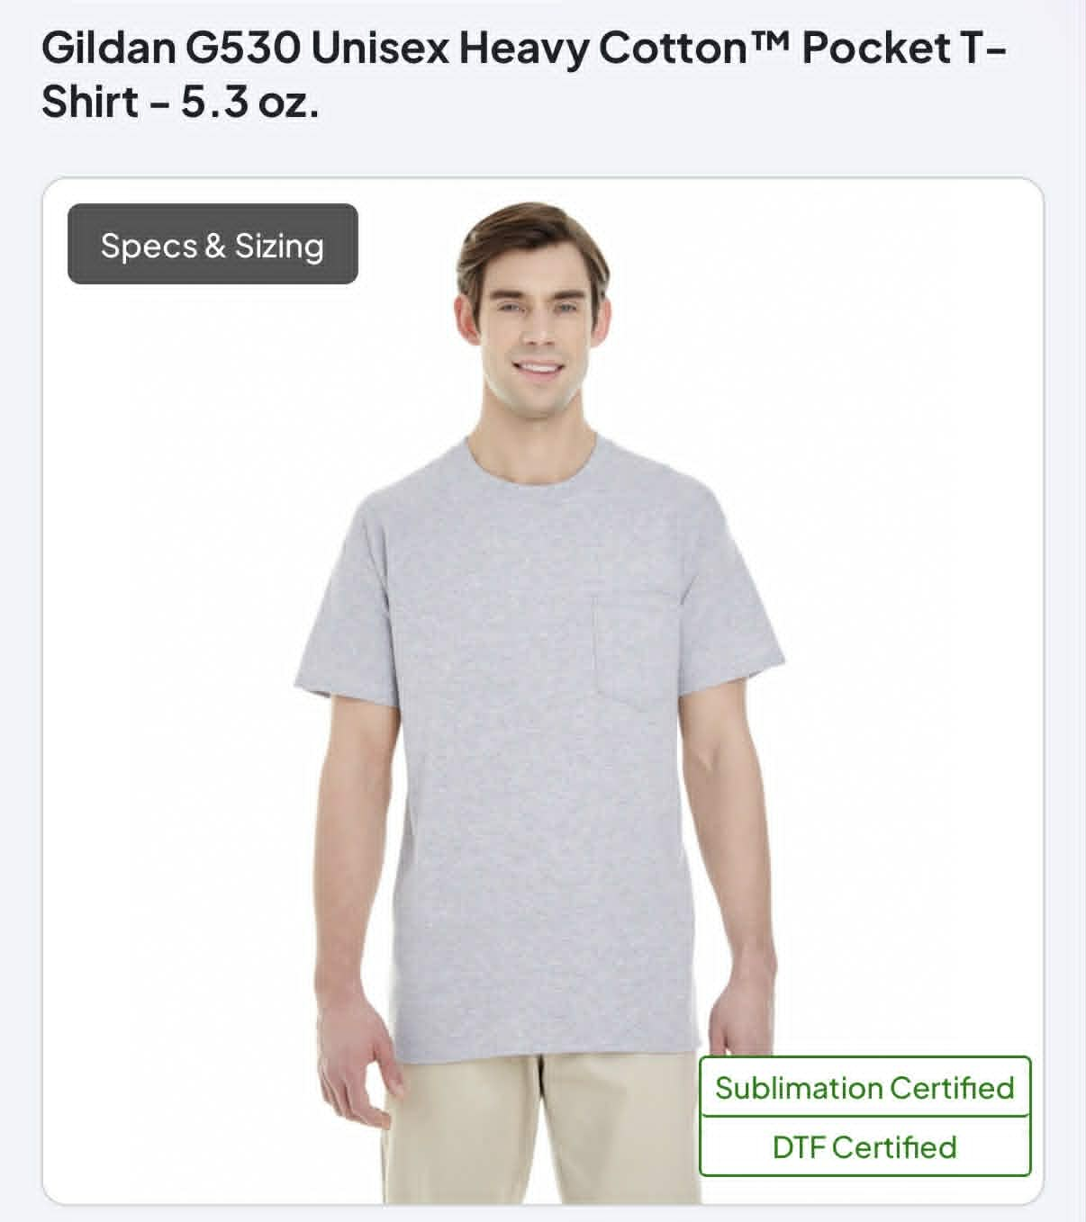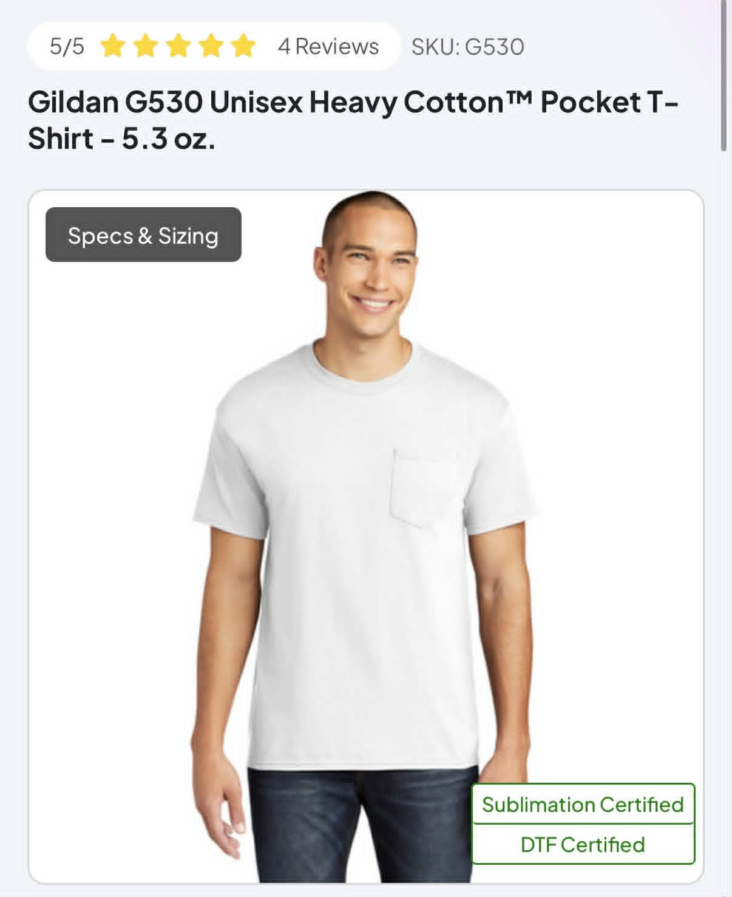
Safety Green Sport Gray White
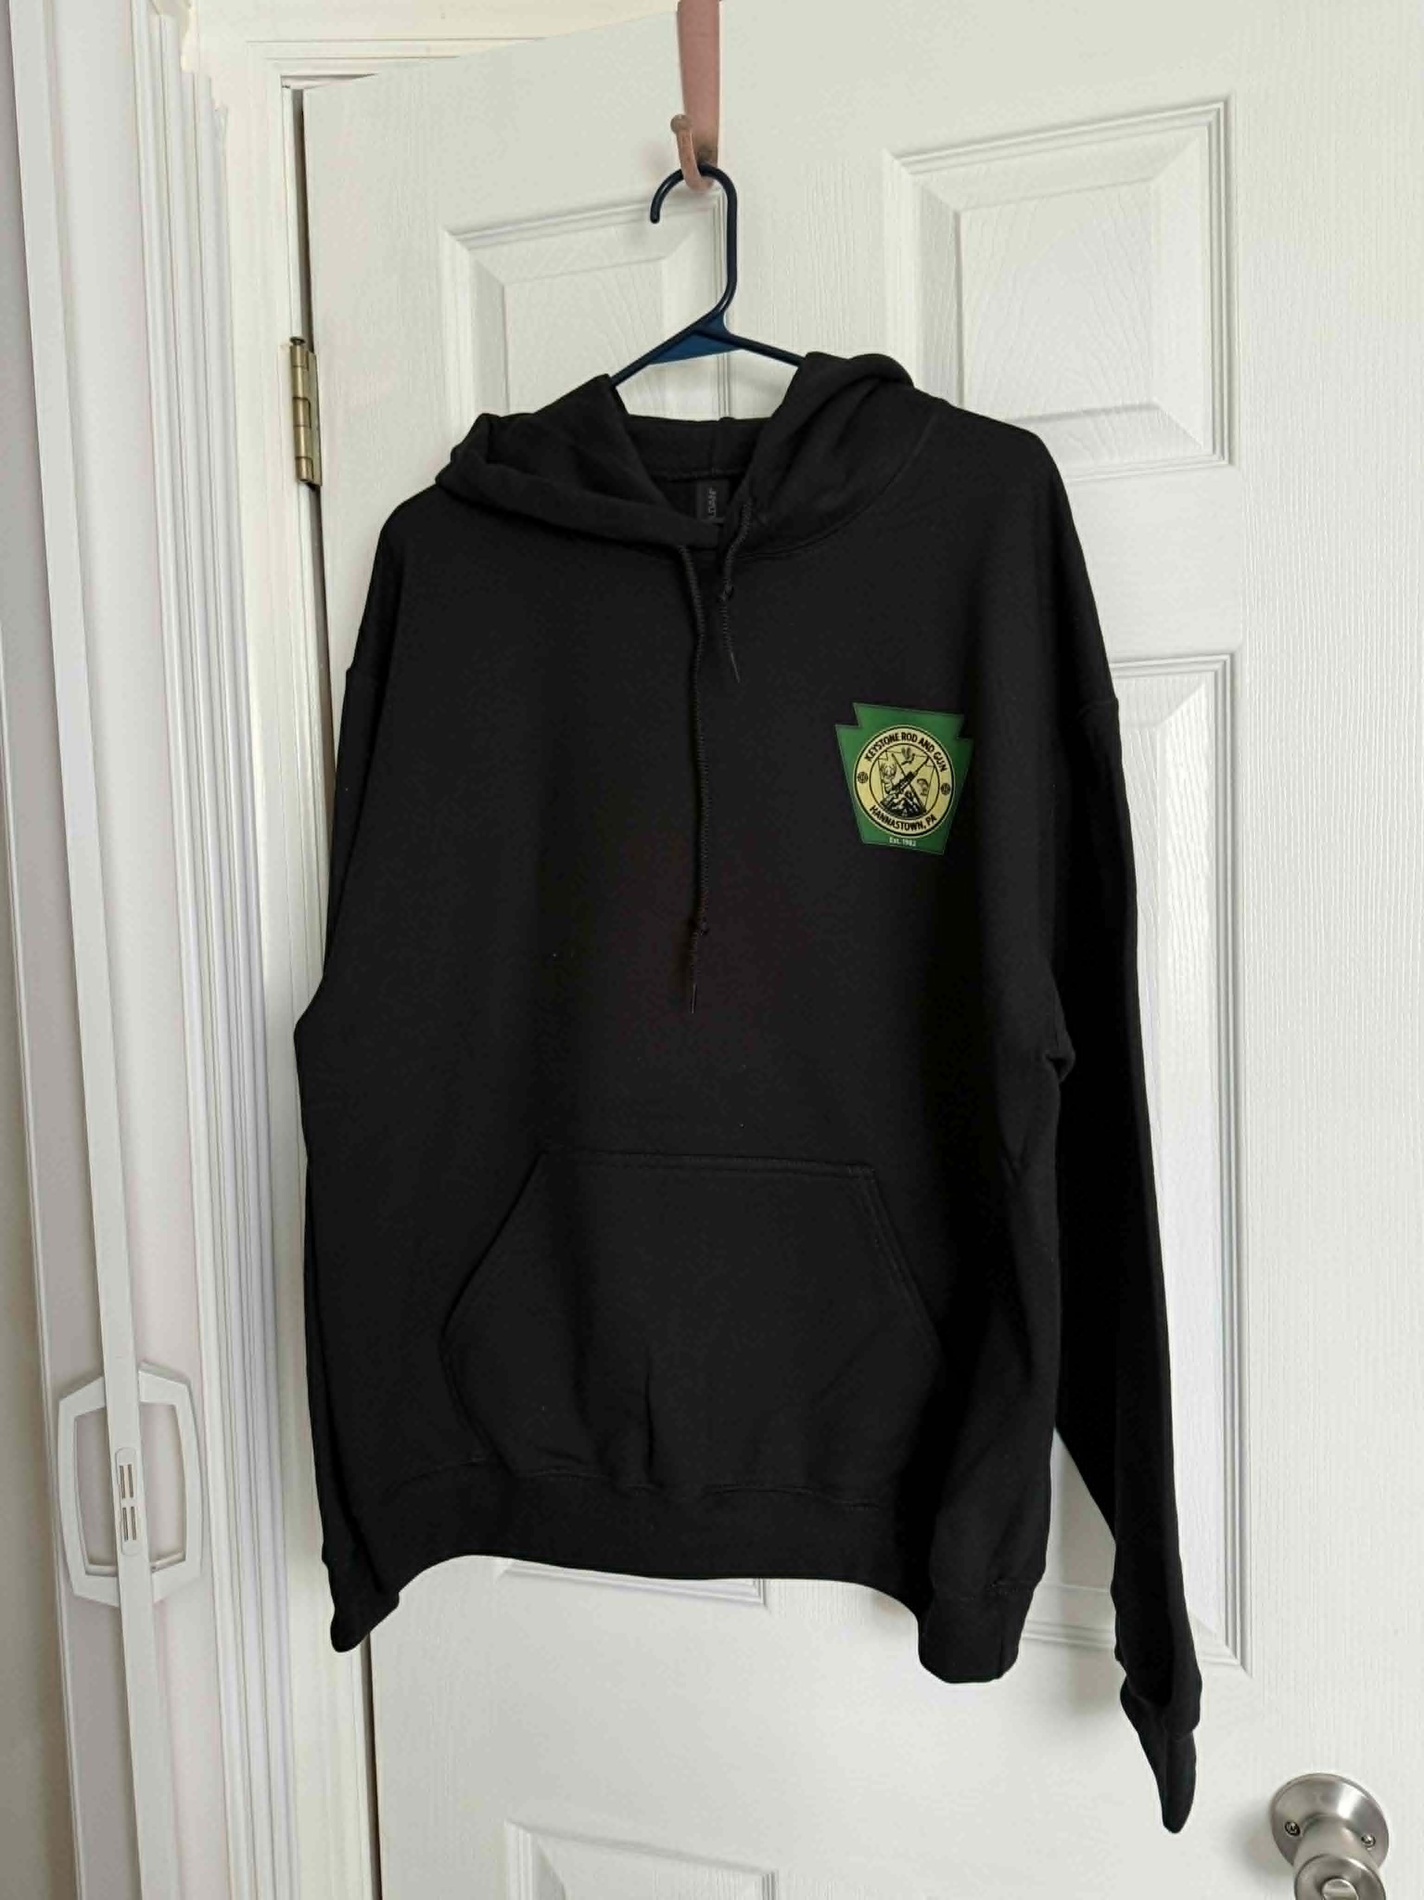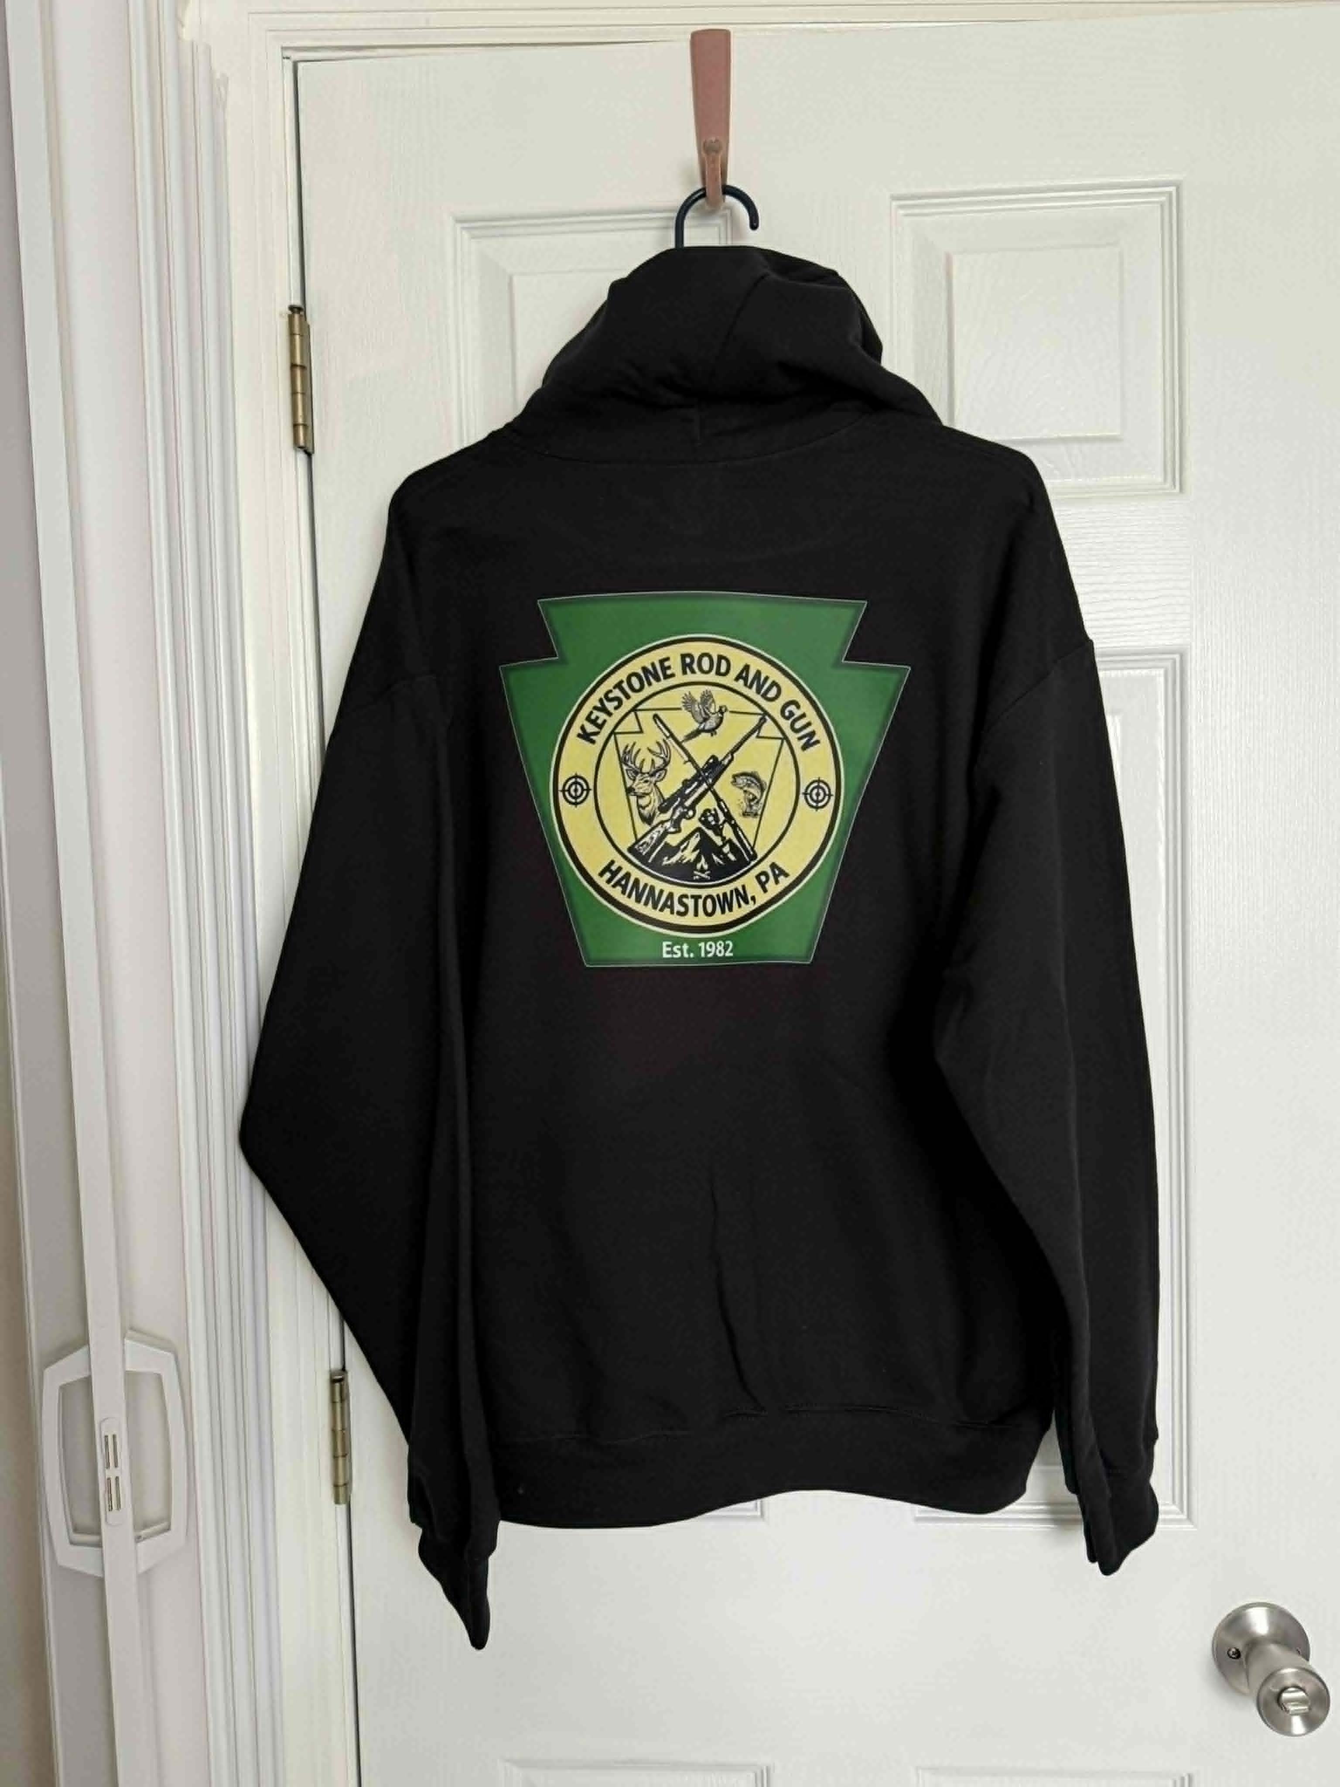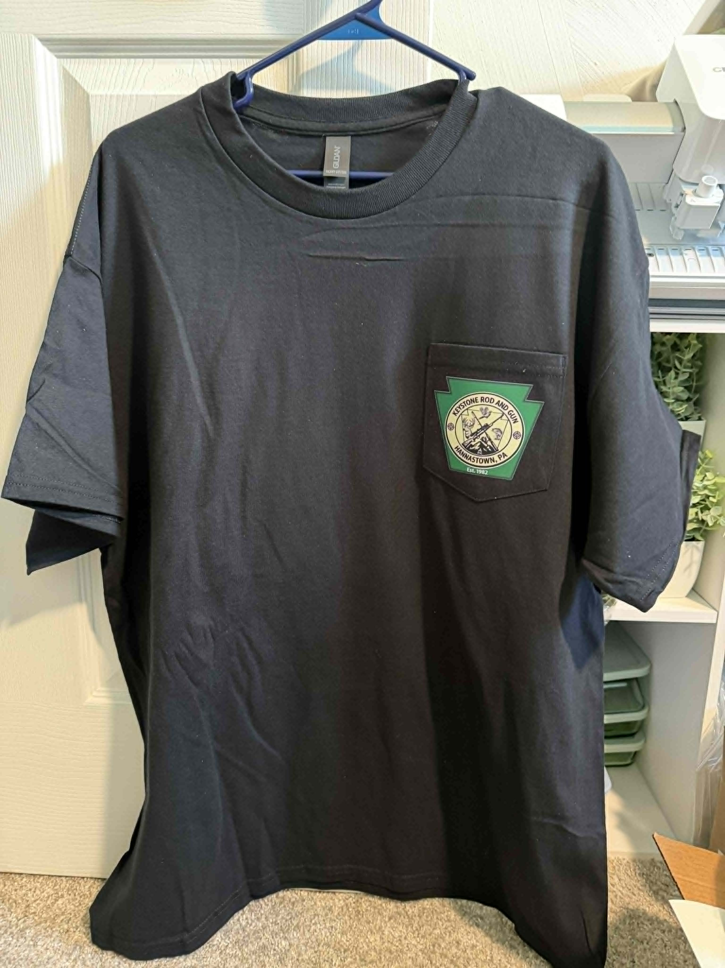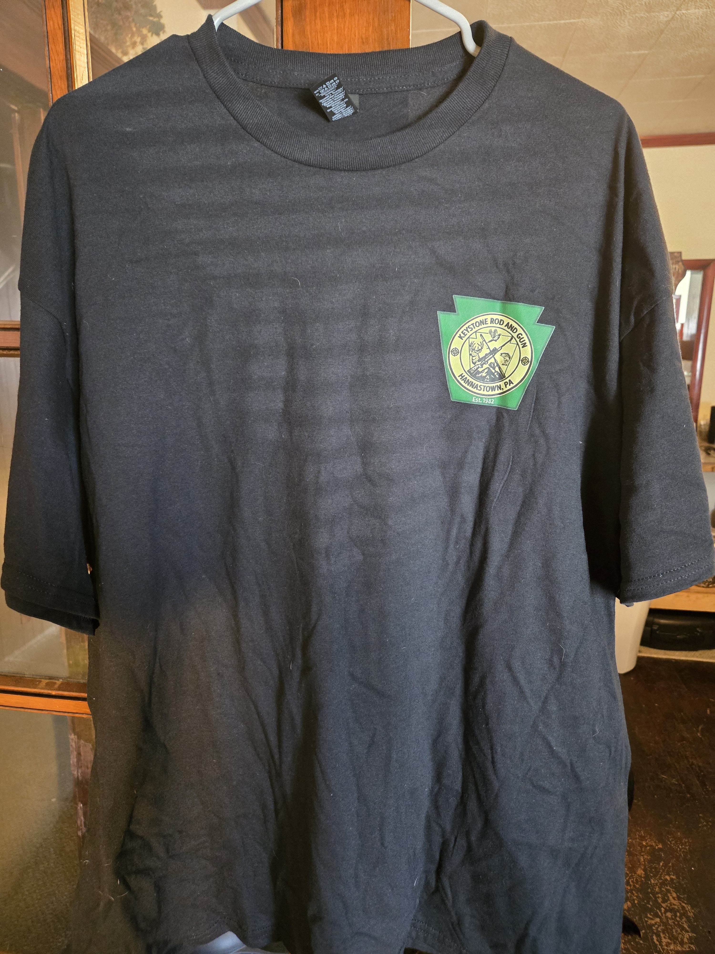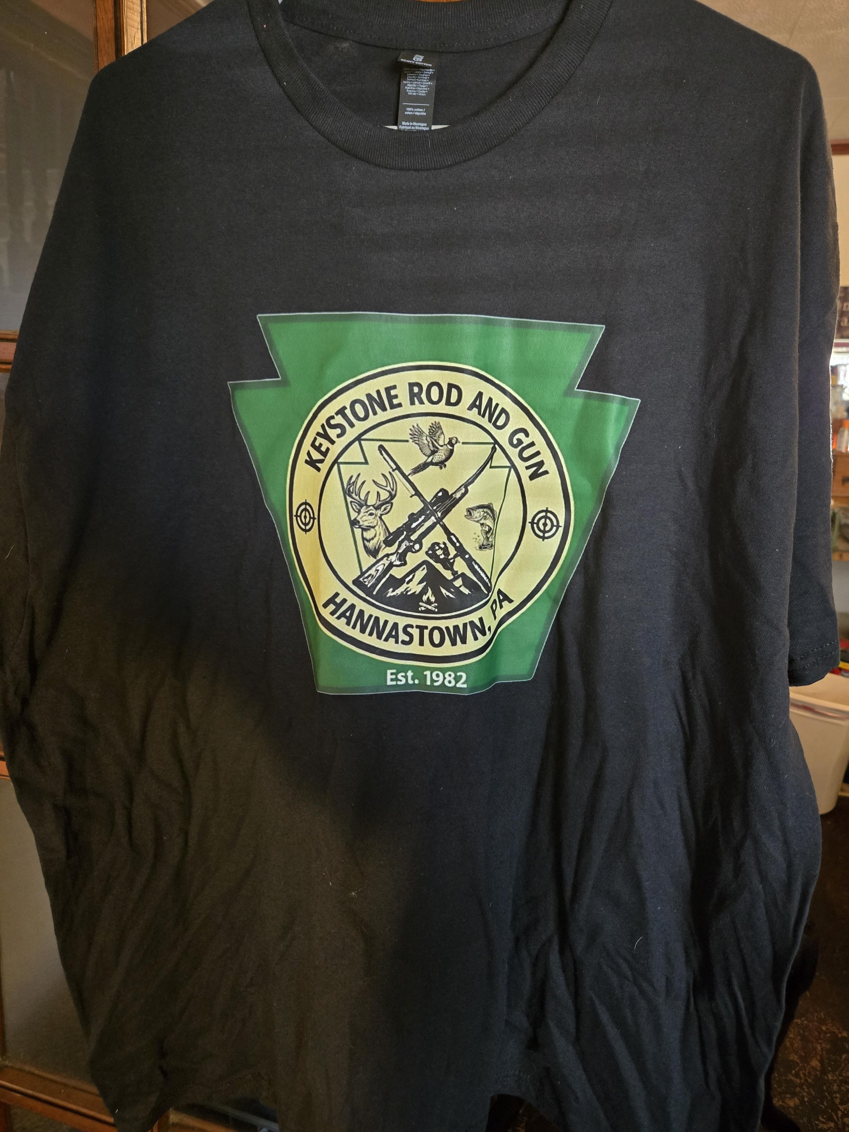
Hoodie Front Hoodie Back Pocket T-Shirt No Pocket T-Shirt Large Logo T-Shirt
(only available on no pocket T-Shirt)

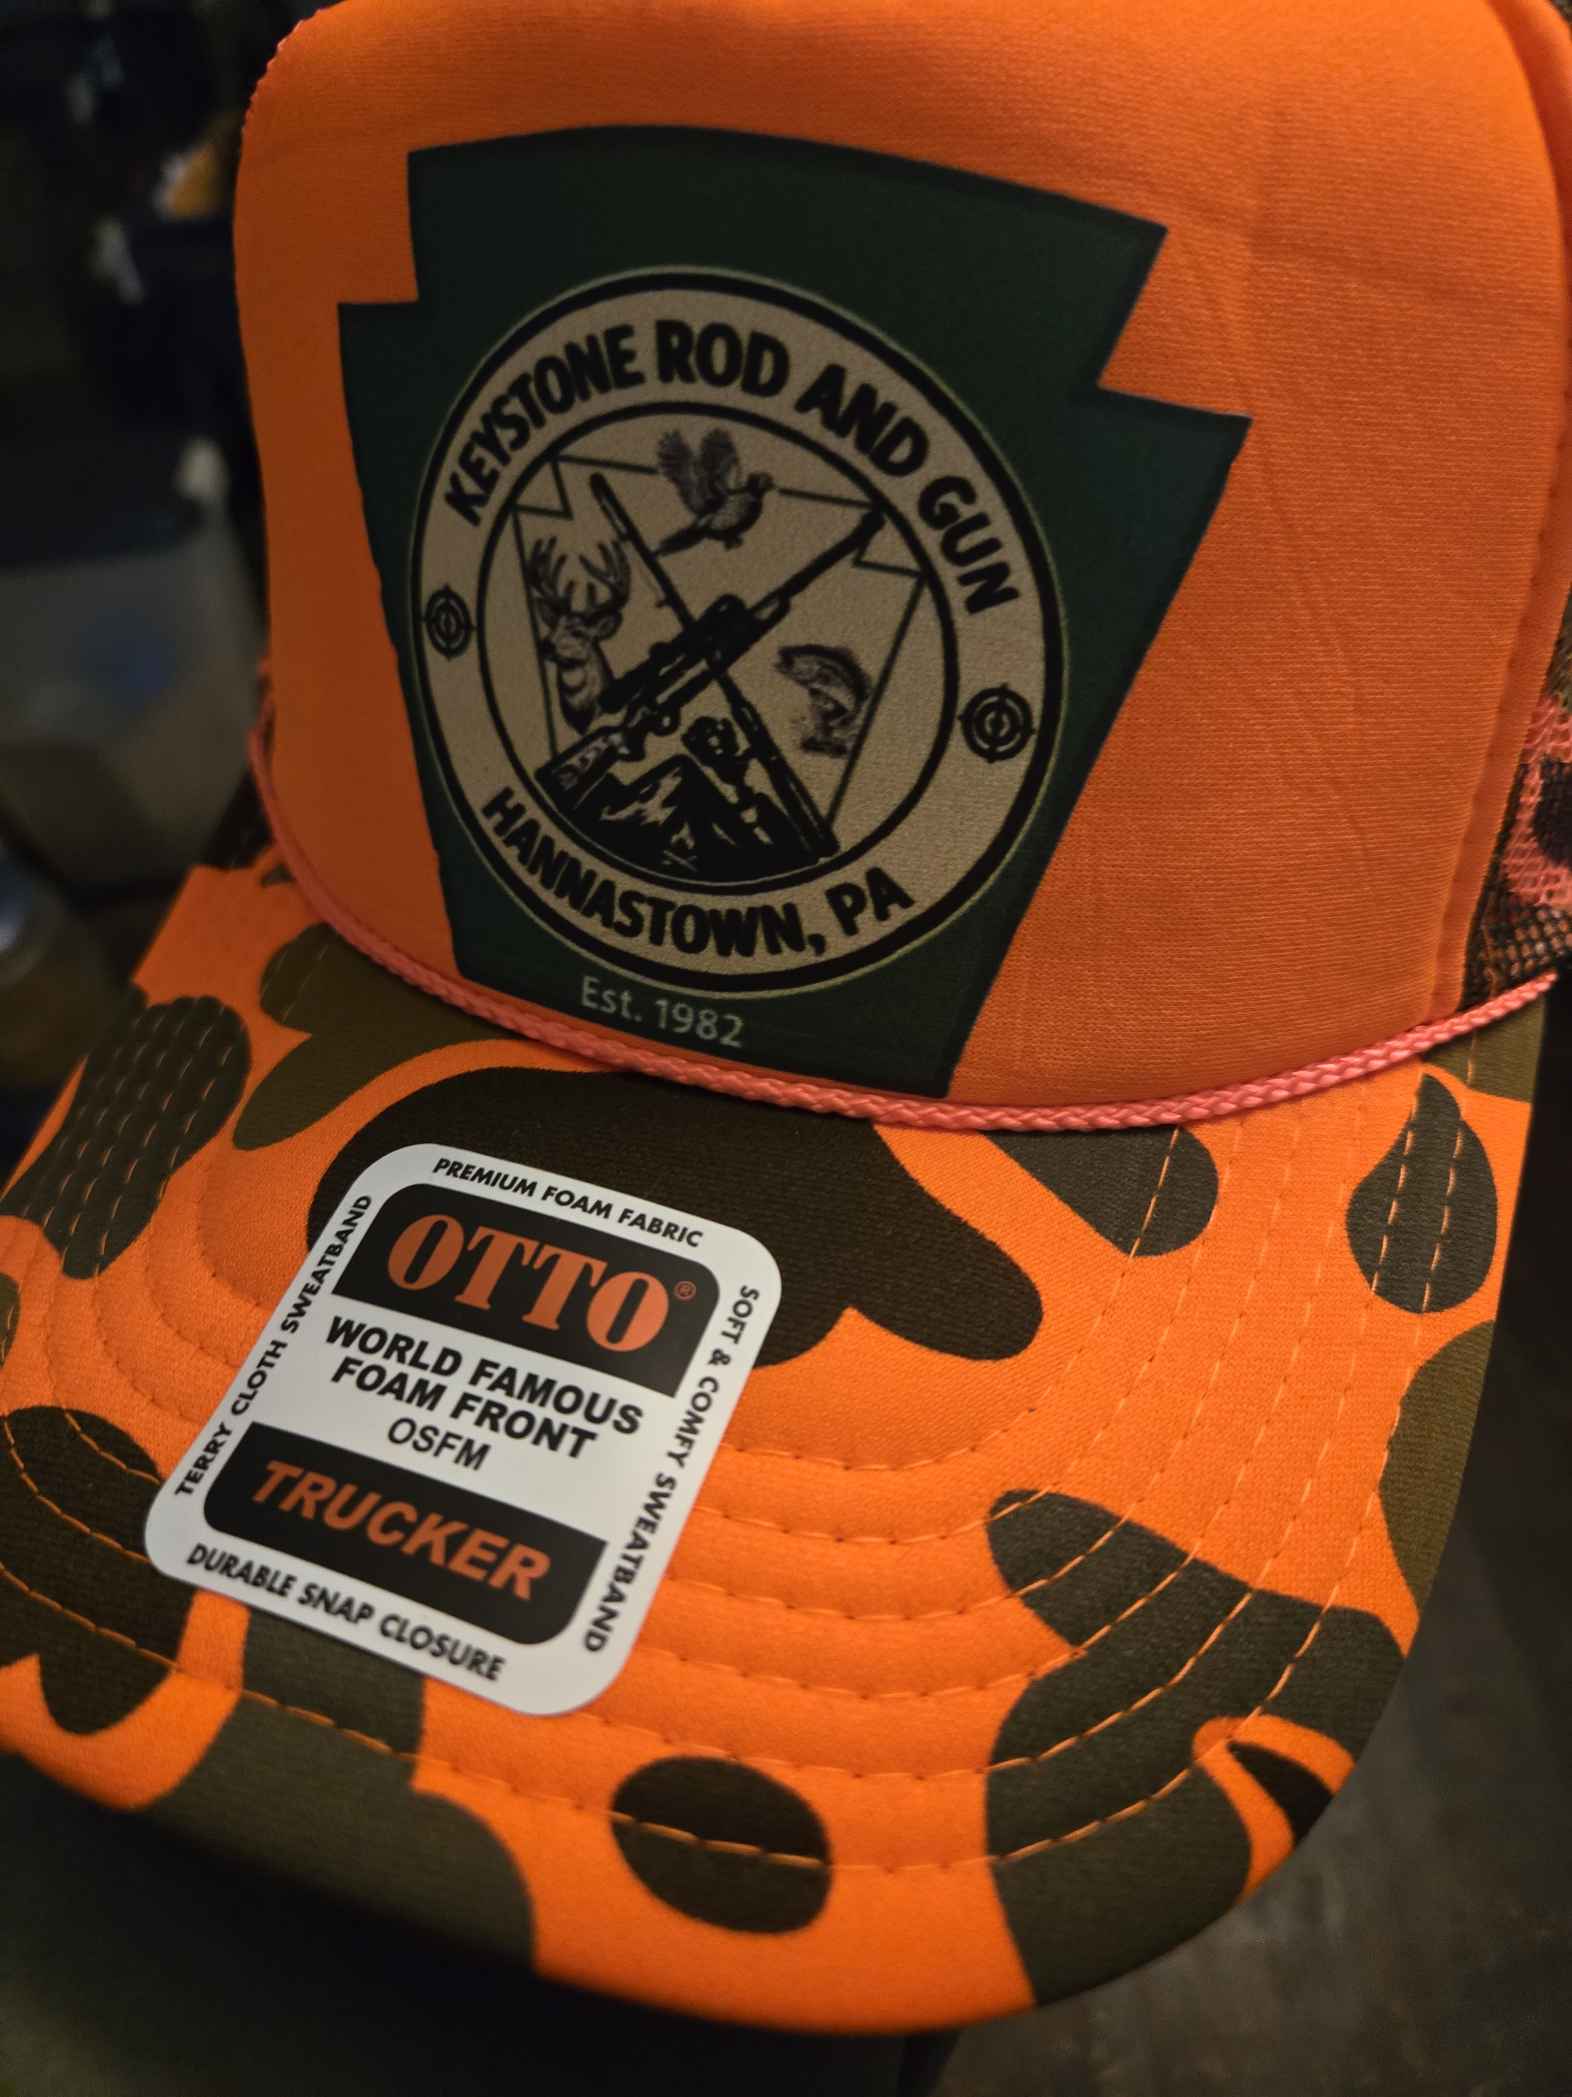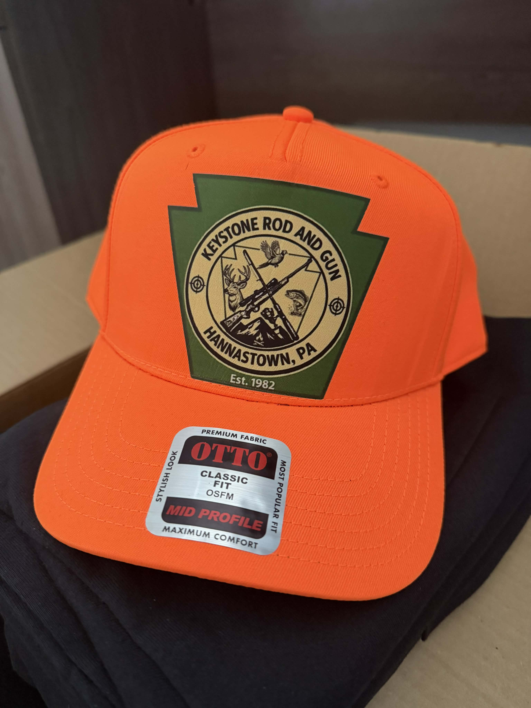
Orange Camo Solid Orange Hat
Mesh Back Hat

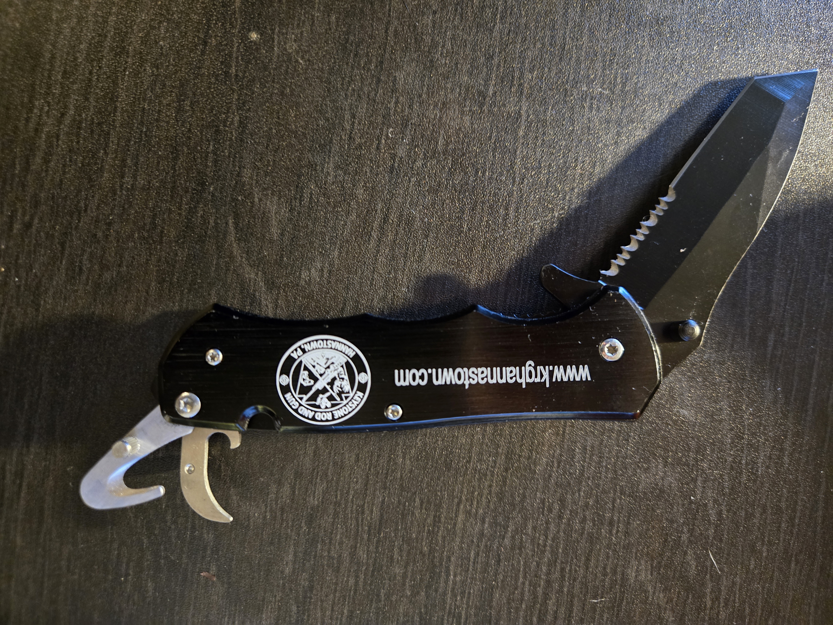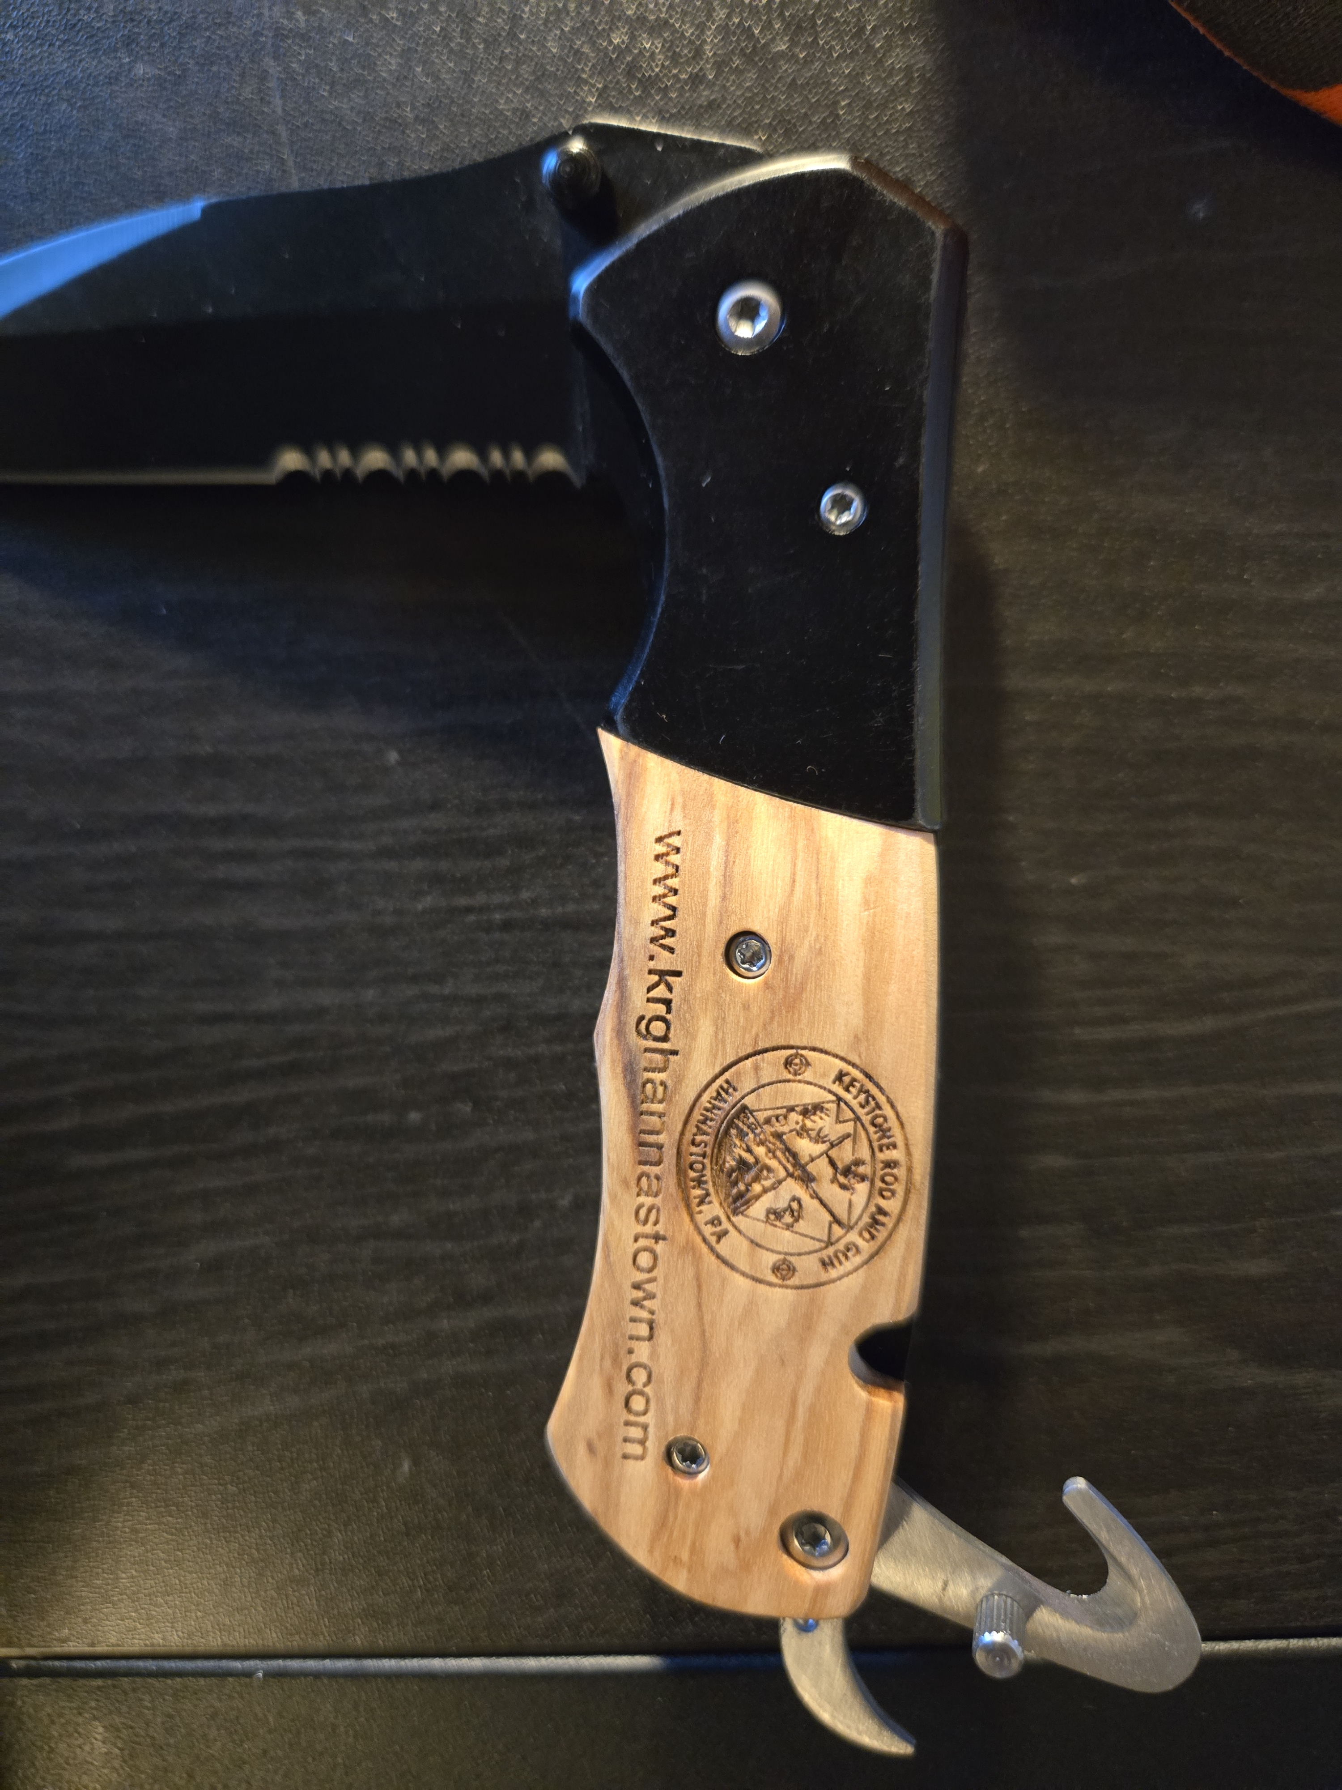
Black Custom Knife Wooden Custom Knife

Payment Info: Amount Paid:______________ Date Paid :________________
Payment Type: Cash or Check Officer receiving payment initials_________
All merchandise created by Tracy Bender at TracyB Tumblers Crazy Customizations. Please visit her Facebook group for custom tumblers and many other one of a kind items!! Her Facebook page is
https://www.facebook.com/groups/5933851306735917

